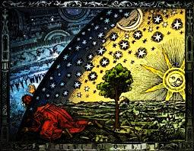**What’s Christianity Ever  
 Done for Science?**

**A short study book**

**By Ian Robinson**

1. SCIENCE IS AWESOME

2. DOES FAITH WEAKEN SCIENCE?

3. FACING FUTURE CHALLENGES

4. THE CHRISTIAN THEOREM

The title of this series comes from a satirical film *Life of Brian*, a youtube clip...

<https://www.youtube.com/watch?feature=player_detailpage&v=ExWfh6sGyso#t=0>

*WXED is dedicated to Prof Brian Hill, who has lived, breathed, written, laboured, thought and prayed in all these ways for many decades, with not a few tears.*

GOAL

To present essential background for the science community and science curriculum.

To spark a rise in the quality of discourse about faith and science.

**In any town where humans live, you will most likely find a mechanics workshop, an art shop, a library, a psychologist, a church or two, top and bottom pub and a grocer. Science is the mechanics shop. All the others need the mechanic but he/she needs them too. Let us not lock everyone in the workshop.**



**INTRODUCTION**

**The Old Married Couple**

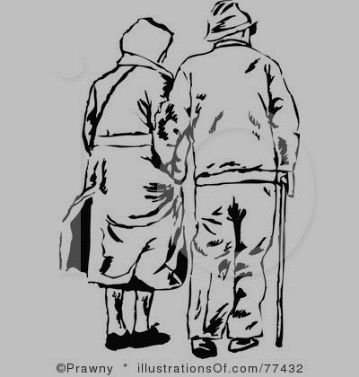We long ago lost the long marriage between science and faith. We ran into trouble when the children had grown up and moved out.

My passion for science brings me to this. It troubles me that new science students come to the university with the assumption that to be intelligent to be objective to be scientific one must be atheist. The history of their discipline has not been fuelled by this. The creative enterprise of science needs those who can connect with a creator, can connect in community, will fiercely practise the highest standards of truth-seeking and who can think with all the intelligences and not just the material, and NOT be belittled, blasphemed or politely barred from the practise of their extraordinary vitality.

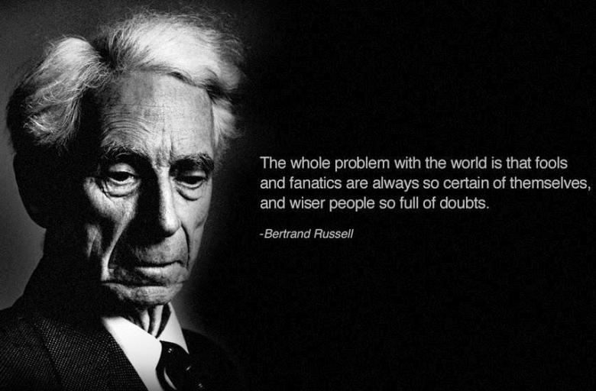

**HOW DID WE GET TO THIS?**

**Religion is something left over from the infancy of our intelligence, it will fade away as we adopt reason and science as our guidelines.”**

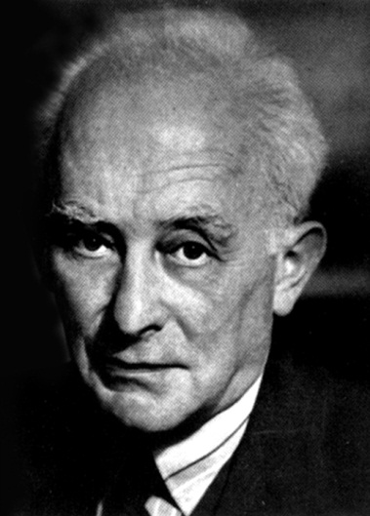***- Bertrand Russell, philosopher, confidently predicts the demise of religion.***

**“Those who say that study of science makes a man an atheist must be rather silly.” *- Max Born, quantum physicist***

Russell’s’ confident prediction has not come about. His contemporary Max Born stated the opposite. The early twentieth century saw a general hardening against anything that can be called ‘mysticism’, that is until after WW2, when other cultures had been encountered. Despite the uncertainty principle and dark energy moderating the philosophy of the physical sciences, the life sciences ran the statistics and continued to harden. The atrocity of 09/11 and the role of unfettered religious extremism ignited that culturally-latent anti-religious feeling.

My story is that since I left school I have studied science, philosophy, sociology, literature, archaeology, history, some languages, inter-cultural communities, priest/pastor role, deserts, and now university chaplain. When I hear: ‘Science uses a rational-inductive critical process but Christians use faith as a ‘leap in the dark’ without evidence,’ I don’t recognise either this science or this faith.

We hear famous atheists like Dr Lawrence Krauss, Dr Richard Dawkins and others shouting down this connection, but their strident shouts are a novel view and not faithful to the history of science. They cite the conflict from the history of modern science that surrounded the emergence of new scientific paradigms (Galileo, Darwin). This shows, they say, a fundamental incompatibility between science and faith, one based on reason and one based on blind belief. That is simply historically unfair. Their approach obscures both the nature and the history of science. We will look at that in a few different ways.

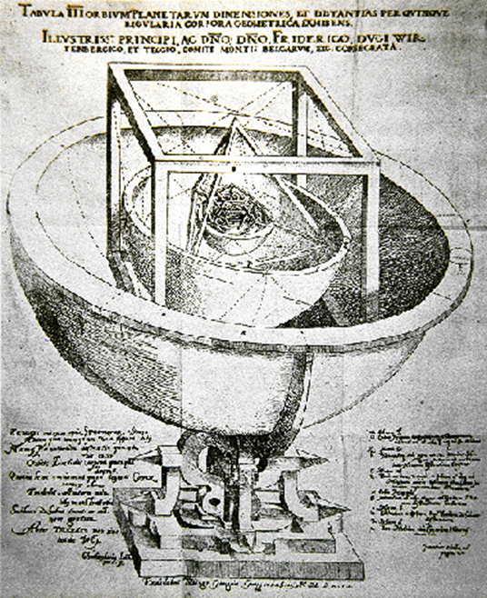Similarly, we hear advocates for *Creation Science* and *Intelligent Design* who cite scientific data that in their view shows a young earth, turning out like clay in the hand of the creator. The minority of Christians and no major denominational bodies that I have found actually support this view but for some reason it is popular in some sectors. It is portrayed as a triumph of common sense and biblical authority over the subtlety of scientific explanations and perhaps over the arrogance of some scientists. It is the theological equivalent in recent times of a wider movement - climate-change deniers, anti-vaxxers, homeopathy and similar ‘remedies’. So, I repeat, it is not being driven by Christian belief.

The opposite is what really happens. The wonders of science connect with the wonder of Him who had the great idea for it all! Science is thinking God’s thoughts after him” Yes, many people are converted to God by the wonders of science.

*Kepler’s helio-sphere.. Kepler was a Christian whose model of planetary motion applied Copernicus’ theory imperfectly but brilliantly.*

**DISCUSS:**

* Why do you think Russell and Born disagreed so firmly?
* Must science and faith always be poles apart?
* Where are you aware of non-polarised viewpoints today, that is, where there is room for reasonable and respectful discussion that will advance understandings?

**STEP ONE SCIENCE IS AWESOME**

With no apology, we begin by marvelling at the things that are powerful in the science enterprise.

* Evidence probability
* Rational empirical Laws
* Predictive and Falsifiable
* Elegant imaginative models
* Remain open –critical
* Good science works for the common good
* Science amplifies wonder

A powerful enterprise for good is, however, not what is being debated, most of the time. Two other things frame the current discussion.

Science can become in some minds a complete and absolute world view, often called ‘scientism’. This is when ‘empirical’ evidence becomes the whole horizon, the whole world, or when ‘Rational’ means anything not intuitive, something where the mathematics translates the phenomena. These are good things to hold on to if you are doing a scientific analysis of something, that is you are doing the job that science is good for. It is only a major problem when the empirical framework of assumptions is unacknowledged - scientists are often not adept at that challenge and feel threatened. So a brilliant tool box for contributing to life gradually becomes a prison for the mind.

We should also acknowledge that faith has founded shaped and sustained science. Science has helped religions to avoid superstition and cultural captivity. Together they have benefited humankind but will they continue to do so? It takes a dedicated scientist to labour in the laboratory year after year to find a cure for, say, malaria. It will be the Christian who goes to live, at risk to their own health, in the swamps where the vaccine will be injected year after year. We will return to this vision for a renewed collaboration.

So where is this going? I will not here pursue the usual philosophical arguments – the cosmology/design and ontology/origin arguments that are treated in many places. Instead this new perspective examines the cultural foundations of modern science. Who were the Pioneers and who of these were/are believers in Christian or another faith?

In principles, in persons and in practise, the strength of science often derives from Christianity. I will recall the five Models of Connection between faith and science, and hope for collaboration to meet some Challenges: science now and the world now. I am simply, evidentially asserting that there is gold in this story, AND that there are five pillars of science that we would do well to connect solidly with lest we fall. Let’s begin with the story...Faith-principles which, and faith-persons who are at the backbone of science.

**Discuss**

* What is one wonder of science that you admire the most?
* What is one wonder of religion that you admire the most?

**STEP TWO DOES FAITH WEAKEN SCIENCE?**

**FAITH-PRINCIPLES UNDERLYING SCIENCE**

The following five principles have lain at the heart of Christianity since at least Eriugena in the ninth century. They underlie science too. Let me put them this way:

1. VERIFY YOUR PERCEPTIONS – rational helps; faulty fabulous humans; received or owned faith
2. STABLE SEPARATE *UNI-*VERSE arising from ONE CREATOR. The ‘two feet’ on Christian revelation – Nature and Bible. i.e. the concepts of Secularity and Mystery lies ***within*** Christian cosmology
3. SCIENCE IS NOT ONE VOICE AND NOR IS RELIGION – theorem-anomaly-reframe. Hegel’s tower, v Riceour’s river <http://www.iep.utm.edu/ricoeur/>
4. MYSTERY - we will one day be seen to be wrong about some things - rational-mystery, personal perception, philosophical fashions (e.g. Humean rationalism), the surprise of “dark energies”, the “uncertainty principle” all describe both theology and science, that is progressing disciplines.
5. HUMANITY - who benefits from scientific discoveries? For the common good? Or just for the powerful? Mangalwadi cites his experience in India where he observes that the powerful control outcomes and benefit from them, a pattern he discerns repeatedly in non-Christian societies...

We will return to this in the final step. The church as organisation does not always keep to its own principles, but these five principles recur constantly. With these in mind, we can turn to the persons who stood on these principles and did truly great science.

**FAITH-PERSONS PIONEERING MODERN SCIENCE**

**Al-Hazen** 965-1040 Egypt, Muslim, “the first scientist”

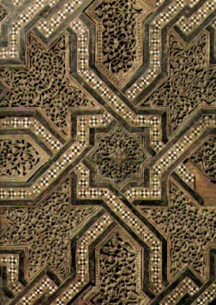"The seeker after truth is not one who studies the writings of the ancients and, following his natural disposition, puts his trust in them, but rather the one who suspects his faith in them and questions what he gathers from them, the one who submits to argument and demonstration.“

A devout Muslim, Alhazen believed that human beings are flawed and only God is perfect. To discover the truth about nature, he reasoned, one had to eliminate human opinion and allow the universe to speak for itself through physical experiments. He was a scientist, polymath, mathematician, astronomer and philosopher. Al-Hazen was the first person in textual history to test hypotheses with verifiable experiments, developing the scientific method more than 200 years before European scholars learned of it by reading his books. Note that it’s his theology that drove the need for testability. With Bacon, early secular science was not a departure from faith but an expression of it.

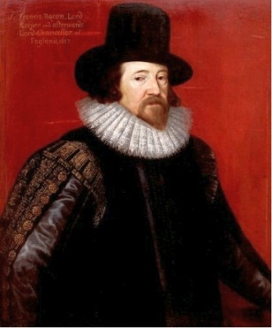

**Francis Bacon 1561-1626**

For our Saviour saith ‘You err, not knowing the Scriptures nor the power of God.” [Matt 22.29] laying before us two books or volumes to study if we will be secured from error: first the Scriptures, revealing the will of God, and then the creatures [natural science] expressing his power, whereof the latter is a key unto the former.’

Francis Bacon is often credited with being the father of modern science in the west. He was an English [philosopher](http://en.wikipedia.org/wiki/Philosopher) and [Franciscan](http://en.wikipedia.org/wiki/Franciscan) friar who placed considerable emphasis on the study of nature through empirical methods. He taught at Oxford and Paris in the founding phase of these two great centres of learning.

Here he states a theology of science – there are in Christianity two sources of truth in some sort of dynamic harmony (The “Two Bibles Theory” as it is sometimes called because the Holy Spirit who made the world also inspired the Holy Scriptures). The idea was not new even then. Bishop Augustine in the fifth century first coined the theory describing the connection between faith-thinking and nature. Bacon however was first and foremost a founder of modern science. He rejected the blind following of prior authorities, both in theological and scientific study, which was the received method of study in his day. But he didn’t come to this just from Christianity. He got it from an Egyptian Muslim, among others....

**These are among the pioneers of modern science Before the Darwinian revolution.** Let’s breeze through some of the great early moderns from 11-18 centuries:

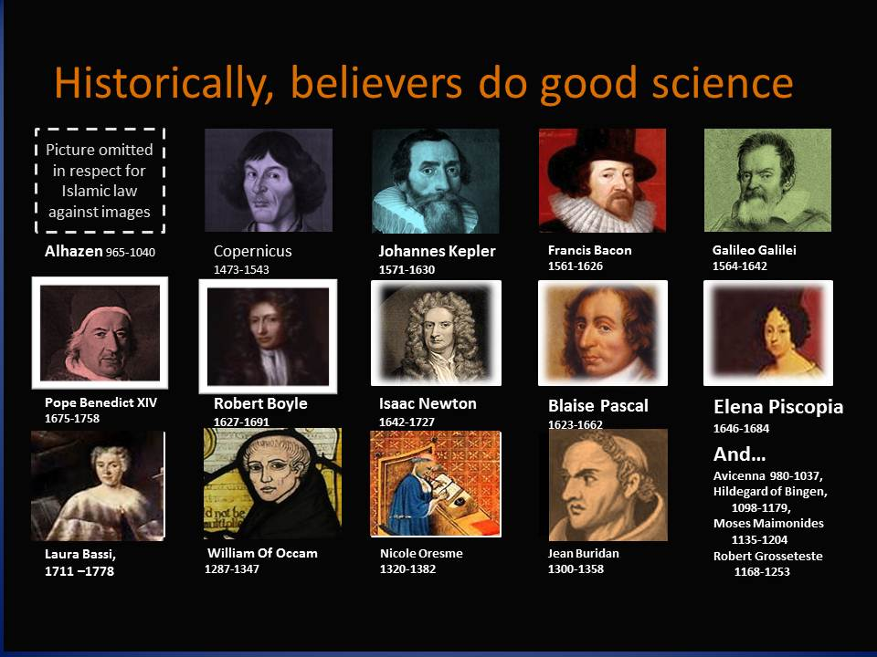**Robert Boyle**, natural philosopher, chemist, physicist, Christian. Boyle’s Law.

**Isaac Newton**, physicist and mathematician, Christian. Among other things, Isaac Newton is famous for the inverse square law of gravitation. He is less famous for being Albert Einstein’s pin-up boy in Einstein’s desk in Princeton. Newton, like many super-smart people in any university, was ‘not an “orthodox” Christian, but his biographer John Dillenberger states that he “...had no intention of being anything else but a Christian.” ... For example, Newton claims this very orthodox Christian theology.... “God governs the world invisibly, and he has commanded us to worship him, and no other God… he has revived Jesus Christ our Redeemer, who has gone into the heavens to receive and prepare a place for us, and will at length return and reign over us…till he has raised up and judged all the dead.”

**Blaise Pascal 1623**-1662 France mathematician, physicist, inventor, Christian philosopher and contemplative.

**Elena Piscopia**, 1646-1684 Italy Theology, philosophy, mathematics, languages and music, First woman to be awarded a doctorate

**Laura Bassi**, 1711-1778 Italy scientist, anatomist, mathematician. She was allowed to teach at home to help with child care.

**William of Occam** 1287-1347 was an [English](http://en.wikipedia.org/wiki/England) [Franciscan](http://en.wikipedia.org/wiki/Franciscan) [friar](http://en.wikipedia.org/wiki/Friar) and [scholastic](http://en.wikipedia.org/wiki/Scholasticism) [philosopher](http://en.wikipedia.org/wiki/Philosopher) and theologian, who is believed to have been born in [Ockham](http://en.wikipedia.org/wiki/Ockham,_Surrey), a small village in [Surrey](http://en.wikipedia.org/wiki/Surrey). He is considered to be one of the major figures of [medieval](http://en.wikipedia.org/wiki/Medieval) thought and was at the centre of the major intellectual and political controversies of the fourteenth century. He is commonly known for [Occam's razor](http://en.wikipedia.org/wiki/Occam's_razor), the methodological principle that bears his name, and also produced significant works on [logic](http://en.wikipedia.org/wiki/Logic), [physics](http://en.wikipedia.org/wiki/Physics), and [theology](http://en.wikipedia.org/wiki/Theology)

**Nicole Oresme** 1320-1382, was [Bishop of Lisieux](http://en.wikipedia.org/wiki/Bishop_of_Lisieux), France. He was a significant [philosopher](http://en.wikipedia.org/wiki/Philosopher) of the later [Middle Ages](http://en.wikipedia.org/wiki/Middle_Ages), writing influential works on [economics](http://en.wikipedia.org/wiki/Economics), [mathematics](http://en.wikipedia.org/wiki/Mathematics), [physics](http://en.wikipedia.org/wiki/Physics), [astrology](http://en.wikipedia.org/wiki/Astrology) and [astronomy](http://en.wikipedia.org/wiki/Astronomy), [philosophy](http://en.wikipedia.org/wiki/Philosophy), and [theology](http://en.wikipedia.org/wiki/Theology), a counsellor to King [Charles V of France](http://en.wikipedia.org/wiki/Charles_V_of_France) and probably one of the most original thinkers of the 14th century

**Jean Buridan 1300-1358 France** was a [French](http://en.wikipedia.org/wiki/French_people) [priest](http://en.wikipedia.org/wiki/Priest_(Catholic_Church)) who sowed the seeds of the [Copernican revolution](http://en.wikipedia.org/wiki/Copernican_revolution) in Europe. After receiving his Master of Arts degree around 1320, Buridan became a lecturer in natural, metaphysical, and moral philosophy at the University of Paris. To make science compatible with Christian dogma, Buridan had to break its traditional ties with metaphysics and define its principles methodologically, in terms of their value in “saving the phenomena”.

[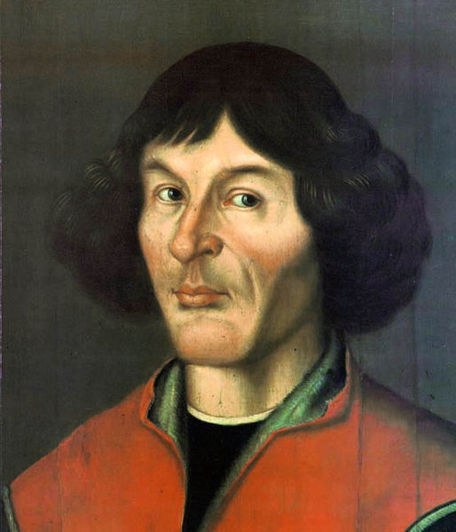](http://upload.wikimedia.org/wikipedia/commons/f/f2/Nikolaus_Kopernikus.jpg)And the famous **Nicolau Copernicus** Poland

COPERNICUS 1473-1543

From the mid-eighteenth century, it has been in the certain interests to promote an artificial conflict between church and science. One case is Copernicus, who, it is alleged “was censored for proposing that the earth goes around the sun, contrary to the flat-earthers in ‘the church’.” Really?

“...a Lutheran prince [Duke Albrecht of Prussia] subsidized the publication of his [Copernicus’s] work, that a Lutheran theologian [Andreas Osiander] arranged for the printing, and that a Lutheran mathematician [Georg Joachim Rheticus] supervised the printing.”

Why the conflict? The Copernican Revolution was THE classic paradigm-change of science against so-called common-sense and the received Aristotelian universe. IT was Aristotle they were fighting over, not the Bible! Same same with Galileo. This chapter of history was as much a saga of church vs Jesus as church vs science. Let’s see what happened next...

**GALILEO GALILEI** 1564-1642

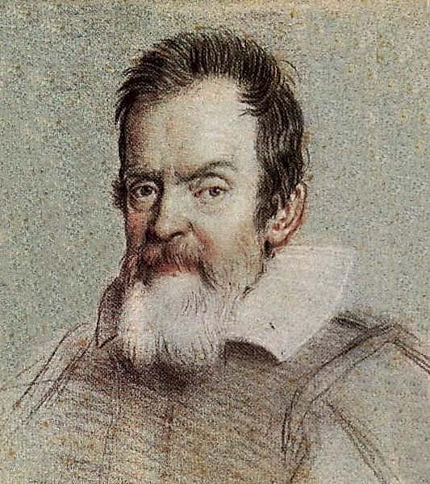 From my reading of this saga, that cocked eyebrow in the picture pretty much describes this brilliant man’s attitude to anyone who questioned him. Yet he said:

“For the Holy Bible and the phenomena of nature proceed alike from the divine word the former as the dictate of the Holy Ghost and the latter as the observant executrix of God’s command.”

[http://www.youtube.com/watch?v3VlyEaesAi8](http://www.youtube.com/watch?v3VlyEaesAi8%20) Let’s hear from the chair for History of science and Christianity Prof Peter Harrison of Oxford University. ... Length 1.31

So, Galileo was allowed to see what he believed he had proved but not that it was proven. He was not burnt at the stake as often repeated, but placed under house arrest. Harrison didn’t own up to it there but a privileged conservative church, who were actually defending Aristotle and Ptolemy not the Bible, went head to head with him and eventually signed an excommunication, which Galileo cocked his eyebrow at and kept working. It took four hundred years to apologise.

APOLOGY

May I pause to join my apology, as an ordained minister of the Church, to those who have been and are still being wronged by sections of a high-handed church who should have been as humble as their Lord.

The reverse can also be said. I have in the past put down people who were not as clever as I am in my scientific and sociological education, in effect despising the wisdom of all other ways. It was just intellectual arrogance. I apologise.

DISCUSS

* What new things did you learn from this survey of faith and science through history?
* What things do you think the church should apologise for? Have you studied to see if it actually did anything wrong?

PIONEERS OF BOTH FAITH AND SCIENCE AFTER DARWIN

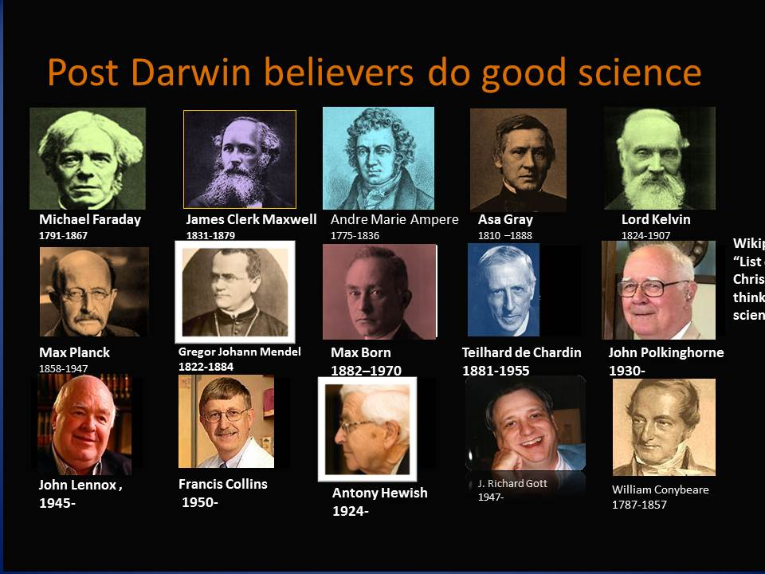

DARWIN

And so the story of science goes on in this creative tension. We come to the next great paradigm change, the age of the earth and the evolution of life as published among others by **Charles Darwin.** When his grandfather put out a similar theory there was barely a ripple of objection from the church. But by the 1850’s the revolutions in Europe had created conservatism in every quarter of royal Britain, in other words there were other drivers at work in politics and public. How was he received at the time? Peter Harrison again:

[**https://www.youtube.com/watch?v=EGxrr55mdeg**](https://www.youtube.com/watch?v=EGxrr55mdeg)

The church was stretched between the *theists*, a God who is involved in this world, and the *deists*, a God who started everything then went home for tea, ‘in the distance watching us’. Meanwhile, these are pioneer scientists who were men of genuine faith working through the controversy and reframe that was going on.

Michael Faraday, electromagnetism,

James Clerk Maxwell, mathematical physicist,

André-Marie Ampère physicist and mathematician

Asa Gray botanist, collaborator with Darwin,

Lord Kelvin, mathematical physicist, engineer,

Max Planck, 1858-1947 Germany, Theoretical physicist, deist

In the same field as Charles Darwin, Asa Gray his American collaborator was a Christian. He and Gregor Mendel (Augustinian monk and pioneer geneticist) and others were holding faith and biological science together, creatively in pursuit of the wonder of God’s handiwork. The monk Mendel discovered the concept of genes and the discovery of his three laws: the law of segregation, the law of independent assortment, and the law of dominance. (Mendel’s successor in the front end of genetics research today was the Christian Francis Collins who headed the US Human Genome Project in pursuit of what he called ‘the fingerprints of God’.)

The debate waited for another century , when Julian Huxley (1887-1975) and AJ Ayer made Darwin’s methodological atheism the basis for their own kind of pro-active secular humanism, but still today it might be called ‘scientism’. It was not today’s kind of atheism, it should be said, Huxley was simultaneously somewhat mystical.

The British Empire was at its height, subjugating colonies all around the world, the largest empire the world had ever seen. Undergirding that enterprise were the philosophy of Darwinism and the ethics of Humean Rationalism. However, at the same time emerged the global missionary movement with its 1906 Edinburgh conference for world evangelization., about which there has been a lot of re-thinking since at least the 1970’s. Two powerful intellectual trends were in collision - it got heated. Within the church there was more heat than light as a new “fundamentalist” movement (it meant something quite accommodating back then) resisted the liberal mythologisers - the latter had gone to anthropology to find a backing for their stories and belief system.

The great theoretical physicist Max Planck is an interesting case. His statements point in two directions. To the humanists he made it clear there was in his scheme an intelligence behind the material world. To the Christians he said he did not believe in any God ‘let alone a Christian God’. Is that a case of ‘keeping your head down in the crossfire’, a practise followed by many believers today? We don’t know.

Nevertheless, many pioneers of science were men and women of sincere faith and worked on creatively. Before we leave this list it is worth pointing out that Einstein also had Faraday and Maxwell as his two other pin up boys alongside Isaac Newton. He did not admire them for their shared Christian faith but, as he said, for their creative genius. Committed Christians with creative scientific genius? Between those voices, any claim that a position of faith cruels your science credentials, reduces your scientific objectivity, must be dismissed on the evidence.

In modern writing it is harder to find out who is a believer and who isn’t. There has been a steady decline in those persons who study everything, called the ‘renaissance intellectual’ or ‘polymath’ who were so evident after the Renaissance. Now a specialist is rarely prepared to say anything outside their narrow speciality, so big-picture quotes or statements of belief are harder to find on any subject.

However, we have hunted well. A large list of names and commitments can still be found. There are many more on <http://extraordinarywonder-thestoryofscienceandfaith.yolasite.com> including lists of Nobel Prize winners and :

William Conybeare 1787-1857, a father of geology

Mary Anning (1799 –1847) a British [palaeontologist](http://en.wikipedia.org/wiki/Paleontology)

They were both pioneers of old earth science.

Max Born (1882–1970) German/British Jewish /Lutheran, quantum physicist

Teilhard de Chardin, philosopher, priest, palaeontologist and geologist

Richard Gott, one of Einstein’s’ successors at Princeton, a co-author with Stephen Hawking and a professor of astrophysical sciences

John Polkinghorne, theoretical physicist, theologian, writer, Anglican priest

John Lennox, mathematician, philosopher of science

DISCUSS: Is the marriage between faith and science just going through a rocky patch but still intact?

These are just a few in the category of leading scientific figures who also held deistic/theistic beliefs and who were *in public* not prepared to side with Bertrand Russell’s dismissals. Some won Nobel Prizes for their science.

**WERE THEY ALL CONFORMING TO THE CHRISTIAN NORM?**

Were they, as Hitchens claimed, all just conforming to the Christian status quo, keeping out of trouble, but secretly atheists? It’s a valid question. I have been hard-pressed in my research to search through many claims in Christian or atheist literature that borrowed from a scientist a sentence out of context in order to recruit the person to their cause, whichever side they were on. E.g.Max Planck is sometimes claimed as a believer but, as already quoted, he actually denied that. I have only added to this list those I can be confident about. Still others alive today like John Lennox, Francis Collins, Alisdair McGrath, Hedley Brooke and John Polkinghorne have spoken directly and unambiguously and have provided many books on the subject - but we can go back even further.

[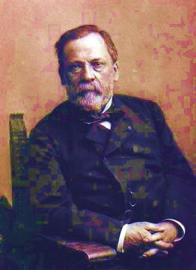](//upload.wikimedia.org/wikipedia/commons/9/96/Louis_Pasteur,_foto_av_F%C3%A9lix_Nadar_Crisco_edit.jpg)

**Louis Pasteur d**iscovered that bacteria cause disease, and he said: “The more I know does my faith approach that of the Breton peasant.” When he died, “one of his hands rested in that of Mme. Pasteur [his wife], the other held a crucifix.”

[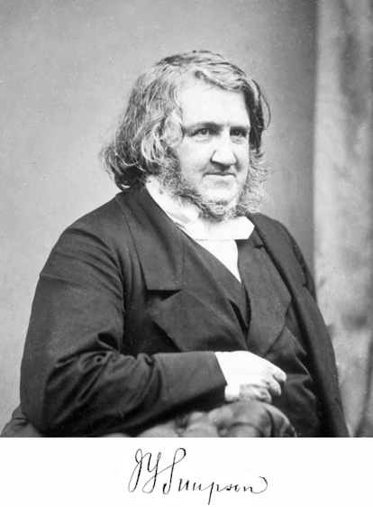](//upload.wikimedia.org/wikipedia/commons/f/f8/Simpson_James_Young_signature_picture.jpg)

**James Simpson i**nvented chloroform, modern anaesthesiology.

He wrote a gospel tract in which he advocated for faith in Jesus Christ. He told his friends that his greatest discovery was “that I was a sinner and Jesus Christ is the Saviour.”

[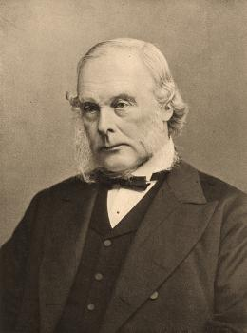](//upload.wikimedia.org/wikipedia/commons/a/a1/Joseph_Lister_1902.jpg)

**Joseph Lister** of ‘Listerine’ fame discovered antiseptics to quell germs and founded the revolution in patient care which taught physicians to wash their hands, or tried to. He was a Quaker then later an Episcopalian.

So, with my milk pasteurised, my hands clean, my mouth fresh, I offer to you that there is nothing conformist about any of them.

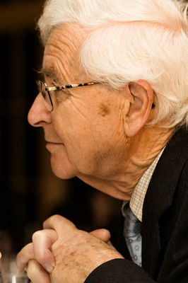**Antony Hewish (1924-) Radio Astronomer**

Hewish won the Nobel Prize for Physics in 1974, and the [Eddington Medal](http://en.wikipedia.org/wiki/Eddington_Medal) of the Royal Astronomical Society in 1969.

"The ghostly presence of virtual particles defies rational common sense and is non-intuitive for those unacquainted with physics. Religious belief in God and Christian belief ... may seem strange to common-sense thinking. But when the most elementary physical things behave in this way, we should be prepared to accept that the deepest aspects of our existence go beyond our common-sense understanding."

Note that Hewish (among others) brings science and faith together not as a *closed system* but as a wide open way of learning. He uses observation as a basis for accepting other kinds of sense, with other appropriate logic. This is an enduring asset from his Christian perspective.

Note also that he concedes that today’s ‘common sense’ is a closed material philosophy. In other words, if you don’t *try* to think more openly such that faith-insights are allowed to be considered, you will be culturally shaped to think as a materialist, it will feel ‘natural and easy’ to be a ‘functional atheist’. Yes, it is as simple as saying that this is merely an intellectual fashion and therefore ultimately intellectually limiting. What Hewson points at is a mind that is wide open for the entry of mystery, critically evaluating all data but not automatically closed to data that is relevant to an intelligible and intelligent Creator. I can’t speak for him however and he would probably say it better.

To summarise the long story of the contribution by faith to science, Prof Peter Harrison from Oxford:

[**https://www.youtube.com/watch?v=QrdkNNJLdPs**](https://www.youtube.com/watch?v=QrdkNNJLdPs) Published on Dec 6, 2012 Length 3.15

Peter Harrison talks about three ways that Christianity has positively impacted the development of science throughout history – motivations, pre-suppositions, longevity.

**DISCUSS**

* How would you state the contribution of faith to science?
* And vice versa?

**MODELS OF CONNECTION BETWEEN FAITH AND SCIENCE**

See also: **The Two Books – scripture and nature**

<http://www.youtube.com/watch?v=KK-JtrmO5qg&list=UU4oVPQcTo0OrStWLrq4daIg> Length 2.15

These are the classic four philosophical positions in the marriage of faith and science:

**1) Conflict** – irreconcilable conflict

**2) Contrast** - each responding to radically different questions; *two magisteria*

**3) Contact** —places of dialogue between science and religion

**4) Confirmation** —how religion supports the scientific enterprise and vice versa.

I am suggesting we all head towards the new number five, collaboration, a more committed project that goes beyond #3 Contact.

5) **Collaboration** - the application of benefit to the widest possible need

At a minimum it means you don’t have to study the philosophy of science to understand the call for Collaboration! Let me give an example: the world’s deadliest animal is – not sharks, not humans, rapacious as we are, but the mosquito. In Sierra Leone just this year, a project to educate households about preventing malaria hit a great milestone – two million homes visited. In collaboration between the research science, Christians and Muslims, visitors have gone around the mosquito-liable areas to teach irrespective of the faith of the household visited.

Real change requires all parties in collaboration over extended time, but I think it most likely (not exclusively) that it takes a Christian or in this case Muslim who will make the risk or the sacrifice of catching malaria themselves and go live in the swamps for the sake of the other. Am I wrong? Both the person of faith on a bicycle and the person of science in the lab coat are needed. They are often the same person.

We must commit to collaboration, to the validity of *both* secular empirical research *and* intuitive faith relationships.

DISCUSS

Do you agree? How would this vision of collaboration work?

The following organisations have been in this pursuit for some time. Here is a list of independent institutes that work on pulling together the application of the bible and practice of science, most of them including medical science, with integrity. If you google them you will find a virtual Aladdin’s cave of well-reasoned, technical and overview topics.

* Faraday Institute
* BioLogos Foundation
* Reasons to Believe
* Reasonable Faith
* Institute for Study of Christianity And Science and Technology (ISCAST-Aust and UK)
* Polkinghorne Trust
* Pontifical Academy of Sciences

**CONCLUSION TO WXED SCIENCE**

Time’s up. We have told a story about the founding persons and principles of science, and seen them full of genuine faith. In the light of the current global needs for collaboration, the current public stoush and the much longer privileging of secular atheism disables both faith and science. I have suggested some new models to help you who inhabit science to take this further. Next year, I hope the talk WXED Talk on Science is being led by a panel of you. Talk to me about that. And so, if you will allow me, I bless you with this dangerous and cheeky prayer...

**A Dangerous Blessing**

Whether we know it or not,

**whether we like it or not,**

we are each a gift of God to the world.

**May we be a nuisance**

**to all closed minds and closed hearts,**

respecting all persons.

**May beauty, truth and goodness**

**flow into the world**

from our faith, hope and love.

**May the God of all wisdom guide our path,**

shine hope into our struggle

and heal our love.

Let us not fear, it is enough to say ‘yes’.

**WXED SCIENCE**

**In any town where humans live, you will most likely find a mechanics workshop, an art shop, a library, a psychologist, a church or two, top and bottom pub and a grocer. Science is the mechanics shop. All the others need the mechanic but he/she needs them too. What would happen if we tried to lock everyone in the workshop?**



**This is one a series of small group discussion books on “What’s Christianity Ever Done?” Each study looks backwards across the cultural impact of Christianity and describes -**

* **how the principles of faith have undergirded that discipline,**
* **how persons of faith have been pioneers of that discipline,**
* **how the church has sometimes corrupted their role and**
* **how there might be collaboration into the future**

Look for more on www.wxed.net