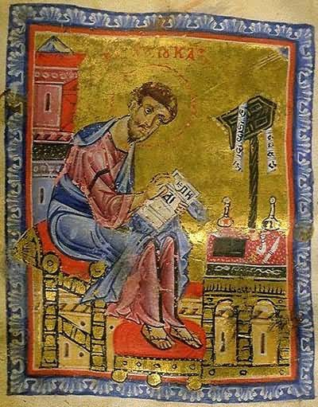

What’s Christianity Ever Done
for EDUCATION?
A small group study book
Ian Robinson

1 PUBLIC EDUCATION
2. UNIVERSITIES
3. LIBRARIES, LITERACY AND THE VERNACULAR
4. CHRISTIAN EDUCATION PRINCIPLES
5. FOUR APOLOGIES
6. WHICH EDUCATION FUTURE?

WXED is dedicated to Prof Brian Hill, who has lived, breathed, written, laboured, thought and prayed in all these ways for many decades, with not a few tears.

GOAL
To spark a change in the quality of discourse about the changes in institutions and society that we are undergoing, under the crushing weight of the business paradigm.

INTRODUCTION TO WXED EDUCATION

If you can read this, someone taught you. They opened to you an amazing world of knowledge. If you are ever tempted to be thankful, thank that teacher. But they did not do it alone. You can also thank your school and those who set it up and the university who trained the teacher and those who keep it going. Many people pioneered and sustained those institutions, not for their own sakes but for the common good, going way back.

There is nothing inevitable about it. There are particular reasons why this education enterprise exists today across much of the world. This study shows why you can thank Jesus who inspired millions of followers to support widespread universities, literacy, libraries, the importance of the child and universal education.

STARTUP QUESTION
DISCUSS: Look at the school photo taken in 2005. What difference, would you guess from the photo and from your general knowledge, did this school make to the lives of those children still living today?
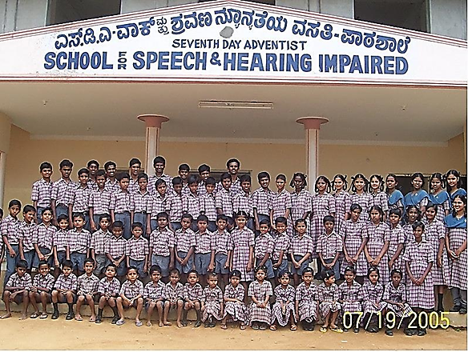
Seventy graduates from a missionary school for the disabled in Kerala, South India.
Think of those who walked away from careers in their home country to establish this school. Their motivation was not new or rare in Christianity.
DISCUSS:
- Why have Christians cared so much about education?
- Closer to home, what was your experience of schooling? Did it cause you to flourish or to conform or worse?

My modest goals are to speak of the persons, policies and principles that have come from Christianity and indeed from other religions, and what part they might play today in the challenges facing Education. I do this by making these assertions:

- Christians have a track record of strong contributions in practise, in person and in principle
- Christians tend to have strong positive influence when Jesus is role-model.
- Christians have done some terrible things within their powerful place in education for which an apology or two is required.
- Christians may still be good for education today

STEP ONE

THE GIFT OF PUBLIC EDUCATION

The credit for our public schools system is often given to a Christian businessman, Robert Raikes, who it is said, established the first ’Sunday schools’ teaching chimney sweeps in Gloucestershire, out of which came the public school system. This story is mostly fiction, but he does have a place in a much longer and more interesting story. We will start by looking way back.

DISCUSS: SEE IF YOU AGREE WITH THIS
http://www.publicchristianity.com/library/education-in-the-ancient-world
Education in the ancient world, Aristotle’s rational categories, no Christian influences in education today just ‘socialisation’. This is because Christianity critiques the truth of the culture.

Since Augustine (5C) de doctrina christiana on Christian learning, all sciences were acknowledged as useful for interpreting the Bible. Cassidorus (485-585) agreed with Augustine’s goal but reorganized the syllabus to focus in sacred or secular learning without providing a theoretical basis for unifying them. Boethius (480-525) translated Greek works of the classics into Latin. This enabled the resilience of these works to be translated into Arabic and later back into Latin…
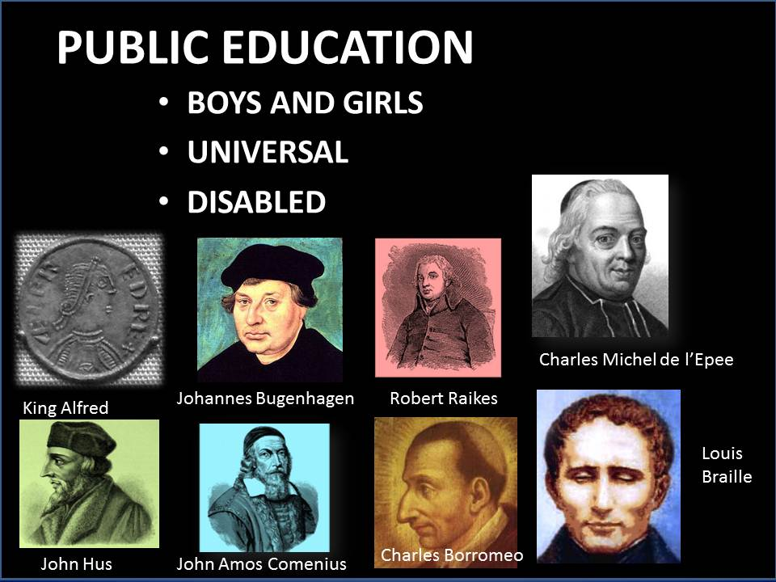
Nevertheless, ‘why did the Bible, an Asian book, retain its hold over the Western mind even after most of the Greek, Roman and Islamic literature became available?’ Mangalwadi p 210

Unlike the Greek and Roman practice of teaching only boys from privileged segment of society, Christians taught individuals from all social classes and ethnic backgrounds, especially in preparation for church membership. Early schools taught primarily …Christian doctrine but [in 12 and 13C] came also to teach the seven liberal arts, the trivium (grammar, rhetoric which included the arts of persuasion and philosophy, and logic, and quadrivium (arithmetic, music, geometry, and astronomy).
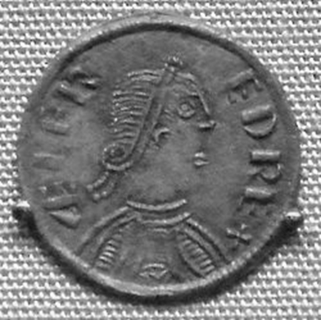
Thus, Christians were not the first to create formal school settings, yet they appear to have been among the first to introduce the teaching of both genders in the same setting. Formal schooling had long been established to train priests and deacons within the church and clerical workers within the families of the royal court or its equivalent. But in the early Byzantine era (4-9 centuries) schooling was extended to other children instructed in monasteries or nunneries.

In the ninth century, two separate threads emerged.

In Iran, the Islamic Madrasas taught girls as well as boys. This is thought to be earliest inclusive education, though it did not spread beyond Iran. In central Western Europe, similarly, Emperor Charlemagne (742-814), himself illiterate, educated girls other than the king’s daughters. King Alfred of England (849-899 pictured on the coin above), following Charlemagne’s example established a court school for both his sons and daughters, those of the nobility, and "a good many of lesser birth".
By the ninth century, Christians also had some parochial (parish) schools.
Schmidt -pg 173

They studied books in both local English and Latin (At that time Latin was the international commercial and academic language in the West. We will return to the vernacular languages.) and "devoted themselves to writing, to such an extent .... they were seen to be devoted and intelligent students of the liberal arts." Alfred actively recruited scholars from the Continent and from Britain to aid in the revival of Christian learning in Wessex and to provide the king personal instruction. Believing that without Christian wisdom there can be neither prosperity nor success in war, Alfred aimed "to set to learning (as long as they are not useful for some other employment) all the free-born young men now in England who have the means to apply themselves to it." However, there were few "books of wisdom" written in English, so Alfred established an ambitious programme of translating into English the books he deemed "most necessary for all men to know."

REFORMATION LEARNING

In fifteenth century Germany, Martin Luther had designed his idea a public school system: “to include vernacular primary schools for both sexes, Latin secondary schools, and universities.” He once said that parents who failed to teach their children were “shameful and despicable”…Schools, to him, were to train and prepare more than just clergy:
…”a system of elementary education in the vernacular for all, including reading, writing, arithmetic, grammar, and religion, and the establishment of secondary schools for the purpose of training citizens for civil and ecclesiastical leadership.”²⁴
-pg 177

It was his principal co-worker, Philipp Melanchthon (1497-1560), who persuaded the civic authorities to implement to first public school system in Germany. The organization of these schools however was largely the accomplishment of Pastor Johannes Bugenhagen (pictured), in Northern Germany and Scandinavia. This is 200 years before the English public schools.
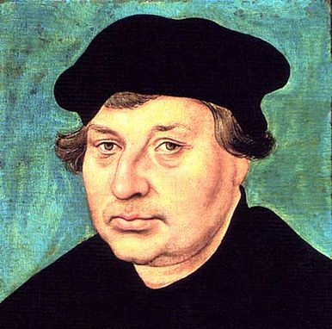

COUNTER- REFORMATION LEARNING

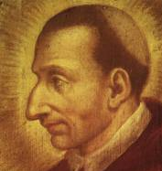
In case you think, as some writers claim, this was all a Protestant affair, we can record at least two great developments within Roman Catholicism also.

By the sixteenth century, the earlier policy of the schooling of priests at monasteries had fallen into neglect. Charles Borromeo (Italian 1538–1584, pictured left) was the cardinal archbishop of Milan from 1564 to 1584. Among the great reformers of the troubled sixteenth century, Borromeo, along with Ignatius of Loyola, Philip Neri, and others, responded to the challenges of the Protestant Reformation with significant reforms within the Catholic Church, including the founding of seminaries for the education of priests, the instruction of youth and the “Sunday School” classes.

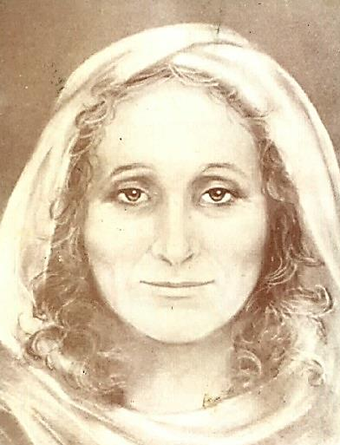
We can add an amazing woman Angela Merici 1474- 1540.
In the fifteenth and sixteenth century, education for women was reserved for the rich or for nuns. Women weren't allowed to be teachers and unmarried women were not supposed to go out by themselves -- even to serve others. She began to notice how little education the girls had and its flow-on effect upon family life.

Angela brought together a group of unmarried women who went out into the streets to gather up the girls to teach them. They were dedicated to education and to Christ. Living in their own homes, not in a convent, they met for prayer and classes where Angela reminded them, " Reflect that in reality you have a greater need to serve [the poor] than they have of your service." She enjoined them to love their students as much as Christ would love them. They were so successful in their service that Angela was asked to bring her innovative approach to education to other cities. In 1535, these women founded the Company of St Ursula, named after the patroness of medieval universities. When Angela died five years later, there were 24 Ursuline communities.
COMENIUS THE GENIUS
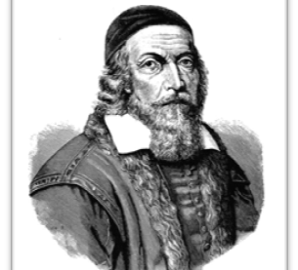
Fifty years after Melanchthon, John Amos Comenius (1592-1670, pictured below) a leader of the Moravian Brethren, and “the father of modern education” opened a school at Fulneck in Moravia, where he taught children about God, man, and nature. So convinced was he that children from all social classes should be educated, that failing to do so he felt, was flouting God’s purpose.

Comenius was a genius who first introduced pictorial textbooks, written in native language instead of Latin, applied effective teaching based on the natural gradual growth from simple to more comprehensive concepts, supported lifelong learning and development of logical thinking by moving away from dull memorization, presented and supported the idea of equal opportunity for impoverished children, opened doors to education for women, made instruction universal and practical. He lived and worked in many different countries in Europe, including Sweden, the Polish-Lithuanian Commonwealth, Transylvania, the Holy Roman Empire, England, the Netherlands and Royal Hungary. In 1641, he responded to a request by the English parliament and joined a commission there charged with the reform of the system of public education. The Cromwell rebellion interfered with the latter project, and so in 1642 he returned to Sweden.

As a theologian, Comenius was a fierce reformer, mystical, a believer in prophecies, dreams and revelations which were typical of the Moravian movement within Protestantism (see Hus and the Moravians below) As an educator, he was a ‘pansophist’, that is, one who attempted to organize the entire field of human knowledge so as to bring it, in outline, within the grasp of every child. Few men since his day have had a greater influence.

1. He was first a teacher and an organizer of schools. In his Didactica Magna (Great Didactic), he outlined a system of schools that is the exact counterpart of the existing American system of kindergarten, elementary school, secondary school, college, and university.

2. Comenius formulated the general theory of education, thus the forerunner of Rousseau, and the first to formulate that idea of "education according to nature". The influence of Comenius on educational thought is comparable with that of his contemporaries, Bacon and Descartes, on science and philosophy.

3. He wrote a lot of forty textbooks of an entirely new nature. He was also the first successful application of illustrations to the work of teaching, though not, as often stated, the first illustrated book for children. These texts were all based on the same fundamental ideas:
- learning foreign languages through the vernacular;
- obtaining ideas through objects rather than words;
- starting with objects most familiar to the child to introduce him to both the new language and the more remote world of objects:
- giving the child a comprehensive knowledge of his environment, physical and social, as well as instruction in religious, moral, and classical subjects;
- making this acquisition of a compendium of knowledge a pleasure rather than a task; and
- making instruction universal.

We might think he was ‘out of date’ now, but the importance of Comenius’ influence in education has been recognized as late as the nineteenth century. In 1892 the three-hundredth anniversary of Comenius was very generally celebrated by educators, and at that time The Comenian Society for the study and publication of his works was formed.

BACKGROUND: HUS and MORAVIA
Comenius built schools across Europe by building upon the heritage of the Moravians or ‘Hussites’.

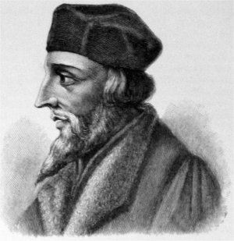
The Hussite movement that was to become the Moravian Church was started by Jan Hus (pictured) in the late 14th century, in what is today the Czech Republic. Hus objected to some of the practices of the Roman Catholic Church and wanted to return the church in Bohemia and Moravia to early Byzantine-inspired practices: liturgy in the language of the people (i.e. Czech), having lay people receive communion in both kinds (bread and wine), married priests, and eliminating indulgences and the idea of Purgatory. The Moravian Church could be said to be among the first ‘Protestant’ churches.

The Council of Constance burned John Hus at the stake for heresy on 6 July 1415. Within fifty years of Hus' death, a contingent of his followers had become independently organised as the "Bohemian Brethren" in 1457. By the middle of the 16th century as many as 90 per cent of the inhabitants of the Czech Crown lands were Protestant. The majority of nobility was Protestant, the schools and printing-shops established by the Moravian Church were flourishing. The Protestant Hussites were working for the provision of universal education. By the middle of the 16th century there was not a single town without a Protestant school in the Czech lands, and many had more than one, mostly with two to six teachers each. In Jihlava there were six schools: two Czech, two German, one for girls and one which was at the level of a grammar school, lecturing on Latin, Greek and Hebrew, Rhetorics, Dialectics, fundamentals of Philosophy and fine arts, as well as Lutheran religion.

In 1566 the Counter Reformation arrived when the Jesuits came to the Moravian capital. By 1622 all Protestant schools in the Czech Crown lands were forced to close. The Habsburgs not only suppressed Protestantism but also the Czech language: books written in Czech were burned and any publication in Czech was considered to be heresy by the Jesuits. The Czech language was gradually reduced to a means of communication between peasants, who were often illiterate. The Brethren were forced to operate underground and eventually dispersed across Northern Europe. In 1722, a revival began among a small illegal remnant living on the estate of Count Nikolaus Ludwig von Zinzendorf, a village called Herrnhut. On 13 August 1727 the community underwent a dramatic transformation when the inhabitants of Herrnhut "learned to love one another", following an experience that they attributed to a visitation of the Holy Spirit, similar to that recorded in the Bible on the day of Pentecost. Herrnhut became the centre of a major movement for Christian renewal and mission during the 18th century.

Moravian historians identify the main achievements of this period as:
1. Setting up a continuous prayer that ran uninterrupted, 24 hours a day, for 100 years.
2. Originating the devotional publication Daily Watchwords.
3. Establishing more than 30 settlements internationally on the Herrnhut model, which emphasized prayer and worship, communal living, simplicity of lifestyle, generosity with wealth, education for children and support for mission work throughout the world.
4. Being the first protestant church to begin large scale missionary work. Within 30 years, the church sent hundreds of Christian missionaries to many parts of the world, from the Caribbean to Africa and the Far East. They were the first to send lay people (rather than clergy) as missionaries, the first Protestant denomination to minister to slaves, and the first Protestant presence in many countries.
5. Forming many hundreds of small renewal groups operating within the existing churches of Europe, known as "diaspora societies".

D. EDUCATION FOR THE DEAF AND BLIND
Fr Charles Michel de l’Epee (pictured below) was prompted by his desire for deaf people to hear the gospel of Jesus Christ. So, he invented a sign language for school use in Paris in 1775.

While formal deaf education is mostly under secular auspices today, originally it arose as the by-product of Christian motivation. Schmidt -pg 182

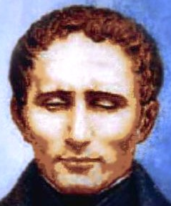
For the education of the blind, here are two significant examples. a. In 630…a typholocomium (typholos = blind +komeo = take care of) was built in Jerusalem.
b. In the early nineteenth century, Louis Braille, a dedicated Christian (mass every Sunday and a church organist) gave to the world of the blind the six embossed dots. He saw his work as a divine mission.
When he lay on his deathbed, he said, “I am convinced that my mission is finished on earth; I tasted yesterday the delight; God condescended to brighten my eyes with the splendour of eternal hope.” Schmidt -pg 183

E. SUNDAY SCHOOLS AND UNIVERSAL EDUCATION

We can return now to the role of Robert Raikes. We saw that the germs of the modern public school may be traced to the methods of instruction established by Luther, Knox and Borromeo. We saw that the Moravian John Amos Comenius in 1642 was invited to England to set up public schooling but stopped by Cromwell rebellion. It took a century to regain the lost ground.

SUNDAY SCHOOLS AND UNIVERSAL EDUCATION
We have already seen that England was to set up public schooling in 1641 but was stopped by Cromwell’s civil war. We can now see how England regained lost ground a century later.

There are many widespread instances of the establishment of schools from 1513, a school was founded in St Mary’s church Nottingham by Dame Agnes Mellers as The Free School of the Town of Nottingham. There are traces of them in France Britain and the USA from the seventeenth century. In 1751 the same St Mary's Nottingham established a Sunday School education for those children unable to attend a day school. These and others preceded the experiment made at Gloucester in 1783 by Robert Raikes, who is therefore wrongly described as the founder of Sunday schools. Schools were still not systematically constructed, though child labour was systematically monitored. That more systematic idea came from Thomas Stock and Robert Raikes.

Thomas Stock went from Oxford to Ashbury then rector of St John the Baptist's, Gloucester. There he met Robert Raikes an Anglican layman and publisher of the Gloucester Journal (pictured ), who became the publicist and champion for what they hoped would be a widespread movement.
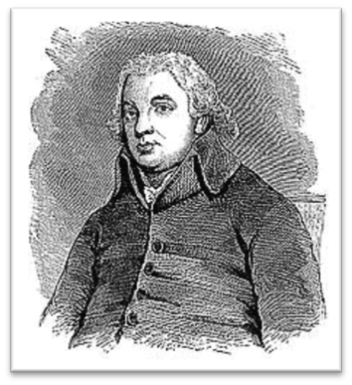
All these early pioneers chose Sundays because before the advent of child labour laws, whether on the farm or in the cities, children worked up to twelve hours per day, six days a week. Towns and cities in Britain were growing rapidly. Raikes’ was distressed at the ‘children, wretchedly ragged, at play in the street’ , adrift on Sunday and getting into trouble. He had visited the prisons of Gloucester and saw how easy it was for the children to slip into crime. Raikes knew the parents of the poor children were "totally abandoned themselves, having no idea of instilling into the minds of their children principles to which they themselves were entire strangers."

If parents could not do it, some public means of teaching these youngsters must be found. Raikes and Stock began the first school in 1780 in a rented kitchen in the home of Mrs Meredith, in a street where the chimney sweeps lived. Originally, only boys attended, and the older boys coached the younger. Later, girls came also, all from the poorest homes. The children were required to come with clean hands and faces, combed hair, and with the clothing they had. For some he provided shoes and clothing. Mrs Meredith found it hard going – the boisterous boys – and she quit within two years. She wasn’t the first or the last teacher to burn out.

After establishing several more schools Raikes appealed to the public that this model of education be supported by them. Support poured forth from church and business.
Lets step back and notice the effects of even a small education resource. One of the local manufacturers commented on the transformation of the children: ‘the change could not have been more extraordinary, in my opinion, had they been transformed from the shape of wolves and tigers to that of men.’ More measurably, the crime rate dropped sharply (90%) after the establishment of the schools.

The idea spread widely and by 1831 schooling 1,250,000 children, they are seen as the first schools of the English state school system. It was 90 years however, in 1870, before children could attend schools during the week. Apparently the idea did not spread to the House of Representatives all that rapidly that the education of children was seen as a public good except through persuasion.

From India, Vishal Mangalwadi:
“Neither colonialism nor commerce spread modern education around the world. Soldiers and merchants do not educate. Education was a Christian missionary enterprise. It was integral to Christian missions because modern education is a fruit of the Bible. The biblical Reformation, born in European Universities, took education out of the cloister and spread it around the globe.” P 194

Pre-British education was Muslim and Hindu elite and theology only. “At the confluence of the ‘holy’ rivers Ganges, Yamuna and the mythical Sarawati, Allahabad is revered as one of India’s holiest places. Islam/Buddhist centres of civilisation…The money pilgrims donated is incalculable. Yet the Hindu, Buddhist and Muslim civilizations did not establish a single significant institution of learning in this centre of Gangetic civilization.” P 194-5

DISCUSS

- Imagine if a very different set of elitist values arose in our society. What do you think would be the personal and social impacts if children were not in school but put to labouring?

- Why are schools now publically funded when they used to be royally sponsored or church-funded?

STEP TWO
THE ORIGIN OF UNIVERSITIES

University education is a minority privilege. Yet it drives the education sector in its entirety, and the business sector to a large degree (pardon the pun) so this story touches everyone. To find where this movement started is not as simple as you might first think. What we mean by ‘university’ is not the full-fledged administrative system that we now see, but something more essential, as appropriate to a cross-cultural story. The word university is derived from the Latin: universitas magistrorum et scholarium, roughly meaning "community of teachers and scholars".

With some difficulty, we have searched for centres of international standard of research and teaching (the ‘universe ‘part of the word) such that graduates were certified to practise their craft within a global environment as it was conceived at the time. The proto-university would not therefore have to teach everything, but for this search it would have covered some sciences and some of the humanities as we now call them. The interchange between those disciplines is an important part of the ‘uni’ part as well, though that difficult task is diminishing in the west under extreme specializations. Libraries and literacy are an important part of any setup. A University is a centre or network in one place set up for the purpose, even if not a set of buildings or a campus. Some had a history of stops and starts, foundations and destructions. For the story of un-interrupted universities (a tall order in a world raked by plagues and war), see:
http://en.wikipedia.org/wiki/List_of_oldest_universities_in_continuous_operation

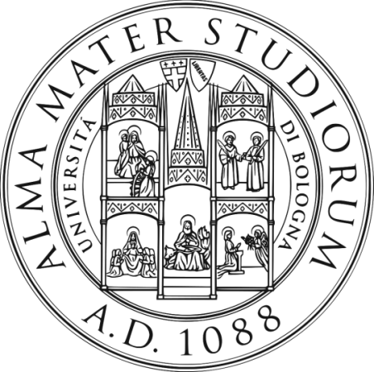
Possibly the first to appear in the west and to operate as a university was the University of Paris (Sorbonne) in 12C some sixty years before its formal founding in 1200. Paris specialized in theology and in 1270 it added the study of medicine. It is this branching out of knowledge that makes it fit our modern definition of ‘university’.

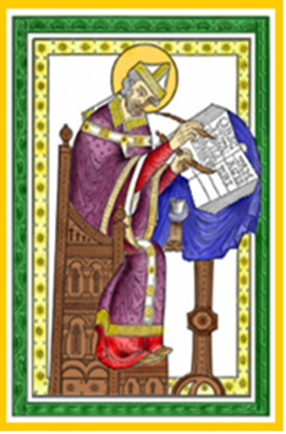
Another candidate is the University of Bologna which claims to be established in 1088. It became the mother of several universities in Italy, Spain, Scotland, Sweden, and Poland. The University of Paris became the mother of Oxford and of universities in Portugal, Germany, and Australia. Cambridge University, through its Emmanuel College, became the mother of Harvard in America.

“With the establishment of the University of Bologna and the University of Paris and their numerous offspring, formal high education had become permanently institutionalized. According to Haskins, the university of the twentieth century is ‘the lineal descendant of medieval Paris and Bologna.’-pg 187 Schmidt

They did not appear out of nowhere. There are several sources with which we can trace the origin of the medieval universities.

The foremost source is the widespread Christian cathedral schools or second, the monastic schools which began with the Benedictines (pictured). They appear as early as the 6th century and they ran for hundreds of years before their formal establishment as university in the high medieval period. Note that when we talk of the early theologians, they were widely based in scholarship, polymaths, students of medicine, astronomy, engineering etc, not just students of doctrine. This was also the case for our third source, Muslim schools. One of the oldest is Al Karaouine in Morocco.

Morocco, Madrasah of Al-Karaouine founded 859CE.

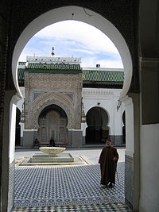
Al Karaouine is considered the oldest continuously-operating madrasah in the world. Founded by a woman, Fatima al-Fihri, first as a mosque, then a madrasah and great library, and later a degree-granting university, Al-Karaouine played a leading role in the cultural exchange and transfer of knowledge between medieval Muslims and other Europeans.

Among the subjects taught, alongside the Qur'an and Fiqh (Islamic jurisprudence), were grammar, rhetoric, logic, medicine, mathematics, astronomy, chemistry, history, geography and music.

Pioneer scholars such as Ibn Maimun (Maimonides), (1135–1204),[6] Al-Idrissi (d.1166 AD), Ibn al-Arabi (1165-1240 AD), Ibn Khaldun (1332-1395 AD), Ibn al-Khatib, Al-Bitruji (Alpetragius), Ibn Hirzihim, and Al-Wazzan were all connected with the university either as students or lecturers. Among Christian scholars visiting Al-Karaouine were the Belgian Nicolas Cleynaerts and the Dutchman Golius. Again we see that the earliest university was inter-disciplinary, inter-faith and inter-national.

We might add the University Al-Azhar in Cairo which became a recognized university in 1961, but traces its origins as a religious madrasa back to 975CE. It has a claim to be the oldest University founded as such and still functioning.

Fourthly, we do not know how much eastern learning fed into Europe. The late medieval histories of Zheng He and Marco Polo alert us to the widest possible reach of international diplomacy. The earliest university I can find was founded in Korea , the Sungkyunkwan University , in 1398.

There were other ancient examples of higher learning - Greece, Persia, Rome, Byzantium, China, and India - though they had major dissimilarities from the medieval European university from which the modern university evolved. That is, they were narrower in curriculum, intention and philosophy. For instance the school of law founded in 425CE in Constantinople was probably only for court purposes, not for the wider public. That pattern can be observed through all the empires - a scribal school only for court purposes. Schmidt also dismissed it from his historical survey, saying:
… the ancient Greeks had their philosophers…..but developed no permanent institutions. They had no libraries, they had no guild of scholars or students, and they certified no one.
-pg 185-6 Schmidt

There is one even greater and older source of the university that we can turn to next.

DISCUSS
From this story, do you think the religious origins of the universities helped them to become ‘universal’ or do you think it might have made them ‘parochial’, that is closed only to their own way of thinking?

THE ACADEMY OF GUNDISHAPUR, PERSIA

Even earlier, one story stands out. The Academy of Gundishapur. (wall-engraving pictured) was founded C 500CE, the world's oldest known medical centre, university and a library with an estimated 400,000 books.
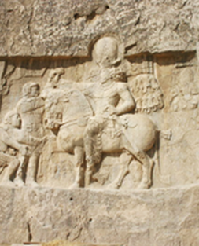
The town of Gundishapur was founded as a fortress by Shapour I, son of King Artaxerxes, after defeating the Roman army of Valerian (253-260CE). In 489, the Christian theological and scientific centre in Edessa (in Mesopotamia) was ordered closed by the Byzantine emperor Zeno, and transferred itself eastwards to Gundishapur in Persia. Here, Christian scholars, together with pagan philosophers, carried out important research in medicine, astronomy, and mathematics.

In the sixth century, Gundishapur started a teaching hospital. According to the Christian writer Georgy Zeidan, Gundishapur began methodically to care for the sick and ill while simultaneously training students of medicine. It wasn’t the first public hospital but the first to act as a university. They brought physicians and scholars from Greece, China, Rome and India. These visitors translated Greek, Chinese and Indian texts on astronomy, astrology, mathematics and medicine and Chinese texts on herbal medicine and religion, establishing a great work of translation and cultural fertilisation. So influential was it that Elgood would say( though not historically accurate as we shall see in the study of healthcare):
[T]o a very large extent, the credit for the whole hospital system must be given to Persia.
—Cyril Elgood, A Medical History of Persia

Some five thousand students were studying at Gundishapur during the reign of Anushiravan (531-579), with five hundred scholars teaching in different scientific fields. In time it came to offer training in medicine, philosophy, theology, mathematics science, anatomy, dentistry, astronomy, mathematics, philosophy, military commandership, architecture, craftsmanship, agriculture and irrigation, and geometry. Thus, the University was inter-disciplinary, inter-faith and inter-national from the beginning.

Anaushivaran also set up some organizations to administrate the affairs of physicians, to test them in order to grant them accreditation and to grant academic degrees. He organized the world's first medical symposium in Ctesiphon in 550 CE, in which hundreds of physicians and religious figures from different countries participated. From this the phenomenon of the great tradition of the doctors’ international conference was born!

Baghdad University is more famous in the history of Islamic Learning. It was founded in 832 CE, by Caliph al-Ma'mūn as the House of Wisdom. There the methods of Gundishapur were emulated, indeed, it was staffed with graduates of the older Academy of Gundishapur. It took over the central educational role and henceforth there are few references in contemporary literature to universities or hospitals at Gundishapur.

STEP THREE
LIBRARIES, LITERACY AND THE VERNACULAR

http://en.wikipedia.org/wiki/History_of_libraries

With regard to the early origin of universities, we mentioned the role of St Benedict of Nursia (480-553?), who founded the Benedictine order’s first monastery at Monte Cassino, Italy, in 528, and soon built monasteries in hundreds of other locations. In the West, they are better known than their equivalent in the East, the Nestorians and the Church Fathers, who also kept libraries. So we shall take the Benedictines as our case study.
Benedictine monasteries all placed great value on the literary treasures of antiquity as well as of Christianity. Daniel Boorstin says that St. Benedict has been called “the godfather of libraries.”

The Benedictines originated an elaborate library system in their many monasteries; they collected books, copied manuscripts in the scriptoria, loaned books to other monasteries, and required monks to read books daily. Benedictine library holdings included the Holy Scriptures, writings of the church fathers, and biblical commentaries as well as secular books of Greek and Roman writers. So indispensable were libraries to this monastic order that the monks said a library was a monastery’s armoury (like the armoury of castle).

In the Middle Ages, monasteries housed the major libraries in medieval Europe. Most books and manuscripts were chosen for their religious value, including versions of the Gospels and books of the Old Testament in Greek, Latin, Hebrew, Coptic and Syriac but also texts of ancient classics were kept for teaching in the seven liberal arts, the trivium (grammar, rhetoric, and logic) and the quadrivium (arithmetic, music, geometry, and astronomy.

The Renaissance was accompanied by a strong interest in the writings of the Greeks and Romans. Old texts were copied, and copies brought in from Byzantine and Islamic sources. They formed the core of libraries sponsored by erudite nobles.

DISCUSS:
The early monasteries and libraries copied and kept texts that they did not agree with, philosophies that taught something else, and even other religions. Why do you think they did that? This is how we know anything about the Greek philosophers and the Romans. Would you spend your limited time and money doing that?

LITERACY
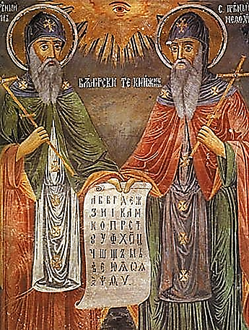
There are a vast number of examples of positive contribution by western missionaries to third world countries by the provision of secular schools in their own language. Hundreds of individuals have risen to national leadership due to this early intervention by Christians. As in the case of Robert Mugabe of Zimbabwe, the church does not claim the credit for anything and everything that they went on to do!

Translation of the Bible created local vernacular scripts which accelerated learning within that culture and introduced new ideas from other cultures. Mistakes were made by missionaries, but those who say this should never have happened are saying that ‘ignorance is bliss’. Russia is one example, thanks to the Byzantine monks Saints Cyril and Methodius (pictured) who created the script now called Cyrillic in the ninth century. The Summer Institute of Linguistics carries on their work globally.

The Gutenberg Printing Press 1450 (although earlier invented in China 1048 and Korea 1378) was used first for the Bible. Many millions of other texts followed, especially in the vernacular language. Books of bestselling authors such as Luther and Erasmus were sold by the hundreds of thousands in their lifetime. Printing soon spread from Mainz, Germany to over two hundred cities in a dozen European countries. In the 16th century, their output rose to an estimated 150 to 200 million copies (source: Wikipedia). Local languages gave way to new creole called ‘English’, which was much more accessible than the high Latin. In 1620, the English philosopher Francis Bacon indeed wrote that the invention of printing, firearms and the nautical compass had “changed the whole face and state of the world".

The relatively unrestricted circulation of information and (revolutionary) ideas transcended borders, captured the masses in the Reformation and threatened the power of political and religious authorities. The sharp increase in literacy broke the monopoly of the literate elite on education and learning and bolstered the emerging middle class. Across Europe, the increasing cultural self-awareness of its people led to the rise of proto-nationalism, accelerated by the flowering of the European vernacular languages to the detriment of Latin's status as lingua franca.

Let us now focus down on the singular importance of vernacular.

VERNACULAR

One strong thread for education has been the adoption of local languages (vernacular) in which to publish and teach, thus bringing greater access to the people. Without this, writings would only be in Latin, Greek or Arabic the international languages, and cultural excellence therefore only available to the learned.

Most readers, thinking of early English language literature, might think of the poet Geoffrey Chaucer of 14th century London. But the move towards vernacular English is much older.

The monk Saint Bede, working in Latin, Greek and English, living around Durham 672-735CE compiled a mammoth Ecclesiastic History of the English People. which was translated into Old English sometime in the 9th century in southern Britain (connected with the promotion of learning that King Alfred fostered). The Anglo-Saxon Chronicle was heavily based upon it and soon followed it. Bede is called the Father of English History.

At the same time as Chaucer was John Wycliffe (c. 1320 –1384), an English Scholastic philosopher, theologian, lay preacher, translator, reformer and university teacher at Oxford in England. He was an early dissident in the Roman Catholic Church a century before Luther. Wycliffe is sometimes called "The Morning Star of the Reformation". He wanted to reform and separate both church and politics.

He was one of the earliest opponents of papal authority influencing secular power. In his great work De Civili Dominio, he introduced those ideas by which the good parliament was governed – which involved the renunciation by the Church of temporal dominion, an idea today known as ‘the secular state’.
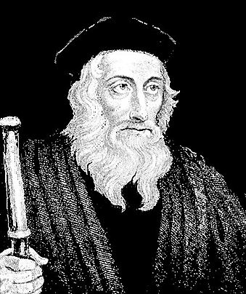
Wycliffe was an early advocate for translation of the Bible into the common language. He completed his translation directly from the Latin Vulgate into vernacular English in the year 1384, now known as Wycliffe's Bible.

Beyond the wide scope of these works, he was also a leader in a local-level reform movement. Wycliffe aimed to do away with the existing hierarchy and replace it with "poor priests" who lived in poverty, were bound by no vows, had received no formal consecration, and preached the Gospel to the people. These itinerant preachers spread the teachings of Wycliffe. Politics swung against them and soon they were accused as traitors to the Crown.

The translation into vernacular was a way of empowering the ordinary people as a safeguard against the hierarchy of both the church and the state. As the Reformation came into full swing, Luther and Tyndale also translated the Bible into the vernacular so that more people would be able to read it or at least understand it if read to them. It was an educational outcome of an evangelistic intention.

William Tyndale (c. 1494–1536) was an English scholar and a leading figure in Protestant reform. He is best known for his translation of the Bible into English. He was influenced by the work of Erasmus, who made the Greek New Testament available in Europe, and by Martin Luther. Tyndale took the ill-regarded Middle-English "vulgar" tongue, improved upon it using Greek and Hebrew syntaxes and idioms, and formed an Early Modern English that Shakespeare and others would later follow and build upon.

Where Wycliffe had worked from the Latin text, itself a translation, Tyndale's translation was the first English Bible to draw directly from Hebrew and Greek texts, the first English one to take advantage of the printing press, and first of the new English Bibles of the Reformation. It was taken to be a direct challenge to the hegemony of both the Roman Catholic Church and English Laws to maintain church rulings. In 1530, Tyndale also wrote The Practyse of Prelates, opposing Henry VIII's divorce on the grounds that it contravened Scripture.

In 1536 he was convicted of heresy and executed by strangulation, after which his body was burnt at the stake. His dying request that ‘the King of England's eyes would be opened’. Just two years later Henry authorized The Great Bible for the Church of England.

Hence, the Tyndale Bible continued to play a key role in spreading English vernacular and Reformation ideas across the English-speaking world. Notably, in 1611, the King James Version New Testament is 83% Tyndale's, and the Old Testament 76%. In 2002, Tyndale was placed at number 26 in the BBC's poll of the 100 Greatest Britons.

Similarly, Charles Grant and William Carey, 18C missionaries in India, treated Indians as allies not imperial subjects and spread the Bible in local languages. Liberals would later criticise them for ‘igniting the fire for India’s freedom’ (Mangalwadi p 206).

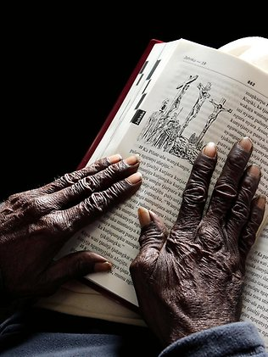
A more recent example of the power of vernacular Bible is in this recent article from Australia: How a Bible translation is preserving the Pitjantjatjara language. Read it here : http://www.theaustralian.com.au/news/features/saved-in-translation/story-e6frg8h6-1226713438361.

It is a good discussion piece. Note how the white author pours scorn on the missionary enterprise with words like – ‘proselytize’, ‘civilising the savages’, ‘nothing if not recruitment’ (he can’t decide which it is) - while the Indigenous spokespersons whom he interviews - from several different areas so it is not just one person’s loyalty - spoke in appreciative ways of the past and future role of the Bible in empowering the recovery of indigenous language.

For example Guilliatt writes: “The whole missionary enterprise, with its roots in colonial notions of "civilising the savages", seems anachronistic in an age of satellite TV. Yet Bible translation has some high-profile support from indigenous leaders, who regard it not only as a crucial way of saving languages from extinction but, more broadly, as a means of looking afresh at the much-maligned missionary era.” That visiting whitefulla’s scorn is contrary to the actual on-the-ground experience.

There is more on this aspect in the study on Christianity and Globalism in Makes You Wonder 3 Our Story.

DISCUSS:
- From these stories, in what ways did the work of vernacular and literacy empower the people?
- Taking the printing press as an example, what are the potential goods or harms if the church learns to use the internet well?
- Let’s talk like political mercenaries for a moment. How do you feel about this deal – the whitefullas are here to stay, so we will let the missionaries to get the Bible translated, then once we get our language into literature, we can establish our own literature and schools?

STEP FOUR
CHRISTIAN EDUCATION PRINCIPLES
We have witnessed so far a sustained priority by the Christian church of the promotion of learning that is generous towards all and aimed at the common good. Other great world religions have had equally great learning and culture led by equally intelligent leaders =- so why this particular strength of Christianity? There are several important principles of Jesus that shape this – his followers were called ‘students’ or ‘disciples’; he taught both women and men; he commanded them to teach others inter-culturally; he prioritised the leadership of children; lastly, the New Testament speaks of learning through multiple intelligences.

- JESUS CALLED DISCIPLES/STUDENTS

Like the Rabbinic movement, of which Jesus was an early example, Jesus deliberately taught. The word ‘disciple’ literally means ‘student’, and to be a rabbi’s disciple was counted a high honour.
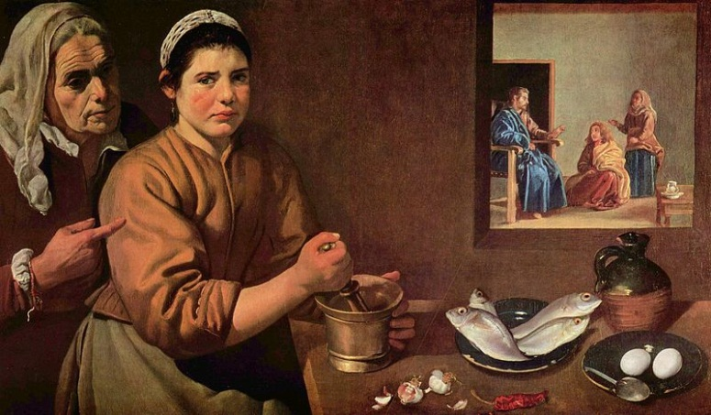
Diego Velázquez (1599–1660) Jesus at the home of Martha and Mary

He called women as well as men as disciples. That is, he was very different, for some today not radical enough, in the way he welcomed women into the cultural setting of his group as equals –
Diego Velázquez (1599–1660) Jesus at the home of Martha and Mary
“In Christ there is no male nor female, slave nor free…” (Galatians 3.28; Col 3.11, 1 Cor 12.13) Their social environment still followed patriarchal lines however, so in the New Testament the men still held public prominence. IT was still a departure from existing values however:
“Instructing both men and women, as the early Christians did, was rather revolutionary in the Roman World. Instruction took place in the …gymnasia, from which girls were excluded.” Schmidt -pg 172

Jesus intended that this be carried on:
”Christ’s teaching was not an end in itself. He taught so that those who followed him might teach others. Shortly before ascending to heaven, he told his disciples to “make disciples of all nations…teaching them to obey everything I have commanded you” (Matthew 28:19-20).
Schmidt -pg 170

- JESUS PRIORITISED CHILDREN,

He affirmed the importance of children’s learning for the health of the community as a whole in the following ways:
Matthew 11.25; 18.1-6; 19.13-15
The disciple must be like a child
Children come within the community
Teach them at home Dt 4.9
Those who are strong ought to bear with those who are weak and do not please yourself, to build up one another. Rom 15.1
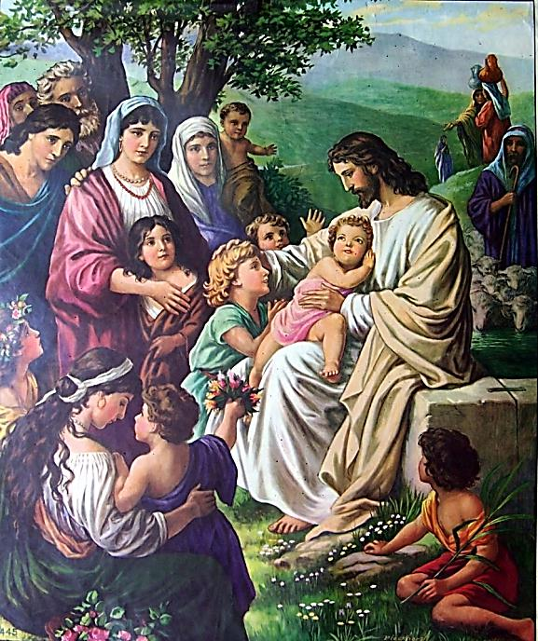
DISCUSS: Where have you seen this priority expressed (or not) in your church or community?

- THE KNOWLEDGE PROCESS

There are several places where the ‘knowledge process’ was named in the New Testament without exposition. The nature of knowledge, the importance of the role of teacher, discernment of falsity, transparency, multiple intelligences and the place of worship within community.

Faith-knowledge is ‘axiomatic’ (‘full acceptance’) (1 Tim 4.9-10 and 1.15): ‘Christ Jesus came into the world to save sinners, of which I am one. And ‘we have placed our hope in the Living God and Saviour of all, especially of those who believe’. The ‘cruciform reality’ is based around ‘witnesses’, personal, inner and historical. Polanyi the philosopher would later call this ‘Fiduciary Knowledge’.

The Apostles took Jesus’ command to teach others seriously, for beginning with Pentecost, Luke writes that “they never stopped teaching… that Jesus is the Christ” (Acts 5:42). Similarly, St Paul in his epistle makes reference to Christian teachings in Ephesus, Corinth, Rome, Thessalonica, and other places. Paul even told Timothy that one of the qualifications for being a bishop (spiritual overseer) was to be “able to teach” (1 Timothy 3:2). This was around 50AD.
Schmidt -pg 171

False teachings were discerned and true teachings ‘held’. . 2 Pete 2.1; 2 Thess 2.15

Growth in discipleship is described as moving away from ‘childish things’ = NOTE: the meaning is not the same as ‘childlike in the same way that simplistic is not the same as simplicity. Heb 6.1

Transparency.
Against today’s custom to see church conspiracies and grabs for power at every turn of history, the bible both old and new testaments actually presents the church and its leaders as very fallible, the movement as a struggle to find and re-find a lived faith amongst the pressures of ‘the world’ and the internal instincts to proud autonomy. This radical humility was opposite to all other records of rulers of the ancient world. There, pride of place, infallibility, perfect control were the values lauded, and humility was laughable.

Multiple intelligences. Romans 12.1-2 employs multiple intelligences:
I appeal to you therefore, brothers, by the mercies of God, to present your bodies as a living sacrifice, holy and acceptable to God, which is your spiritual/reasonable worship. ^{2.}Do not be conformed to this world, but be transformed by the renewal of your mind, that by testing you may discern what is the will of God, what is good and acceptable and perfect.

Here are the root meanings behind in the English translation:
- Present your bodies – kinetic
- Acceptable – pleasing, the criterion of elegance like Occam’s Razor
- Reasonable = logical
- Conformed = coherence taken to its extreme
- Transformation – transformational learning (see STEP SIX in this study)
- Renewed mind – practical wisdom, new paradigms
- Discernment – applied wisdom, tested knowledge not gullibility
Those seven forms of learning appear from time to time throughout the New Testament.

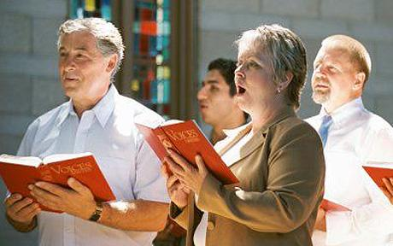
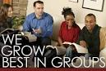
Worship within community. On the first day of the week, then as now, Christians met for worship. We might picture a sort of ritualised religious karaoke but it was not always so. The biblical scrolls, texts and later Bible books were read publically, explained and argued. Everyone was expected to understand and be able to explain to another if and when asked (1 Peter 3.15), and acted upon in Monday-Saturday worlds.
The following excerpt from Justin Martyr’s First Apology is the oldest record outside of the Bible on Christian congregational worship. Justin Martyr (110-165 A.D.) wrote the First Apology as part of the defence of his faith in a Roman court. Justin states that for ‘those who are absent a portion is sent by the deacons.’ The widows and poor present in the congregation apparently received support from the offering on Sunday. Reference: http://www.graceonlinelibrary.org/church-ministry/worship/justin-martyr-on-congregational-worship-in-the-ancient-church/
‘On the day called Sunday, all who live in cities or in the country gather together to one place, and the memoirs of the apostles or the writings of the prophets are read, as long as time permits; then when the reader has ceased, the president verbally instructs, and exhorts to the imitation of these good things. Then we all rise together and pray, and, as we before said, when our prayer is ended, bread and wine and water are brought, and the president in like manner offers prayers and thanksgivings, according to his ability, and the people assent, saying Amen; and there is a distribution to each, and a participation of that over which thanks have been given, and to those who are absent a portion is sent by the deacons. And they who are well to do, and willing, give what each thinks fit; and what is collected is deposited with the president, who succours [give assistance to] the orphans and widows, and those who, through sickness or any other cause are in want, and those who are in bonds, and the strangers sojourning among us, and in a word takes care of all who are in need. But Sunday is the day on which we all hold our common assembly, because it is the first day on which God, having wrought a change in the darkness and matter, made the world; and Jesus Christ our Saviour on the same day rose from the dead.’
Justin Martyr also had “…established catechetical schools, [which] provided the theological and literary foundation for future Christian leaders.” Schmidt -pg 171-2

From at least the second century then, ‘Worship within community’ was and is a structured form of learning, not least because of all the stories that were told from the gospels, responded to in prayers and songs, enacted in sacraments, later painted large on walls, ceilings and windows, discussed and acted upon in collaborative groups.
Today, most learning takes place within ‘small groups’ or ‘cell groups’ or other names. In vital churches, a large percentage (50%) attend a small group regularly. These days the classic “sermon” has lost its educational value though it has been revived in some places with ‘Q and A’ sessions, panel discussions, visuals, video, drama, interviews and ‘TED-talk quality’ oration.
A theological model of education
The gospel can be stated in educational terms. Indeed Jesus’ founding call to ‘follow me’ was a rabbinic custom inviting potential students to enter a process of learning and formation that includes:
- Revelation is a witness-statement not a law;
- Reason - multiple intelligences Rom 12.1-2; transformation, various learning methods.
- Response that is freely brought forward by the whole person (in mind, heart and action)
- Repent means re-think, re-evaluate and change direction
- Renew the whole world
- Share Responsibility – the parent Dt 4.9 and the gifted teacher 1 Tim 3.2
Learning from the experiences of oneself and others in history in which God’s nature has been revealed clearly, humans are invited to discern what’s true, to see the world anew within a Jesus axiom, and bring their own responses, to change their thinking in order to make progress in transforming the whole world and in sharing responsibility with and for one another.
DISCUSS
- How important to you is the educational -formational element of your life as a Christian disciple?
- Review the paragraphs above - what are the learning methods that you can identify within your church community? Looking more widely, what other learning methods are employed in your professions and schools which might bring added value to the church?

STEP FIVE
APOLOGIES
CORRUPTION IN EDUCATION BY THE CHURCH

I wish to apologize for four trends often seen in Church involvement in education. As a university chaplain I routinely encountered the anger of many from their experience at church schools. Forced to go to church with strict and unloving religious teachers, pressured to be an unquestionning believer, trained into harsh monastic disciplines, it was not good for any child.

This corruption goes beyond certain individuals. Some phases of Christian history have seen church officials act as mind-police, restricting enquiry and persecuting dissent.

Four dark areas we can name here are:
- Punitive Discipline focussed on fear and conformist obedience instead of love and development
- Tower of Learning: the centralisation of authority did not allow people who are diverse in culture or abilities or personalities or even just a new generation to be starting from where they were. Therefore they were allowed no focus on being child-like or gift-driven. Learning is more complex and more mulifaceted than a tower.
- Forced to church: when church pushed legalistically the structure of Christian behaviours, propositions (dogma) they were (however ‘correct’) void of inspiration, made the gospel boring or harsh.
- If you know you are always right, you breed arrogant apologetics , that is parts of the church did not seek to listen and did not provide imaginative answers to those questions about faith that normally arise in every generation.
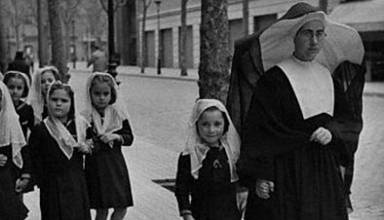
I wish I could be sure that I had not done those things myself – it is hard to be as brutally honest as I would like to be. I wish I could be sure that the churches are on a different path now - in some things I know we are. But I do hear from many students and teachers who still sound like they came from that world. For your hurt and profound disappointment, I am truly sorry. It was not from Jesus that it came. I make no easy apology to cover up the harm done - the principles outlined above show the truth of that claim.

In some places, the corruptions of punitive, arcane, institutionalised and arrogant religious teaching still happen. In most places, lessons have been learned and the heart or wholism is regaining its place in education.

STEP SIX
WHICH EDUCATION FUTURE?

Can the Christian faith bring strength and sustenance to the future of the education enterprise again?

CURRENT THREATS TO EDUCATION
Against the historic richness of education by countless persons over millenia, several culture-borne threats are now dumbing us down, day by day.

- Where NO thinking is required: Dumb TV, Facebook automatic-preferencing
- Where only ONE VIEW dominates : public media privately funded only
- Where no one cares about DISCOURSE: Two-sided only non-debates, therefore trolling, flaming
- Where NO THINKING WORK is ever required of us: Infotainment
- Where there is too little social VARIETY: Peer-group isolation is school streams, churches and sporting codes

DISCUSS:
- Where in private or public life do you see the effects of these dumbing and numbing behaviours?
- What % of your time do you give to these things? Take some non-think time by all means, but that is not my question. Why does this question now matter?

We see threats and opportunities in these five areas:
- WHICH PUBLIC WILL BE EDUCATED?
- WHAT RESPECT WILL GROW?
- CAN LEARNING BE TRANSFORMATIVE?
- HOW POLARISED IS EDUCATION?

WHICH PUBLIC WILL BE EDUCATED?

A number of articles are wondering why education standards are not improving. Why many young people are emerging illiterate wilfully ignorant. Should we change the philosophy we are using?

We have always had multiple educational philosophies and there is widespread feeling emerging in the western world that the cost of the education system surpasses the quality of its outcomes. The debate is heated and political interests try to close it off and push through. What Christians have contributed fresh new ideas to where these systems can go?

https://www.youtube.com/watch?v=dilnw_dP3xk
Several fabulous TED talks on education addressing the high school drop-out rate in the USA
Length 55.31 Published on 11 May 2013

It is easy to complain about the cost of education but what is the cost of ignorance? After centuries of sustained building, we have inherited a system that works with every child to adopt the effort of education and topples the idol of ignorance. It is a fragile yet strong system. By applying only the values of efficiency and marketting to courses in University and TAFE systems we will see many persons in smaller niches shut out, that is if the staff dont all burn out first. The establishment and spread of education systems for the common good, a Christian heritage by this reading, is under threat today. Change it if you will, but know what you are changing, and how we got to here.

EDUCATION FOR WHOM AND FOR WHAT?
https://www.youtube.com/watch?v=e_EgdShO1K8 Uploaded on 17 Feb 2012 Length 1.59.37
Prof Noam Chomsky, a world-renowned linguist, intellectual and political activist, spoke at the University of Arizona on Feb. 8, 2012.It comes in the context of falling government funding for public education His lecture, "Education: For Whom and For What?" featured a talk on the state of higher education, followed by 30mins question-and-answer session.

DISCUSS
- What is the cost of education and what is the cost of ignorance?
- Who will be educated and who should pay for it?

THE SOCIAL IMPACT OF INEQUALITY
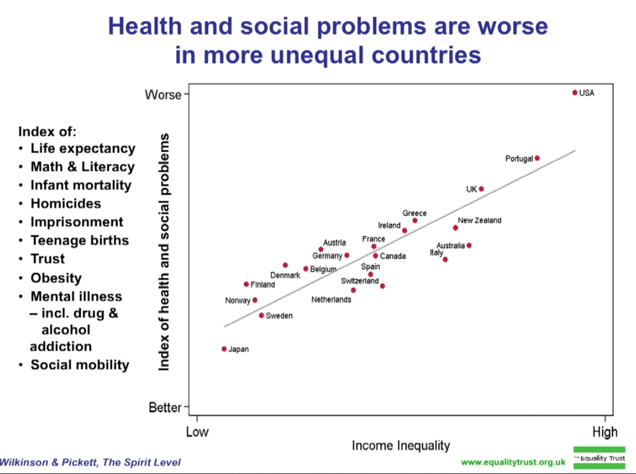
DISCUSS
- Who does higher education affect directly, therefore how should it be financed?
Which side do you lean towards and why - If it is only a meal ticket, each should pay their own. If it is a community school of virtue and learning, then all benefit indirectly so the only way to manage that is for all to pay through taxation?

Inequality is real, it's personal, it's expensive and it was created
Economic Policy Institute https://www.youtube.com/watch?v=ik1y4ZNSjek
Published on 20 Jun 2013 Length 2.28

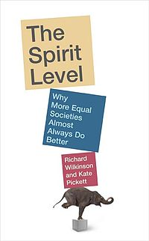
Today many governments are making decisions towards more private funding for more private benefits, despite the evidence of thirty year research in “The Spirit Level” (not a religious or an ideological reference).
https://www.youtube.com/watch?v=cZ7LzE3u7Bw Uploaded on 24 Oct 2011 Length 16.54
We feel instinctively that societies with huge income gaps are somehow going wrong. Richard Wilkinson charts the hard data on economic inequality, and shows what gets worse when rich and poor are too far apart: real effects on health, lifespan, and even such basic values as trust.

Spirit level provides graphs of publically available information on the spread of incomes (as structured by laws and cultural norms) matched against the risks and costs involved in several social indicators, as seen on the graph above, including literacy. It consistently shows that structured inequality within a society reduces the potential for all of that society in all of those social indicators.

DISCUSS
- Why does it matter to you (if it does) that all people should have access to an education that extends all persons?
- Is the value of education a private or public good?

Another popular public issue is about the place of religious instruction classes in a secular public school. It’s important but I won’t go into this. I think there are more pressing matters, but here are some references:

The place of religion in the public square and the need for good religious education.
https://publicchristianity.org/library/public-religion Part 1, part 3 AUGUST 10, 2011
Length 5.53 Interview with Dr Peter Vardy, Heythrop College, University of London, a leading expert on religion and values education. He notes a wide variety of voices but all Christians stand for similar things.

Does religion have a place in secular education and does a belief in God hold students back? https://publicchristianity.org/library/does-a-belief-in-god-hold-back-students by Brian Rosner - general intro – text AUGUST 14, 2011

Living Values Education Uploaded on May 31, 2011 Length 15.04
Britain, India and Kuwait. A partnership amongst educators around the world.
https://www.youtube.com/watch?v=hhuUhYUU4eI
DISCUSS
What are your best ideas on educational reform?

WHICH RESPECT WILL GROW?
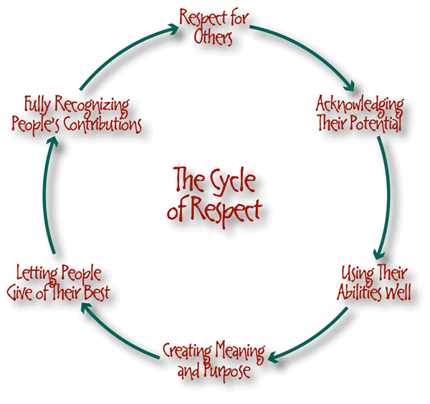
Consider all those exhausted teachers who love their subject and want to invest in young people but who are harassed by the core of students until frustrated beyond their sense of calling, they burn out. They should be highly respected, as in Asian cultures, but they are not. Few disciplinary systems seem to work in time. Few teachers can be inspiring at all times. It is unsustainable for ordinary people. We need to move to a different set of imperfections that do not undermine its own leadership.

Let’s not blame the students. Life is really very hard for young people in schools. Their agenda is to figure out how to tackle the competitive world of being liked and being employed. We all know that youth culture is visually saturated with unhealthy sexualisation, and we all know that it is already difficult enough to handle from behind their own eyes. The press make profits from this, and so they keep the pressure up by a focus on homo, peado, porno questions. Developmental sexuality has been thrashed and trashed, virtue is hard to find. Young people are fairly right if they feel abandoned by the system. They are thrown at this at the same time as their physical growth spurts are confusing, depressing and powerful. As an African saying observes: “If you don’t initiate the boys into manhood they will burn the village down”. Who actually helps them? Why is this agenda left to young people to fend for themselves while we talk about something else that is ten-years –away?

So is it any wonder that bullying on the play ground and on social media has grown into a cause of suicide, and all the tragic things might precede it. Changing the culture to respect is not impossible. One programme that has been successful in changing school cultures is CHOOSE RESPECT, authored by a school chaplain, which began in Armadale and has moved slowly and without any support to other schools. An important Christian contribution to our educational future.

NOT ANOTHER BRICK IN THE WALL- TRANSFORMATIVE EDUCATION

DISCUSS
What was your experience of schooling? Did it cause you to flourish or to conform or worse?

Here are several recent Christian or Christian-inspired thinkers who have sought to make education transformative.

Ivan Illich (1926 –2002) was an Austrian philosopher and Roman Catholic priest. He was a critic of the institutions of contemporary Western culture and their effects on the practice of education, medicine, work, energy use, transportation, and economic development.

In 1956, at the age of 30, he was appointed as the vice rector of the Catholic University of Puerto Rico, "a position he managed to keep for several years before getting thrown out—Illich was just a little too loud in his criticism of the Vatican’s pronouncements on birth control and comparatively demure silence about the [threat of the atomic] bomb." It was in Puerto Rico that Illich met Everett Reimer and the two began to analyze their own functions as "educational" leaders. In 1959, he travelled throughout South America on foot and by bus.

A decade later. Ivan Illich came to public attention with his book Deschooling Society (1971), a critical discourse on education as practised in "modern" economies. He gave examples of the ineffectual nature of institutionalized education. Then he suggested self-directed education, supported by intentional social relations, in fluid informal arrangements:
Universal education through schooling is not feasible. It would be no more feasible if it were attempted by means of alternative institutions built on the style of present schools. Neither new attitudes of teachers toward their pupils nor the proliferation of educational hardware or software (in classroom or bedroom), nor finally the attempt to expand the pedagogue's responsibility until it engulfs his pupils' lifetimes will deliver universal education. The current search for new educational funnels must be reversed into the search for their institutional inverse: educational webs which heighten the opportunity for each one to transform each moment of his living into one of learning, sharing, and caring. We hope to contribute concepts needed by those who conduct such counterfoil research on education--and also to those who seek alternatives to other established service industries. —Ivan Illich,
The book is more than a critique—it contains suggestions for a reinvention of learning throughout society and lifetime. The last sentence makes clear what the title suggests—that the institutionalization of education tends towards the institutionalization of society and that ideas for de-institutionalizing education may be a starting point for a de-institutionalized society. Particularly striking is his call (in 1971) for the use of advanced technology to support "learning webs." Today’s web-based learning was simply unimaginable then but it is now moving to the forefront of educational philosophies, if not strategies.

According to a contemporary review in The Libertarian Forum, "Illich’s advocacy of the free market in education is the bone in the throat that is choking the public educators." Although it is important to note that Illich's opposition was not merely to publicly funded schooling, as with the libertarians, but to schooling as such; the disestablishment of schools was for him not a means to a free market in educational services, but a deschooled society, which was a more fundamental shift. As he later asserted in After Deschooling, What? (1973): 'We can disestablish schools, or we can deschool culture'. He actually opposed advocates of free-market education as "the most dangerous category of educational reformers."

Two years later he generalized this study to all of social technology in “Tools for Conviviality”.

DISCUSS
How well founded is the fear that a student will be treated as ‘another brick in the wall’?
What kinds of conformity are required by a young person if they are to do well in a large scale system of peer-group classrooms?

2. RESTORING HEART AND LEADERSHIP IN EDUCATION

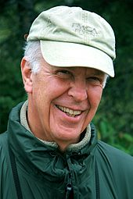
Parker J Palmer, The Heart of Higher Education, To Know As We Are Known: Education as a Spiritual Journey, A Hidden Wholeness: The Journey Toward an Undivided Life and other practitioners of ‘wholistic’/ ‘mindful’/’contemplative’ practises.

Parker J Palmer talks of putting the wisdom of the heart back in education,
http://www.youtube.com/watch?v=z4_DTbLVRoYhttp://www.youtube.com/watch?v=z4_DTbLVRoY Length 3.09 Uploaded on 22 Sep 2009

Teaching as a form of leadership and the fears that freeze us. http://www.youtube.com/watch?v=5YBEhY8d8lE. Length 3.57. Uploaded on 12 Feb 2010

Sir Ken Robinson – Educating the Heart and Mind
https://www.youtube.com/watch?v=I1A4OGiVK30
Uploaded on 2 Nov 2011 Length 48.58
http://www.dalailamacenter.org Sir Ken Robinson speaks during the Dalai Lama Centre’s Educating the Heart Series

DISCUSS:

What do you need to have around you if you were to live more ‘heart’ or more meaningfully and more reflectively?

What are the particular fears that freeze your expression of your values and ideas?

3. TRANSFORMATIVE EDUCATION

http://www.youtube.com/watch?v=lVPhpEiqoLohttp://www.youtube.com/watch?v=lVPhpEiqoLo Length 5.35 Uploaded on 13 Feb 2010
Video Project for EDUC 7102 Principles of Distance Education.

http://www.youtube.com/watch?v=BpUukqlUAqE Length 17.02 Published 6 Jul 2013
A survey of learning theories which sets the scene for a description of Transformational learning.

Transformative Learning theory is usually credited to Jack Mezirow (pictured). He identifies his main influences as the Christian philosophers Freire and Polanyi and as well as Jurgen Habermas , who describes himself as a ‘methodological atheist’ and calls for a post-secular education future.

In one study, Mezirow also acknowledged that Thomas Kuhn, (1962), The structure of scientific revolutions, (University of Chicago Press) was also influential in his thinking. The now popular phrase ‘paradigm shift’ comes from Kuhn.

Like Kuhn, the same theory of knowledge (‘all knowledge is personal and social’, ‘positivism reduces knowledge’) was being developed by Michael Polanyi. Kuhn and Polanyi were frequent intellectual exchangers on this theory. To both their dismay it was Kuhn who became famous for it. Polanyi’s philosophy preceded Kuhn by two decades.
Michael Polanyi (1891–1976, pictured left) was born to parents who were secular Jews, but became a Christian. In 1926 he was appointed to a Chemistry chair in Berlin but in 1933 when Hitler came to power he accepted a Chemistry chair, then in 1948 a Social Sciences chair at the University of Manchester. In 1946 he wrote Science, Faith, and Society.

‘Transformative Learning' theory says that the process of ‘perspective transformation’ has three dimensions:
- psychological (changes in understanding of the self)
- convictional (revision of belief systems)
- behavioural (changes in lifestyle).

Transformative Learning is the expansion of consciousness through the transformation of basic worldview and specific capacities of the self. Transformative Learning is facilitated through consciously directed processes such as appreciatively accessing and receiving the symbolic contents of the unconscious and critically analyzing underlying premises.
"A defining condition of being human is that we have to understand the meaning of our experience. For some, any uncritically assimilated explanation by an authority figure will suffice. But in contemporary societies we must learn to make our own interpretations rather than act on the purposes, beliefs, judgements, and feelings of others. Facilitating such understandings is the cardinal goal of adult education. Transformative learning develops autonomous thinking."

Perspective transformation leading to transformative learning, occurs infrequently. Mezirow believes that it usually arises from a disorienting dilemma, which is triggered by a life crisis or major life transition, although it may also result from an accumulation of transformations in meaning schemes over a period of time. Less dramatic predicaments, such as those created by a teacher, also promote transformation.

An important part of transformative learning is for individuals to change their frames of reference by critically reflecting on their assumptions and beliefs and consciously making and implementing plans that bring about new ways of defining their worlds. This process is fundamentally rational and analytical.

Another definition of transformative learning was put forward by O'Sullivan.

Transformative learning involves experiencing a deep, structural shift in the basic premises of thought, feelings, and actions. It is a shift of consciousness that dramatically and irreversibly alters our way of being in the world. Such a shift involves our understanding of ourselves and our self-locations; our relationships with other humans and with the natural world; our understanding of relations of power in interlocking structures of class, race and gender; our body awarenesses, our visions of alternative approaches to living; and our sense of possibilities for social justice and peace and personal joy.

Interest in Mezirow’s transformative learning theory has resulted in seven inter- national conferences, numerous peer-reviewed papers, and the Journal of Transformative Education. Many books, scholarly papers and presentations, and doctoral dissertations have addressed the theoretical and practical implications of the theory.

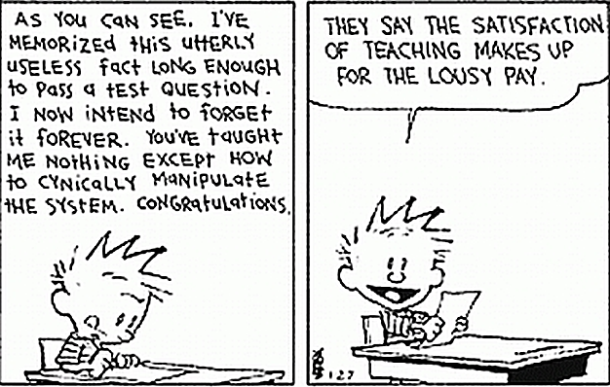
DISCUSS:
- How much are the goals stated above actually happening in your school?
- Do you believe that an education system is morally neutral?
- Has the preponderance of the idea of neutrality actually been a hard version of secularity which allowed ‘puerile disrespect’ to become dominant?
- What does this say about the role of religious perspectives in the public square?

All these are sources of hope for mainstream educational systems.

HOW POLARIZED IS EDUCATION?

WHICH SECULAR?

To be secular is to separate government institutions (and their representatives) from religious institutions (and religious dignitaries). (http://en.wikipedia.org/wiki/Secularism). But that doesn’t end the matter . There is more than one version of this.

One manifestation of secularism is the right to be free from religious rule and teachings, or, in a state declared to be neutral on matters of belief, free from the imposition by government of religion or religious practices upon its people. The other side also applies, the government cannot control the appointment of church officials or dictate its beliefs. This is ‘soft secularism’, allowing various forms of truth-claims to co-exist in the interest of freedom of thought and expression.

A second manifestation, ‘hard secularism’, is the view that public activities and decisions, especially political ones, should remain uninfluenced by any religious beliefs and/or practices. This view wants the public decisions to be solely influenced by some form of atheism or scepticism, partly in the belief that that would make them ‘neutral’, but there are no value-free institutions. Religion is tolerated only in the private sphere.

DISCUSS: Which view of secular to you prefer and why?

- Who decides what values are taught within a school community and curriculum? Is that appropriate? What are the alternative sources?

- If a school or university permits no religious perspectives at all to be taught in the curriculum, can it be said that they (as one belief system among many) are proselytizing for atheism, that is, forcing methodological atheism on everyone?

WHICH GENDER?

A lot of the people referred to so far have been men, but most of the teaching is actually done by women in my society. Is that true in yours too? What does that say about how masculinity and schooling go together?
Many of the challenges facing women’s leadership are long-standing and have important historical and cultural contexts that must be considered. That is, the men! the abstract male philosophies!
This forum was created “for fresh, engaging, and viable ideas that will be useful to researchers, practitioners, and policymakers, and, more importantly, to encourage learning, collaboration and action.” People can lead from the bottom up, if Illich’s network idea has reached its time.

VIEW AND DISCUSS:

International Women Leading Education (WLE) Conference, 2013, Ghana
Seeking New and Deeper Understandings of Women's Educational Leadership Across the Continents
The conference looks at the role of community contexts in which women leaders learn, work, lead and serve, and…
- Connections between and among research, policy, and practice, with attention to a broad range of local, regional, national and international concerns.
- Many of the challenges facing women’s leadership are long-standing and have important historical and cultural contexts that must be considered.
- A forum for fresh, engaging, and viable ideas that will be useful to researchers, practitioners, and policymakers, and, more importantly, to encourage learning, collaboration and action.
https://www.youtube.com/watch?v=aZb1hHwa96A
Uploaded on Aug 13, 2009 Length 5.22
.

THE MISSING MALE TEACHER
From an Education Policy Brief from the Centre for Evaluation and Education Policy (CEEP) at Indiana University. The study called "The Status of Male Teachers in Public Education Today"

https://www.youtube.com/watch?v=nLvQX2DWlJs
Uploaded on 4 Mar 2008 Length 3.32

DISCUSS:
- Looking back at your own education, was there a male teacher? What difference did he bring? In what part of your schooling were they more or less important?
- What would it take to make it more or less possible for male and female educators to work together?
- Why would you want more males in teaching?

CONCLUSION
This study is not evidence that Christianity is more clever than other religions or philosophies. This is not an attempt to write a history of education. What this story shows is that Christianity has shown a genius for spreading education for the common good at all levels of society , repeatedly through the ages. They have expressed the way in which Jesus asks his followers to be students, to teach one another, to focus on the child in the midst. The establishment and spread of education systems for the common good has been a heritage of Christian values and spirituality. The church has sustained that priority along with some corruptions that were conspicuous partly because they took place within the wide and positive sphere of influence the church had established. Christians are still in the business of pioneering educational progress. That heritage is under threat today. Change it if you will, but know what you are changing, and how we got to here.

I can read, the world lies open like a book.
Thank you to my teachers,
Thank you to those who stopped child labour
And gave us schools,
Libraries, literacy, universities.
Thank you for Jesus’ call to be disciples
who make disciples,
Transformative, heart-felt, child-like, faithful,
In church , homes and community. Amen

