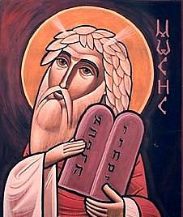**What’s** **Christianity Ever**  
**Done**

**for the LAW?**

A small group study

Ian Robinson

1. **CHRISTIAN PRINCIPLES IN LAW**
2. **THREE GREAT LEGAL CONTRIBUTIONS**
3. **FIVE ABOLITIONS OF SLAVERY**
4. **SEVEN THINGS YOU MIGHT TAKE FOR GRANTED**
5. **FOUR GREAT CORRUPTIONS OF THE CHURCH**
6. **CAN CHRISTIANITY STILL BE GOOD FOR THE LAW?**

The title of this series borrows from a satirical film Life of Brian, a youtube clip...

https://www.youtube.com/watch?feature=player_detailpage&v=ExWfh6sGyso#t=0

*WXED is dedicated to Prof Brian Hill, who has lived, breathed, written, laboured, thought and prayed in all these ways for many decades, with not a few tears.*

**This is one a series of small group discussion books on “What’s Christianity Ever Done?” Each study looks backwards across the cultural impact of Christianity and describes -**

* **how the principles of faith have undergirded that discipline,**
* **how persons of faith have been pioneers and creators of that discipline,**
* **how the church has sometimes corrupted their role and**
* **how there might be potential need for collaboration into the future.**

WXED LAW

GOAL

* To provide essential background to our shared history in the Law within late modern culture, both Christian and non-Christian. This is not a ‘theory of law’ class so much as a history magazine.
* To spark a rise in the quality of discourse about the value of Christian spirituality in the professions.

**INTRODUCTION**

Have you heard it said by Christians and Jews that the Ten Commandments are the basis of the law in this country and many others.?

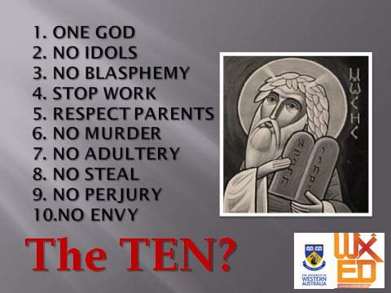I think it’s not nearly true enough.

I see no legal status to commands 1-5, nor 10 “- envy- which is the basis of the consumer economy.

That leaves us with 6-9 – murder, adultery, stealing and perjury - of which 7 and 9 are currently pretty shaky.

Today’s society has different contests in mind

In practise, in principle and in persons, the huge creative contribution of the church to the Law of this culture and internationally has so shaped western culture that Christian humanism is unknowingly the widespread common sense - for instance the value of the child, of each life, womens rights in marriage, just war charters, the right to conscientious objection, secular government, help in emergency, the right to healthcare, universal education, welfare support, freedom from slavery, human rights, prison habilitation, the prevalence of voluntary charity. That’s an impressive description of much that we hold dear in Western society.

What if all this became sidelined by an uninformed disregard or anti-Christian ignorance? New influences are here and shouting, what will sustain these human values? IN late modernity we have trouble integrating outside our silos of thought, can’t action changes that we all know we need, which leaves the public square dominated by self-interest, fashions in cultural priorities or propaganda. Spirituality is inherently wholistic, so its voice adds value in our dilemma.



Let us acknowledge that our body of Law is not just Christian. Church does not own the Law. Western Law has many Mosaic, Roman, Christian, Secular **and** Enlightenment streams of thought. In time of change, once you hear this story, choose carefully, that’s all.

Religion and law are colliding in new ways.

CUSTOMS

This 11 year old girl is being married to this man in India. It happens here in Australia too. How can it be lawful to stop this practise when their community supports it? Whose law is it?

CONVICTIONS

 In Arizona it is now lawful for a commercial proprietor to refuse to serve people towards whom they have a religiously-based conscientious objection, namely gays. Here, they would be prosecuted for this. Should they give up their religious scruple or give up running commercial enterprises to the public?

Or is it a case of ‘religion being only a private matter’?

Is this true, as often stated, that “Religion is a private matter” ? Faith is a point of view and a source of empowerment that affects everything we do. Religion can never be simply a private matter.



CONVENTIONS

These youth are incarcerated indefinitely by Australia, treated as illegal criminals without trial or charge, in contravention of a UN Convention which Australia has signed. The are called “illegal” when in law they are legally entitled to seek asylum.

CRISIS

There are two opposing arms in Christian responses to the changes.

1. I witness a new level of engagement by church leaders in opposing the laws, more than I have seen before. **Anglican priest arrested at coal mine development March 2014. Buddhist Catholic and UNITINGS.** Also in recent ******months that there have been several sit-down prayer-protests by an even wider range of clergy against children in detention. Each Australia Day Christians gather for a flag-washing.
2. Christians in the public sphere attack the questions with legalistic bible-verses, applied like band aids, instead of engaging with the questions. It just turns people off. Legalism, even in matters of law, does not create change.

Something about Christianity and law has changed. It is not as simple as “getting back to the christian basis of this nation”. Acknowledge that our body of Law is not just Christian. Church does not own the Law. Western Law has many Mosaic, Roman, Christian, Secular **and** Enlightenment streams of thought. No one is neutral. The track record is that Christians and Xty have been significantly good for the Law.

This study comes at the right time.

As a specialist in Christian history, spirituality and philosophy, and not in Law, I am offering a shared history. I hope it raises the quality of discourse about the value of Christian spirituality in the professions.

**STEP ONE – CHRISTIAN PRINCIPLES IN LAW**

Let us begin by putting to rest the theory that a neutral stance towards religion is better for law, and we should be not just ‘methodological secularists’ but divorce all religious insights from the public square, Such a theory holds that to be a Christian is biased, that is, more biased than other views. The real story has in fact been opposite – Christianity has been good for the Law.

It would be easy to say that Christianity is always about mercy, that is Love and not Law. It would be equally easy to say that judgemental religious people are *only* about the law – happy to manipulate others when it suits them and happy to cry ‘martyr’ when it does not suit them. We hear it often!

The church has both **positive and negative in their track record in law and ethics**. So let us examine what the church has actually contributed to law and ethical debate. **Four principles,** in my view, shape Christian responses.

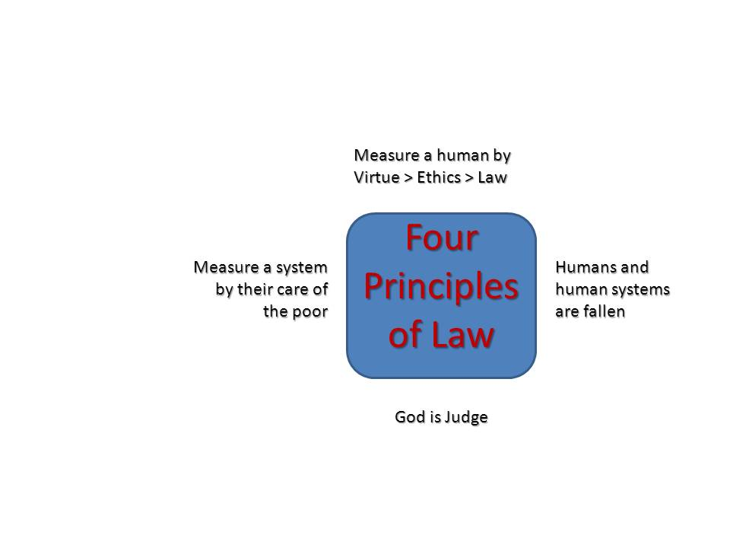**1.God is the impartial Judge of all humans, a bedrock concept.**

Romans 1.18-20. The Bible throughout represents God as a judge - secure, impartial and merciful. God promises to be the bastion of justice, not because he likes to punish people (contrary to popular imagery), but because he does not.

OPTION ON JUDGEMENT

The ‘wrath of God’ in the bible *combines* two modern concepts – the normal consequences of our choices from which we will not be protected by any interventions (no lightning strikes) AND God’s active agency in seeing complete justice done without leftover at some end point. The supreme defining point in Christianity is that in Jesus’ death on the cross, the wrath of God has been satisfied/redeemed/ransomed/healed/atoned/propitiated..

**What and how will God judge?** In Xty, God gives this task to Jesus, because he has been tested as we have, therefore trustworthy. Jesus uses three images, all to do with the mercy of God that should not be taken as granted, to describe how we shall be judged:

* Jesus description of the judgement of God upon humanity is in Matthew 24-25 is about the care of the least. It is not to the wealthy that salvation comes easily.
* The measure you mete Luke 6.38 , Romans 2.12. One’s own values and natural law are the benchmarks, not God’s eternal purity. Those who choose to avoid the way of eternity will be granted what they wish.
* Unless you repent you will ‘all likewise perish’ Luke 13, 3,5. God is active in bringing about justice. In the context of suffering, justice will be granted to unrequited sufferers.
* Is ‘perishing’ a lake of fire? An outer darkness? Hades? Anhialation? Purgatory? All these images are used but what do they mean and how much does it matter?

DISCUSS

* If your whole life and all its dreams had been ruined by a callous criminal who was intent on nothing but the pleasure of evil, what might it mean to you that God will be the fair and impartial judge after we all die? Could you trust a god who did nothing about that?
* Could you trust a god who could consign an ordinary evil person to an eternity of punishment for their misdeeds?

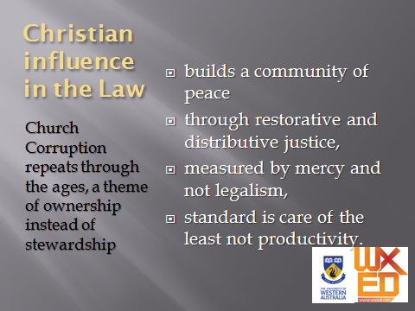

2. **Humans and human systems are fallen. We are all in need of inner change, personally and corporately. Duh!**

We are a magnificent and stupid species. Does anyone doubt it? There is a deep problem to be managed. Every human faculty and system, including Reason, can be a tool for that stupidity and that magnificence, even at the same time or in the same person!

There are several law-codes in the Bible, but it seems to go on to admit that laws can not change us. Manifestly, any group must form standards or laws in order to control the ever-near bad impulses of its people. The bottom-line corrupting impulse is what the the bible calls ‘sin’, though it has many names - rebellion against God, hubris, cupidity, irrationality, selfishness, ‘shooting yourself in the foot’, and many more. Romans 2.1;7.7-25

As well as personal sin, Systems and organisations (including Church) are also corruptible. Governments, businesses, committees, groups of friends, staff rooms – all can intuitively conspire to scapegoat another, to privilege themselves, brazenly without regard for the rightness of it nor for the suffering they inflict. This too needs must be called out and changed. This what is meant by social justice, restorative justice. But it is persons in power who make the decisions for systems, so the discussion tends to return to them and their sinfulness.

In personal life, Christianity has been really effective when emphasising the importance of listening to conscience and exercising self-control. But Romans 7.7-25 makes it clear that even an apostle does not keep to that standard either. So, the church has done some terrible things. That actually proves its point and does not disprove it. No other ancient code describes the problem so radically as a ‘root of all evil’ and describes itself as one of those fallen systems. Prof Edwin A Judge.

<https://publicchristianity.org/library/Christian-history> length 7.36

DISCUSS

Give an example in your understanding where a group-system or organisation has been set up by people in such a way that when it operates well it still routinely pushes certain kinds of person down/aside.

Is it inevitable? How could it be changed?

**3. Measure a person by the qualities of their Virtue >more than their performance on a gold-standard ethics > more than external application of law > more than application of forceful conformity**

The measure of Virtue is the opposite trajectory to a Macchievellian real-politick view, or evolutionary survivalism, or Marxist class-struggle.

It is not externally-derived laws that make us ethical. It is inwardly chosen pathways or virtues that matter to God. Gal 5.22 portrays the outworking of the Holy Spirit is characterised by self-control. 2 Cor 4.2;1 Tim 1.5; 1.19;3.9; Heb 10.22. That is, universal Human Rights imply universal Human Responsibilities: “Every fundamental human right draws its indestructible moral force from the natural law, which in granting it imposes a corresponding obligation. Those, therefore, who claim their own rights, yet altogether forget or neglect to carry out their respective duties, are people who build with one hand and destroy with the other.” Pope John XXIII, Peace on Earth (Pacem in Terris, 1963) No.30

This holds very important political force also. In Christianity, focus goes first to cultivating virtues chosen by conscience or self-control, which informally become shared ethical platforms (policies or covenants) that can change from time and circumstance, which may also become laws when codified formally. **The direction of this logic** is to build politics and economics upon the creation of virtuous persons and families, not the other way around . We are not here to build up or conform to the empire, the church, the state or the business.

DISCUSS

‘**The direction of this logic** is to build politics and economics upon the creation of virtuous persons and families, not the other way around . We are not here to build up or conform to the empire, the church, the state or the business.’ What happens if you reverse this logic and legislate for humans to change in certain ways and enforce it through police action or social exclusion?

**4. Measure a system (church, government, business, civic) by how well it looks after the poor and vulnerable.**

The ten spiritual KPI’s (Exodus 20) from the Jewish Prophets and the Jewish Jesus. Just a few examples of many…

* Ex 23.6 Do not deny justice to your poor people in their lawsuits:
* Deu 15:4 However, there need be no poor people among you, for in the land the LORD your God is giving you to possess as your inheritance, he will richly bless you,
* Psa 12:5 “Because the poor are plundered and the needy groan, I will now arise,” says the LORD. “I will protect them from those who malign them.”
* Psa 35:10 My whole being will exclaim, “Who is like you, LORD? You rescue the poor from those too strong for them, the poor and needy from those who rob them.” The LORD enters into judgment against the elders and leaders of his people: “It is you who have ruined my vineyard; the plunder from the poor is in your houses.
* Isa 10:1-2 Woe to those whop make unjust laws, to those whpo issue oppressive decrees, to deprive the poor of their rights and withhold justice from the oppressed of my people, making widows their prey and robbing the fatherless.
* Jer 22:16 He defended the cause of the poor and needy, and so all went well. Is that not what it means to know me?” declares the LORD. They trample on the heads of the poor as on the dust of the ground and deny justice to the oppressed. Father and son use the same girl and so profane my holy name.
* Amo 5:12 For I know how many are your offenses and how great your sins. There are those who oppress the innocent and take bribes and deprive the poor of justice in the courts.

Let us be careful about codifying ethics: we can be subtely guilty of reading into the bible what we want to see there (a mistake called called ‘isogesis’) through our failures to analyse well enough our current situations or the biblical context, or our failure to listen to those with whom we differ.

**STEP TWO**

**THREE GREAT CONTRIBUTIONS**

On these four planks of a platfrom then, let us look historically at three broad contributions by the church to the Law, before we proceed to tell the story of one particular set of laws.

* The codification of law that makes all persons subject to it
* Moral force that underlies the operation of law
* The Church as societies rescue squad

**The Holy
Right-Believing Emperor Justinian and Empress Theodora:THE** **WORK OF CODIFICATION** of laws to take precedence over imperial edict.

Emperors Theodosius II (5th cent) and Justinian (*pictured* 6th century) appointed commissions to reform Roman law in Byzantium, removing the force of imperial edict and codifying the laws. This codification allowed regional differences and addressed the cultural particularity of globalism. A still more resonant aspect of this legacy was the uniform rewriting of Roman law, the [**Corpus Juris Civilis**](http://en.wikipedia.org/wiki/Corpus_Juris_Civilis), which is still the basis of [civil law](http://en.wikipedia.org/wiki/Civil_law_(legal_system)) in many modern states and continues to have a major influence on public international law.

The **Codex Theodosianus** (Eng. Theodosian Code) was a compilation of the [laws](http://en.wikipedia.org/wiki/Roman_law) of the [Roman Empire](http://en.wikipedia.org/wiki/Roman_Empire) under the [Christian](http://en.wikipedia.org/wiki/Christian) emperors since 312. A commission was established by [Theodosius II](http://en.wikipedia.org/wiki/Theodosius_II) and his co-emperor [Valentinian III](http://en.wikipedia.org/wiki/Valentinian_III) in 429 and the compilation was published to both east and west nine years later.

**Justinian,** was a champion of orthodox Christian beliefs, a builder of churches and a writer. He was born in Bulgaria. He won military victories in Persia, Africa, Italy and he closed the pagan schools in Athens and among the Vandals. With the aim of spreading Christianity, Justinian used imperial funds to send missionaries and built 90 churches. His finest structures of the time are considered to be the monastery of St Catherines at Sinai, the Saint Vitale at Ravenna and the church of Hagia Sophia at Constantinople. He established the education of clergy and monks, ordering them to be instructed in rhetorics, in philosophy and in theology. In his personal life, Saint Justinian was strictly pious, and he fasted quite often. Bubonic plague wiped out the empire and cut off Justinians attempt to restore the glory of former Rome.

Under his supervision was compiled a complete compendium of Roman laws, which has come down to us as a codex of law known as "the Justinian Codex". The work of Codification means strict impartiality - the emperor too was under the Law of God. No longer are laws simply the decree of emperors, nor is justice liable to a whim. When the Emperor Theodosius I ( [Emperor](http://en.wikipedia.org/wiki/Roman_Emperor) from 379 to 395) ordered the punitive massacre of thousands of the citizens of Thessaloniki, Ambrose the bishop of Milan admonished him publicly, refused him the Eucharist and called on him to perform a public penance, a call to which the Christian Emperor submitted. While paganism in the Roman Empire was not yet finished, the episode prefigured the role of the Church in the political life of Europe in coming centuries.

[](http://www.loc.gov/pictures/item/2005683652/)

Gratan’s Compendium of Canon Law 12th century to 20th

*Decretum Gratiani* is a collection of [Canon law](http://en.wikipedia.org/wiki/Canon_law_(Catholic_Church)) compiled in the 12th century as a legal textbook by the [jurist](http://en.wikipedia.org/wiki/Jurist) Gratian. (image shown is the 1561 edition 400 years later). It forms the first part of the collection of six legal texts, which together became known as the [*Corpus Juris Canonici*](http://en.wikipedia.org/wiki/Corpus_Juris_Canonici). It was used by [canonists](http://en.wikipedia.org/wiki/Canonist) of the [Roman Catholic Church](http://en.wikipedia.org/wiki/Roman_Catholic_Church) until 1918, when a revised [*Code of Canon Law*](http://en.wikipedia.org/wiki/Code_of_Canon_Law) was promulgated by [Pope Benedict XV](http://en.wikipedia.org/wiki/Pope_Benedict_XV).

**FOUR WATERSHEDS**

Christians were not first with Law.

All codes of law go back to this one - *pictured* is the earliest known code of law of Hammurabi, the sixth king of Babylon. 1750bc

[](http://en.wikipedia.org/wiki/File:Code-de-Hammurabi-1.jpg)

In Hebrew history, Moses’ codes of law , including the Ten Commandments, have proved flexible and influential for three millennia.

In Christian history, the law went through four watershed phases, as recounted by de Witte. In overview -.

1. Christianity began as a **Jewish sect** and often faced **persecution** during the early centuries, particularly for their refusal to join in worshiping the emperors. Nevertheless, carried through the synagogues, merchants and missionaries across the known world, the new global religion quickly grew in size and influence. Beginning sporadically and later systematically, the empire persecuted Christians by spreading scandalous untruths (they were ‘cannibals’) , forbidding them to meet, confiscations and executions.

Emperor Constantine's Edict of Milan in 313 AD ended the persecutions and his death-bed-conversion to Christianity was a significant turning point in history. Constantine offered **civic toleration to Christians**, and through his reign instigated laws and policies in keeping with Christian principles - making Sunday the Sabbath "day of rest" for Roman society (though initially this was only for urban dwellers) and embarking on a church building program. In AD 325, Constantine convened the First Council at Nicaea to gain consensus and unity within Christianity, which had never before been an organization. In 330, just across the Bosphorus from Nicaea, Constantine established the city of Constantinople as the new capital of the Byzantine Empire, New Rome. Until this time Xty had no legal standing so no direct influence in the Law.

There were three other periods when Christianity excelled in shaping the western law tradition

1. Medieval Catholicism and the rise of canon law to common law 11thC (Gratan)
2. Reformation and ‘two magisteria’ doctrine furthering secularity 16thC
3. Modernity and Enlightenment 18thC

Shall we add the age of Technology 20-21C? This is where we are with many ethics/law questions.

**2. MORAL FORCE AGAINST CORRUPTION**

Christians have a track record of ethical strength.

Christianity is a strategically placed entity characterised by a particular ethical strength for the prevention and interception of corruption. Why does this matter and how big a problem is it?

**Corruption is the abuse of entrusted power for private gain**. It hurts everyone whose life, livelihood or happiness depends on the integrity of people in a position of authority. Corruption holds back economic development, prevents a free market operating for businesses and consumers, and further exploits already marginalised groups:

<http://www.transparency.org.uk/corruption/measuring-corruption>

includes introductory podcast Length 1.50

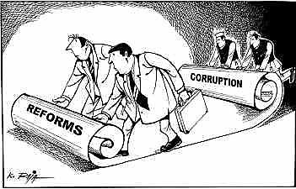

Private-sector corruption in developing countries is a tax on growth, costing at least $500 billion a year - more than three times all foreign assistance in 2012.

*Source: The Center for Strategic and International Studies,The Costs of Corruption, 2014*

More than 40 percent of employees at board and senior manager level said that sales or cost numbers had been manipulated by their company. This included reporting revenue early to meet short-term financial targets, under-reporting costs to meet budget targets, and requiring customers to buy unnecessary stock to meet sales targets.

*Source: Ernst and Young, 'Navigating today’s complex business risks Europe, Middle East, India and Africa Fraud Survey 2013', pg. 8*

According to the EU Commissioner for Home Affairs, an estimated €120 billion is lost to corruption each year throughout the 27 EU member states

**This is not a matter of established churches or dominant religion. It is worth noting that the pre-dominant national religion is not an indicator of lack of corruption.**

In the global corruption indicator, a higher number means cleaner business practise. Highest scoring are secular countries Sweden (89) and Australia (81). Below them, Communist Hong Kong (75) has the same measure as Christian USA (74). Catholic Ireland (72) is roughly the same as secular France (71) and Muslim United Arab Emirates (69). Below that the Jewish state of Israel shares the same score as Catholic Poland, and Muslim Brunei (60-61)

Transparency International lists five determinative factors in the *Integrity System* of a nation: Media, Police, Judiciary, Legislature and Civil Society. The latter includes citizens and citizen associations that keep an eye on perceived corruption in government or business. **Religious persuasion would influence all of these** – mostly in the area of the degree of ethical commitment. Thus it is predominantly the work of citizens, not officials or laws, to prevent and police corruption:

[http://www.transparency.org.uk/component/content/article/9-event/843-citizens-a-corruption-solution-or-problem](http://www.transparency.org.uk/component/content/article/9-event/843-citizens-a-corruption-solution-or-problem%20)

As churches are everywhere local and always a community of learning (discipleship) the influence of the local church, (not the popular or established institutions which seem to have their own transparency issues), is strategic for mobilising the ethical strength that lies at the base of anti-corruption measures.

We will soon see this at work in the Christian role in human rights, anti-slavery and many other things (Grotius and Calvin). At this broad brush moment, let us note that, at base, Christianity has doctrines of morality that are ultimate, connected to the holiness of God. Christians are not frightened into goodness by the threat of punishment by God, nor out of legalism and duty, but out of love for a good God and responsibility for their neighbours.

A MORAL ENGINE

Moral order is as important and as real as the natural order, a perspective that is hard for materialists to grasp. It means that human actions really matter in the grand scheme of things and are not able to be overlooked. It is called (in one stream) “Gods Moral Order”:

Famous for his *Satisfaction theory of the atonement* was Anselm of Canterbury (1033-1109 not the Anselm who confronted the emperor). In his book, *'Why the God-Man?'* he argued that achieving human atonement with God is only possible for Jesus Christ, the Son, who is both God and man. Because this rationale became central to much Christian theology, it also established the principle of **God’s moral order** within which laws operate and in which human deeds were to be accounted.

Let us pause to recognize the limits of what we are talking about and its basis in moral force and natural law:

*“Every fundamental human right draws its indestructible moral force from the natural law, which in granting it imposes a corresponding obligation. Those, therefore, who claim their own rights, yet altogether forget or neglect to carry out their respective duties, are people who build with one hand and destroy with the other.” Pope John XXIII, Peace on Earth (Pacem in Terris, 1963) No.30*

Good people do not need laws to tell them to act responsibly, while bad people will find a way around the laws.

― Plato

The more laws and order are made prominent, the more thieves and robbers there will be.   
― Laozi

Must the citizen ever for a moment, or in the least degree, resign his conscience to the legislator? Why has every man a conscience then? I think that we should be men first, and subjects afterward.   
― Henry David Thoreau

1. **CHURCH CALLED TO THE RESCUE**

Christians have often stepped up to help or been asked to step in to power. The wider society has placed a demand for moral and pastoral inputs at crisis times. Here are several examples to show the historical consistency of this demand:

a.. In 5th century collapse of Rome

After the Fall of Rome in the fifth century, sacked by invaders, , the church served as **a source of authority and continuity**. In the absence of a magister militum living in Rome, even the control of military matters fell to the pope. Gregory the Great (c 540–604) administered the church with strict reform. A trained Roman lawyer and administrator, and a monk, he represents the shift from the classical to the medieval outlook and was a father of many of the structures of the later Roman Catholic Church. According to the Catholic Encyclopedia, he looked upon Church and State as co-operating to form a united whole, which acted in two distinct spheres, ecclesiastical and **secular,** but by the time of his death, the papacy was the great power in Italy:

“ [ Pope Gregory the Great ] made himself in Italy a power stronger than emperor or exarch, and established a political influence which dominated the peninsula for centuries. From this time forth the varied populations of Italy looked to the pope for guidance, and Rome as the papal capital continued to be the centre of the Christian world. ”

b. In 1075 church power in Holy Roman Empire - canon law became civil law then common law.

The historian of Christianity, Geoffrey Blainey, likened the Catholic Church in its activities during the Middle Ages to an **early version of a welfare state**:

"It conducted hospitals for the old and orphanages for the young; hospices for the sick of all ages; places for the lepers; and hostels or inns where pilgrims could buy a cheap bed and meal". It supplied food to the population during famine and distributed food to the poor. This welfare system the church funded through collecting taxes on a large scale and possessing large farmlands and estates.

For the next several hundred years, the Church held great influence over Western society; church laws were **the single "universal law** ... common to jurisdictions and peoples throughout Europe", giving the Church "preeminent authority". With its own canon law and court system, the Church retained jurisdiction over many aspects of ordinary life, including education, inheritance, oral promises, oaths, moral crimes, and marriage. Church attitudes were also reflected in many secular laws of the time.

The Church was very powerful, essentially internationalist and democratic in it structures and run by **monastic organisations** generally following Benedictine rule. Men of a scholarly bent usually took Holy Orders and frequently joined religious institutes. Leading churchmen from faraway lands were accepted in local bishoprics, linking European thought across wide distances. Ordinary people also trekked vast distances on **pilgrimages**.

c. 18C Australia - Rev Johnson (the first priest in Australia) sat on the bench as a magistrate in the first ever Court case.  Similarly Rev Samuel Marsden flogged the convicts as the law required. He was one of few people who could have fulfilled the role of magistrate separate from the arresting officer or prosecuting officer, a role he fulfilled in Australia, but it is unlikely the prisoners who he flogged within an inch of their life would have appreciate his delicate position. Marsden soon left and went on to do amazing things in establishing education in New Zealand.

d. Emergencies - personal and natural – Red Cross and a host of others, including chaplains to emergency services, including 19-20 centuries, *as follows*

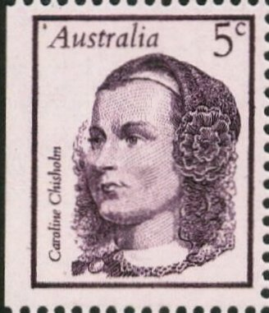 Women were imported to be **“Gods police”** in the settlement of Australia. Caroline Chisholm brought women by the boatload “to settle the men” in the nineteenth century colonies of New South Wales. Christian virtues and family codes, especially led by women, have made a positive impact on Australian culture.



Rev John Flynn in the Australian outback, a **‘mantle of safety’** for the remote regions ( though he is more famous for the flying doctor service).

I want now to take the time to tell one big story of positive Christian impact in Law, a case in international human rights particularly the abolition of slavery, before skipping through several other contributions and moving on to name some of the great corruptions of law by the church.

**STEP THREE – A BIG STORY - FIVE ABOLITIONS OF SLAVERY**

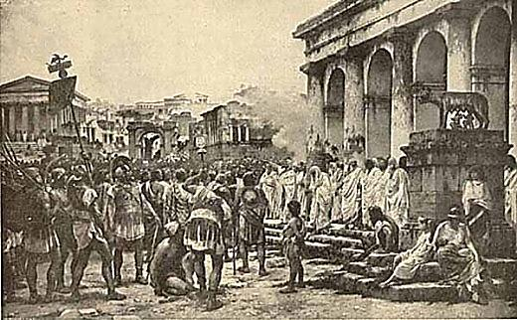

Slavery was indigenous to African and Arab countries before it made its way to Europe. But by the time of Christ, slaves made up an estimated 75 percent of the population in ancient Athens and well over half of the Roman population. Slavery was also widely practiced by many tribes of the American Indians long before Columbus set foot on the shores of the New World. With few exceptions kings, priests, and philosophers approved of it. Aristotle, the influential Greek philosopher, saw it as natural, expedient, and just (Politics 1.1255). Unlike in more recent history when slaves performed only unskilled labour, in ancient Greece slaves not only did all of the menial work but also the work that required skilled labour.

Schmidt -pg 272

Aristotle argued that “a slave is a living, tool ... Therefore there can be no friendship with a slave as slave” (Nichomachean Ethics 8.11).

While some masters were humane, the principle of ownership of a human being allowed many to be brutal.

**THE FIRST ABOLITION - The Bible on slavery**

The seed of Christian anti-slavery is in the tiny biblical book of Philemon. Paul requests of Philemon that he was no longer to treat Onesimus, his former slave, as a slave to be punished for running away but rather to welcome him home as a brother. Paul, a Roman freeman, sets an example by promising to repay anything that is owed (stolen?) by Onesimus. (Philemon 16). This was a small change with explosive potential for disruption, for the economy of Greco-Roman empire was built upon the institution of slavery.

Similarly, he told the Galatian Christians that in Christ we are to regard a person as “neither Jew nor Greek, slave nor free…for you are all one in Christ Jesus” (Galatians 3.28). The culturally ingrained practice of slavery had existed for centuries in the ancient world, so Paul’s words were revolutionary.

“Slaves now communed with masters at the same altar and the same table as one family in Christ. The Philemon and Galatians passages laid the foundations for the abolition of slavery, then and for the future.” Schmidt pg 273

Here is the earliest record of the freeing of slaves after church on Sunday worship. From the *First Apology* by Justin Martyr 150AD

‘On the day called Sunday, all who live in cities or in the country gather together to one place, and the memoirs of the apostles or the writings of the prophets are read, as long as time permits; then when the reader has ceased, the president verbally instructs, and exhorts to the imitation of these good things. Then we all rise together and pray, and, as we before said, when our prayer is ended, bread and wine and water are brought, and the president in like manner offers prayers and thanksgivings, according to his ability, and the people assent, saying Amen; and there is a distribution to each, and a participation of that over which thanks have been given, and to those who are absent a portion is sent by the deacons. And they who are well to do, and willing, give what each thinks fit; and what is collected is deposited with the president, who succors [give assistance to] the orphans and widows, and those who, through sickness or any other cause are in want, *and those who are in bonds*, and the strangers sojourning among us, and in a word takes care of all who are in need. But Sunday is the day on which we all hold our common assembly, because it is the first day on which God, having wrought a change in the darkness and matter, made the world; and Jesus Christ our Saviour on the same day rose from the dead.’

DISCUSS:

* What do you do after church on Sunday? How does it compare?
* Try to imagine – what else realistically could an illegal religion (at that time) have done to influence the institution of slavery? Ideas to try - street protest, buying back slaves, set up escape routes, ...
* The act of conquest was justified by saying ‘we are superior’ or ‘they are less than human’. This is Australia’s ‘original sin’ as Sr Veronica Brady called it. What then do these two biblical passages ask of us here?

**The practise of slavery in early church**

How did this anti-slavery influence work its way through society when Christianity was no longer illegal? Remember, slavery was not just a social structure but an economic institution. Slavery skewed the entire labour market. It did not just affect the slaves but everybody. Why hire a freedman in Ephesus and pay more for their labour when you can buy a slave to do the work in Athens? Then as now, sweatshops of slaves in one country mean that there is low employment of free citizens in the next.

How many slaves were freed during the early years of Christianity can never be known, but that there was many illustrated by W.E.H. Lecky, who says, “St Melania 383-439 was said to have emancipated 8,000 slaves; St. Ovidius, a rich martyr of Gaul, 5,000; Chromatius, a Roman prefect under Diocletian set 1,400 prisoners free; Hermes, a prefect under Trajan, 1,200. [And] many of the Christian clergy at Hippo under the rule of St. Augustine, as well as great numbers of private individuals, freed their slaves as an act of piety.” It is also known that Constantine in A.D. 315, only two years after he issued the Edict of Milan, imposed the death penalty on those who stole children to bring them up as slaves. Schmidt pg 274-275

For instance, in the first half of the sixth century Emperor Justinian built and dedicated the grandest example of Byzantine architecture Ravenna, Italy, the Church of San Vitale, in memory of a martyred slave of fourth century.

-pg 275

Freeing slaves not only took Christian conviction, but it took courage as well. Edicts issued by Roman emperor did not favour liberating slaves. In time, however, an emperor (Justinian, 527-65) arose who was sympathetic to what his fellow Christians were doing. He abolished all laws that prevented freeing slaves. This change, together with the numerous slaves who had already been freed and who still were being liberated, was consistent with what some of the leading theologians had been saying. Early in the fourth century Lactantius (the “Christian Cicero”) in his Divine Institutes said that in God’s eyes there were no slaves. St. Augustine (354-430) saw slavery as the product of sin and as contrary to God’s divine plan (The City of God 19.15). St. Chrysostom, in the fourth century, preached that when Christ came he annulled slavery. He proclaimed that “in Christ Jesus there is no slave… Therefore it is not necessary to have a slave…Buy them, and after you have taught them some skill by which they can maintain themselves, set them free” (Homily 40 on 1 Corinthians 10). These words and actions as well as others had continuing salutary effects. Slavery was also condemned in the fifth century by St. Patrick in Ireland. For several centuries bishops and councils recommended the redemption of captive slaves. And for five centuries the Christian monks redeemed Christian slaves from Moorish servitude. By the twelfth century slaves in Europe were rare, and by the fourteenth century slavery was almost unknown on the Continent.

Schmidt -pg 274-275

**Some Christians condoned slavery**

This change in thinking was not universal. Christians had owned slaves. Even prominent church leaders such as Polycarp, a second-century Christian philosopher. Clement of Alexandria and Origen, both third-century church fathers, spoke approvingly of slavery. Similarly, in the thirteenth century St. Bonaventure saw slavery as a divine institution.

Schmidt -pg 276

**Its important to note both the conviction and the courage that freed slaves in the early churches, whether they themselves were free or not, whether it was legal or not.**

**THE SECOND ABOLITION - SPANISH AND CATHOLIC 16th CENTURY**

While the Spanish military was known for its ill-treatment of Amerindian men and women, Catholic missionaries are credited with championing all efforts to initiate protective laws for the Indians and fought against their enslavement. Within 20 years of the invasion of the New World by Christopher Columbus.

Many know the film THE MISSION (pictured). This tells a story that gave rise to this second abolition. The movie is set In 1750s Paraguay, surrounding the life of Jesuit Father Gabriel. Later, the Spanish Governor (Chuck Low) pronounces the Jesuits' mission the work of Satan for opposing commercial exploitation!  These parallels become more pointed considering the plight of Archbishop Romero and other left-wing priests in '80s Latin America

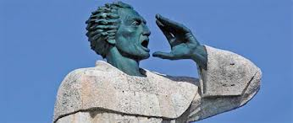The work of the second abolition started well before Fr Gabriel. **Antonio de Montesinos**, a Dominican friar, in 1511 openly rebuked the Spanish rulers of Hispaniola.

Pictured in this statue in the act of preaching, he listed the injustices that the indigenous people were suffering at the hands of the Spanish colonists. The Spanish on the island "are all in mortal sin and live and die in it, because of the cruelty and tyranny they practice among these innocent peoples.”  Montesinos asked those in attendance,

"Tell me by what right of justice do you hold these Indians in such a cruel and horrible servitude? On what authority have you waged such detestable wars against these people who dealt quietly and peacefully on their own lands? Wars in which you have destroyed such an infinite number of them by homicides and slaughters never heard of before. Why do you keep them so oppressed and exhausted, without giving them enough to eat or curing them of the sicknesses they incur from the excessive labor you give them, and they die, or rather you kill them, in order to extract and acquire gold every day."

[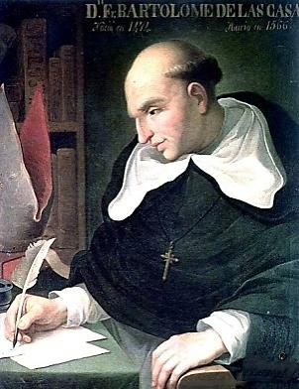](http://upload.wikimedia.org/wikipedia/commons/d/db/Bartolomedelascasas.jpg)The initial result of the protests of the friars at Santo Domingo was an order from [King Ferdinand II](http://en.wikipedia.org/wiki/Ferdinand_II_of_Aragon) that Montesinos and other Dominicans who supported him should be shipped back to Spain. There are two longer term outcomes.

Firstly, back in Spain, they were more able to advocate. King Ferdinand enacted the Laws of Burgos and Valladolid in response to Papal Bulls outlawing the slave trade. Secondly, Montesinos’ moral stand but political failure combined to ignite the faith of others, like **Bartolome Delascas,** *pictured,*upon whom the film THE MISSION was modelled (though he was Dominican not Jesuit). The issue resulted in a crisis of conscience in 16th-century Spain. Further abuses against the Amerindians were denounced by missionaries such as Bartolomé which led to debate on the nature of human rights and **the birth of modern international law**. He became the first resident [Bishop](http://en.wikipedia.org/wiki/Bishop) of [Chiapas](http://en.wikipedia.org/wiki/Chiapas), and the first officially appointed "[Protector of the Indians](http://en.wikipedia.org/wiki/Protector_of_the_Indians)". His extensive writings, the most famous being [*A Short Account of the Destruction of the Indies*](http://en.wikipedia.org/wiki/A_Short_Account_of_the_Destruction_of_the_Indies) and *Historia de Las Indias*, chronicle the first decades of colonization of the [West Indies](http://en.wikipedia.org/wiki/Spanish_West_Indies) and focus particularly on the atrocities committed by the colonizers against the indigenous peoples.

.

**[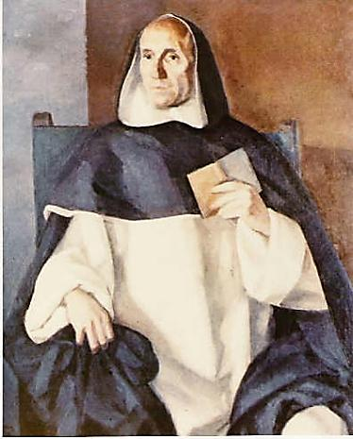](http://upload.wikimedia.org/wikipedia/en/3/39/Francisco_vitoria.jpg)Francisco de Vitoria**, (1483, 1546) was a Spanish [Renaissance](http://en.wikipedia.org/wiki/Renaissance) [Roman Catholic](http://en.wikipedia.org/wiki/Roman_Catholic) [philosopher](http://en.wikipedia.org/wiki/Philosophy), [theologian](http://en.wikipedia.org/wiki/Theology) and jurist, founder of the tradition in [philosophy](http://en.wikipedia.org/wiki/Philosophy) known as the [School of Salamanca](http://en.wikipedia.org/wiki/School_of_Salamanca), noted especially for his contributions to the theory of [just war](http://en.wikipedia.org/wiki/Just_war) and [international law](http://en.wikipedia.org/wiki/International_law). He has in the past been described as ‘the father of international law ‘ along with [Alberico Gentili](http://en.wikipedia.org/wiki/Alberico_Gentili) and [Hugo Grotius](http://en.wikipedia.org/wiki/Hugo_Grotius), to whom we shall turn.

Enforcement of the Spanish and Papal anti-exploitation laws was lax and some historians blame the Church for not doing enough to liberate the Indians. Others point to the Church as the only voice raised on behalf of indigenous peoples. Both are true. The church had already become almost as colonised as the New World, or at the very least tamed before the imperial authorities.

To leap three centuries to mark a significant parallel experience in Western Australia, Rev John Gribble (1847–1893, *his biography and tombstone pictured)* ) was expelled by the colonial and church authorities just as Montesinos was.

In 1884 Gribble a Congregational minister was invited by Bishop Henry Parry of Perth to open a mission on the Gascoyne River. It opened a year later but was strongly opposed by the settlers who enslaved native labour. In 1886 he published *Dark Deeds in a Sunny Land,* which created an almighty furore. In 1887 the mission was wound up and Gribble had to leave. His tombstone in Waverley, Sydney described him as the 'Blackfellows' Friend'. This biography is by a Mandurah pastor, Cavan Brown. The book by John Harris ONE BLOOD gives accounts of many such Christian ministries in Australian history.

 This tradition of the colonial era still operates to this day, though with notable exceptions like Archbishop Oscar Romero, martyred 35 years before the time of writing.

In the case of Abolition Two, it laid the foundation and caused the spark for a European debate about international human rights, to which we will now turn.

**THE GROTIAN MOMENT**

The work of **Hugo Grotius** is so pivotal that his era in Law is known as ‘The Grotian Moment’ . Hugo Grotius (1583 –1645), was a [jurist](http://en.wikipedia.org/wiki/Jurist) in the [Dutch Republic](http://en.wikipedia.org/wiki/Dutch_Republic), who with [Francisco de Vitoria](http://en.wikipedia.org/wiki/Francisco_de_Vitoria) and [Alberico Gentili](http://en.wikipedia.org/wiki/Alberico_Gentili) laid the foundations for [international law](http://en.wikipedia.org/wiki/International_law), based on [natural law](http://en.wikipedia.org/wiki/Natural_law).

Grotius changed the paradigm in international relations. In 1604 he laid the foundation for Intern’l Natural Law and Human Rights including the Law of the High Seas. Without his legal work, providing as basis for law at sea, the Wilberforce arguments for abolition could not have proceeded. We shall return to that work very soon.

[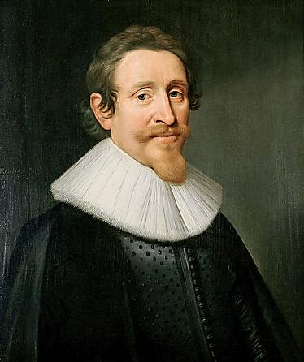](http://upload.wikimedia.org/wikipedia/commons/8/80/Michiel_Jansz_van_Mierevelt_-_Hugo_Grotius.jpg)He was also a [philosopher](http://en.wikipedia.org/wiki/Philosopher), [theologian](http://en.wikipedia.org/wiki/Theologian), [Christian apologist](http://en.wikipedia.org/wiki/Christian_apologist), [playwright](http://en.wikipedia.org/wiki/Playwright), [historiographer](http://en.wikipedia.org/wiki/Historiographer), [poet](http://en.wikipedia.org/wiki/Poet), [statesman](http://en.wiktionary.org/wiki/statesman) and [diplomat](http://en.wikipedia.org/wiki/Diplomat). But it is his legal work that is monumental.

He did two great things.

1.Grotius described the general principles which ought to be the foundation of laws of all nations based on [natural law](http://en.wikipedia.org/wiki/Natural_law), the social nature and natural [reason](http://en.wikipedia.org/wiki/Reason) of man. He saw nature as God's [creation](http://en.wikipedia.org/wiki/Creationism) and sustained by his will, one society of states, governed not by [force](http://en.wikipedia.org/wiki/Force) or [warfare](http://en.wikipedia.org/wiki/Warfare) but by actual laws and mutual agreement to enforce those laws.

You can tell already that he was going to upset some political authorities, can’t you. He was sent to prison and then continued his work ‘in exile’ in Paris. He wrote on both the resort to war and justice in the conduct of war which influenced all *just-war theory* thereafter.

2. His contributions to [Arminian](http://en.wikipedia.org/wiki/Arminian) [theology](http://en.wikipedia.org/wiki/Theology) provided the seeds for [Methodism](http://en.wikipedia.org/wiki/Methodism) and then [Pentecostalism](http://en.wikipedia.org/wiki/Pentecostalism). He was a lawyer so he could argue adequately against the Calvinists who in the majority in the Netherlands. He was not afraid of trouble.

This broad work of codification of legal thought arose from secularizing the principles of a Christian worldview and was indispensable for the global future. Note simply that this codification was inspired by Grotius’ vibrant Christian faith.

In 1609, Grotius wrote one of the most important international legal doctrines  - “[the freedom of the seas](http://en.wikipedia.org/wiki/Freedom_of_the_seas)” which has been the essence and backbone of the modern [law of the sea](http://en.wikipedia.org/wiki/Law_of_the_sea). International legal scholars like [Richard Falk](http://en.wikipedia.org/wiki/Richard_A._Falk) and [Michael Scharf](http://en.wikipedia.org/wiki/Michael_Scharf) talk of the concept of “Grotian Moment”, a (1985) term that denotes a paradigm-shifting development in international law.

As a sincere Christian, Grotius 'secularized' [natural law](http://en.wikipedia.org/wiki/Natural_law). by grounding it solely in the social nature and natural [reason](http://en.wikipedia.org/wiki/Reason) of man. It had a strong impact on the philosophical, theological and political developments of the 17th and 18th centuries. In Grotius' understanding, [nature](http://en.wikipedia.org/wiki/Nature) was not an entity in itself, but God's [creation](http://en.wikipedia.org/wiki/Creationism). Therefore his concept of natural law had a theological foundation.Both biblical [revelation](http://en.wikipedia.org/wiki/Revelation) and natural law originated in God and could therefore not contradict each other

The 'Grotian tradition‘ holds that [states](http://en.wikipedia.org/wiki/Sovereign_state) are bound not only by rules of prudence or expediency but also of [morality](http://en.wikipedia.org/wiki/Morality) and [law](http://en.wikipedia.org/wiki/Law).

He was not the first one to formulate the international society doctrine, but Grotius was the first one to expressly and clearly define the idea of one society of states, governed not by [force](http://en.wikipedia.org/wiki/Force) or [warfare](http://en.wikipedia.org/wiki/Warfare) but by actual laws and mutual agreement to enforce those laws. The Grotian moment secured the legal and philosophical foundations for moral statehood and international law. However it was not to slavery that he was primarily directed in his own time. To we shall make small digression.

Living in the times of the [Eighty Years' War](http://en.wikipedia.org/wiki/Eighty_Years'_War) between [Spain](http://en.wikipedia.org/wiki/Spain) and the Netherlands and the [Thirty Years' War](http://en.wikipedia.org/wiki/Thirty_Years'_War) between the so-called ‘Catholic and Protestant’ European nations (though Catholic France was in the otherwise Protestant camp), it is not surprising that Grotius was deeply concerned with matters of conflicts between nations and religions. His most lasting work, begun in prison and published during his exile in Paris, was a monumental effort to restrain such conflicts on the basis of a broad moral consensus. Grotius wrote:

Fully convinced...that there is a common law among nations, which is valid alike for war and in war, I have had many and weighty reasons for undertaking to write upon the subject. Throughout the Christian world I observed a lack of restraint in relation to war, such as even barbarous races should be ashamed of; I observed that men rush to arms for slight causes, or no cause at all, and that when arms have once been taken up there is no longer any respect for law, divine or human; it is as if, in accordance with a general decree, frenzy had openly been let loose for the committing of all crimes. [*De jure belli ac pacis libri tres*](http://en.wikipedia.org/wiki/De_jure_belli_ac_pacis_libri_tres) (*On the Law of War and Peace: Three books*)

The treatise advances a system of principles of natural law, to be binding on all people and nations regardless of local custom. The work covers justice in the resort to war and justice in the conduct of war. These two aspects remain the foundations for just war theory today.

The way that Grotius conceived of these matters had, together with [Francisco de Vitoria](http://en.wikipedia.org/wiki/Francisco_de_Vitoria)'s *De potestate civili*, a profound influence on the tradition after him and on the later formulation of [international law](http://en.wikipedia.org/wiki/International_law).

Without his legal work, providing as basis for law at sea, the Wilberforce arguments for abolition could not have proceeded. We shall proceed to look at this.

**DISCUSS**

* Did the Church do enough to liberate the Indigenous peoples and slaves?
* What in your view does this mean: ‘ The church had already become almost as colonised as the New World, or at the very least tamed before the imperial authorities.’?

**THE THIRD ABOLITION**

**British and Evangelicals 19th cent**

**The British revival of slavery**

By the fourteenth century slavery had essentially come to an end in Europe, including England, a triumph of a Christianized culture. It was revived in colonial Europe with the complicity of the same church that had already outlawed it. This is scandalous. The work of law reform may be described thus: You slay the dragon, it comes back next year.

In 1548 Pope Paul III had granted to all men, and to the clergy the right to keep slaves (it would not be reversed by Gregory XVI until 1839). The British in the seventeenth century, revived slavery in England’s colonies, as they tried in every way to compete with other European powers and as they tried to emulate the Greco-Roman empires. A London church council decision of 1102, which had outlawed slavery and slave trade, was ignored.

Slaves were transported from Africa to the colonies in the British West Indies as well as to the American colonies and to Canada. International competition meant that the Portuguese and the Spanish also went to Africa to get slaves and then shipped them to their colonies in Brazil, Central America, and parts of South America. We now know that the inhumanity of these transportations is a stain on history.

Their effect was much more widespread than just the slaves themselves:

“The slave trade bred and fed financial greed. It brutalized masters’ and slaves’ lives….The Industrial Revolution was gradually spreading, and the attitudes of the slave traders influenced many owners of mines, factories, and mills in the treatment of their workers. “

Mangalwadi p 260-261

This revival of slavery was all the more lamentable because this time it was implemented by countries commonly identified themselves as Christians. This contradiction deserves study by itself, since it repeats throughout church history – how can such a vicious violation of biblical beliefs have been so conveniently ignored by some Christians? However, other Christians saw slavery as a gross violation of basic Christian values, and before too long some courageous individuals came to the forefront of the battle against slavery.

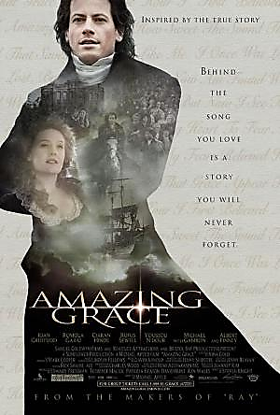

*Wilberforce biographical movie “Amazing Grace” (2012)*

One such courageous abolitionist was **William Wilberforce** (1759-1833) (*pictured above*), a member of England’s House of Commons. As a devout evangelical Christian, he declared:

“The Christian’s motto should be, ‘Watch always, for you know not in what hour the Son of man will come.’ Also ‘Help me, O Jesus, and by Thy spirit cleanse me from my pollutions; give me a deeper abhorrence of sin; let me press forward.’”

His biographer, John Stoughton, says, “He believed in Jesus Christ as the image of the invisible God; he believed that we are saved by grace; he believed in justification by faith; he believed in the work of the Holy Spirit; he believed in the world to come. These beliefs with their practical consequences and applications were as dear to him as life.”

 Sir Walter Scott credited Wilberforce with being the leader of the religious members in Parliament. A gifted orator, he delivered many powerful speeches during his twenty-some years in Parliament against Britain sending slaves to the West Indies. According to his biographer, his speeches were most effective when he “appealed to the Christian consciences of Englishmen.” in 1823, two years before he had to relinquish his seat in the House of Commons because of ill health, he presented a petition to the House of Commons to abolish slavery, a petition that a close associate of his, Thomas Fowell Buxton, moved “as a resolution declaring slavery repugnant to Christianity and the Constitution.” There can be no doubt from these anecdotes that his motivation is Christian and not a political ideology.

It was not until a few days before he died on July 26, 1833, that he received word that Parliament had passed the Abolition act. This act freed 700,000 slaves by England in its West Indies colonies. Upon hearing this good news, he exclaimed, “Thank God that I should have lived to witness a day in which England is willing to give twenty millions sterling for the Abolition of Slavery.”

It is difficult to find a better example than Wilberforce to show the powerful effect the teaching and spirit of Christ have had in fighting the social sin of slavery. No proponent for the abolition of slavery ever accomplished more. Largely as a result of his indefatigable efforts, slavery came to a complete end in all of the British Empire’s possessions by 1840, making it the first modern country to outlaw slavery.   
-pg 276-278

**Similar moves were afoot in the other European powers.** In his 1839 bull *In Supremo Apostolatus*, Pope Gregory XVI condemned all forms of slavery and approved the ordination of native clergy in the face of government racism. Nevertheless some American bishops continued to support slavery for several decades.

Pope Gregory covers the involvement of Christians with slavery through the ages and says of his own time:

 We say with profound sorrow - there were to be found afterwards among the Faithful men who, shamefully blinded by the desire of sordid gain, in lonely and distant countries, did not hesitate to reduce to slavery Indians, negroes and other wretched peoples, or else, by instituting or developing the trade in those who had been made slaves by others, to favour their unworthy practice. Certainly many Roman Pontiffs of glorious memory, Our Predecessors, did not fail, according to the duties of their charge, to blame severely this way of acting as dangerous for the spiritual welfare of those engaged in the traffic and a shame to the Christian name; they foresaw that as a result of this, the infidel peoples would be more and more strengthened in their hatred of the true Religion.”

This affected the north atlantic trade only. Fortunately similar moves were afoot in the other European powers. In 1839 Pope Gregory XVI condemned all forms of slavery and approved the ordination of native clergy and he did so in the face of government racism. Gregory covers the involvement of Christians with slavery through the ages and says of his own time: “We say with profound sorrow - there were to be found afterwards among the Faithful men who, shamefully blinded by the desire of sordid gain, in lonely and distant countries, did not hesitate to reduce to slavery Indians, negroes and other wretched peoples, or else, by instituting or developing the trade in those who had been made slaves by others, to favour their unworthy practice. Certainly many Roman Pontiffs of glorious memory, Our Predecessors, did not fail, according to the duties of their charge, to blame severely this way of acting as dangerous for the spiritual welfare of those engaged in the traffic and a shame to the Christian name; they foresaw that as a result of this, the infidel peoples would be more and more strengthened in their hatred of the true Religion.”

Nevertheless it is 1839 and some American bishops continued to support slavery. Slavery continued in a number of countries for more than a hundred years after it was outlawed in the United States in 1865. Ethiopia had slavery until 1942, Saudi Arabia until 1962, Peru until 1964, and Indian until 1976. All these took their impetus from the work of Wilberforce.

**ABOLITION FOUR – Quakers and The American Civil War**

After the 1833 abolition three in Britain and Europe, the passage of slaves ceased, slaves were freed in British colonies by 1840, but slavery continued in a number of countries, the United States one of them, eventually outlawed by the victory of the Union Army over Confederacy in 1865.

In the usa, many people wanted to abolish slavery.

****Not all the activists were Christian, but many of the leaders and much of the culture saw abolition as a pivotal belief of Xty . Slavery was an institution that seemed so unmovable that its end was unimaginable. But it fell. I want to focus on the *Underground Railroad*, which built up the Abolitionist movement by moving slaves to freedom in Canada. Gradually, the minds of Americans were changed.

(*MAP*) The Underground Railroad was a network of meeting places, secret routes, passageways and safe houses used by slaves in the U.S. to escape to northern states and Canada. By one estimate, 100,000 slaves escaped between 1810 and 1850. Abolitionists determined to free as many slaves as possible, even though it was against the law.

**Established in secrecy around** 1780. George Washington complained in 1786 that one of his runaway slaves was aided by "a society of Quakers, formed for such purposes." Quakers, a short name for a Christian (which was at that time charismatic) a denomination correctly called the Religious Society of Friends, were among the earliest abolition groups. Pennsylvania, where many Quakers lived, was the first state to ban slavery.

Two Quakers, Levi Coffin and his wife Catherine, are believed to have aided over 3,000 slaves to escape over a period of years. For this reason, Levi is sometimes called the president of the Underground Railroad. Their Indiana home is now a National Historic Landmark.

During the Second Great Awakening 1790-1840, a xn revival, you couldn’t become a Christian unless you became an abolitionist. Methodist, Wesleyan, Baptist, and Presbyterian churches grew dramatically though they later divided along north and south lines.

I am not going to pass judgement that some of them resorted to force of arms. The whole country did so soon after. As you know, Abraham Lincoln’s election as President ushered in the politics of the abolitionist cause, not a cause that he had previously been very enthusiastic about. The Civil War was a bloody series of slaughterhouse battles. They won the war and the slaves were freed but did they win the peace? Racism in Confederate states is still a major issue for US police, churches, politics and society.

**ABOLITION FIVE- Coalitions against 21st century human trafficking**

The modern-day slave trade is one of the fastest growing industries in the world, enslaving more than 30 million individuals today. According to the U.S. Department of Health and Human Services, “After drug dealing, trafficking of humans is tied with arms dealing as the second-largest criminal industry in the world.” Combating this $32 billion-dollar-a-year industry takes enormous effort as well as a large framework of diligent abolitionists. Slavery is wrapped up in almost every industry’s supply chain, tainting the food we eat, the clothes we buy and the electronics we love.

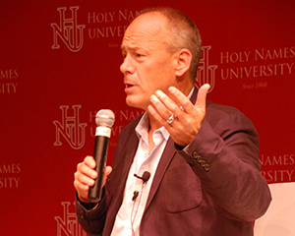

**NOT FOR SALE Campaign for the** Re- abolition of slavery

*Pictured* David Batstone who leads a global coalition of evangelicals and others

FROM <http://www.notforsalecampaign.org/>

<http://www.notforsalecampaign.org/about/> includes Podcast Length 5.49 on David Batstone (pictured)

All businesses have supply chains. Numerous small companies work to provide the cotton in our t-shirts, the metals in our laptops and cellphones, as well as the sugar in our desserts. These raw materials come from all over the world. The businesses selling our t-shirts and chocolate and cell phones rarely know where these raw materials are coming from, or who is assembling the products before their final stages. This lack of transparency allows for unregulated production and many times unsafe or illegal practices in the workplace, including modern day slavery.

Vulnerable people and communities are targeted by recruiters, and traffickers and through deception, fraud and coercion are brought into slavery. While sex trafficking is often at the forefront of our awareness, slave labor and debt bondage are more common. Sometimes entire villages with few economic opportunities are targeted as ideal laborers who do not have other options. Often they will not immediately realize that the small loan they accepted will never be paid off due to the high interest rate charged by the lender. These situations are largely contextualized by a lack of economic empowerment. Identifying these regions and people is critical to stemming the tide of human trafficking.

Awareness of human trafficking has been on the rise over the past few years and it is important to be clear with our definition of slavery. Our definition of slavery is similar to that of the CNN Freedom Project:

Slavery occurs when one person completely controls another person, using violence or the threat of violence, to maintain that control, exploits them economically and they cannot walk away.

The definition of trafficking has 3 main components:

■The action of trafficking; which means the recruitment, transportation, transfer, harboring or receipt of persons

■The means of trafficking; which includes threat of or use of force, deception, coercion, abuse of power or position of vulnerability

■The purpose of trafficking; which is always exploitation. In the words of the Trafficking Protocol, article 3 “exploitation shall include, at a minimum, the exploitation of the prostitution of others or other forms of sexual exploitation, forced labor or services, slavery or practices similar to slavery, servitude or the removal of organs.

More in depth definitions are available from the Trafficking of Victims Protection Act as well as the U.N. Trafficking Protocol.

**CONCLUSION TO STEP THREE**

Both the abolition of slavery and rejection of racial segregation have their roots in the earliest teaching of Christianity. As the great historian Will Durant has shown, Christianity was not segregated religion: “It offered itself without restriction to all individuals, classes, and nations; it was not limited to one people, like Judaism, nor to the freemen of one state, like the official cults of Greece and Rome.”55 and as noted above the early Christians received slaves into the church’s membership and often freed them where they were able to do so. Slaves regularly communed at the same alter with Christians who were not slaves. Receiving and accepting slaves as equals, and having some of them in leadership roles, as in the case of Callistus, says Herbert Workman, was in some instances another reason for persecuting Christians: “Roman governors, conscious of the vast slave populations, were ever anxious lest there should be a servile outbreak.”56  
-pg 289

Now lets skip across seven more specific and highly significant examples across the history

**DISCUSS:**

Why do you think the Christians were opposed to the institution to slavery, undermined it then abolished it?

How can it be that people of the church, Christians, can be blind to this impulse of the faith they hold? The same ‘blindfold’ happened in the massacre of indigenous persons during colonisation in many nations, and during the tragic removal of children from their parents by Christians.

Pope Gregory XVI said: ‘...among the Faithful men who, shamefully blinded by the desire of sordid gain, in lonely and distant countries, did not hesitate to reduce to slavery Indians, negroes and other wretched peoples, or else, by instituting or developing the trade in those who had been made slaves by others, to favour their unworthy practice.’ Is it as simple as saying, as Schmidt often does, that they are not ‘true Christians’ or is there something else happening here? Where do you see that happening today?

**STEP FOUR - 7 THINGS YOU MIGHT TAKE FOR GRANTED**

An infant skeleton found at Yewden Roman villa, 1st to the 4th century, located at Hambleden, Bucks, England. The site has 97 infant burials, the largest number of such burials for any Roman location in Britain. The excavator at the time suspected infanticide "with surreptitious disposal of the bodies."  Numerous other Roman sites tell the same story.

Source: <http://archaeologynewsnetwork.blogspot.com.au/2011/05/infanticide-common-in-roman-empire.html>

**COUNTERING INFANTICIDE**  
One way that Christianity underscored the sanctity of human life was its consistent and active opposition to the widespread pagan practice of infanticide—killing newborn infants, usually soon after birth. Frederic Farrar had noted that “infanticide was infamously universal” among Greeks and Romans dying the early years of Christianity.2 Infants were killed for various reasons. Those born deformed or physically frail were especially prone to being wilfully killed, often by drowning. Some were killed more brutally. For instance, Plutarch (ca. A.D. 46-120) mentions the Carthaginians, who, he says, “offered up their own children, and those who had no children would buy little ones from poor people and cut their throats as if they were so many lambs or young birds; meanwhile the mother stood by without a tear or moan” (*Moralia* 2.171 D). Cicero (106-43 B.C) justified infanticide, at least for the deformed, by citing the ancient Twelve Tables of Roman law which he says that “deformed infants shall be killed” (*De Legibus* 3.8). Even Seneca (4 B.C?- A.D 65), whose moral philosophy was on a higher plane than that of his culture, said “we drown children who at birth are weakly and abnormal” (*De Ira* 1.15).

So common was infanticide that Polybius (205?-118B.C) blamed the population decline of ancient Greece on it (*Histories 6)*. Large families were rare in Greco-Roman society in part because of infanticide. Infant girls were especially vulnerable. For instance, in ancient Greece it was rare for even a wealthy family to raise more than one daughter. An inscription at Delphi reveals that one second-century sample of six hundred families had only one percent who raised two daughters.

Early Christian literature repeatedly condemned infanticide. The *Didache* (written between ca, 85 and 110) enjoins Christians, “ [T]hou shalt not… commit infanticide.”7 one finds infanticide also condemned in the *epistle of Barnabas* (ca. 130) as it comments on the *Didache’s* opposition to this immoral practice.8Callistus of Rome (d ca. 222), a onetime slave who later became bishop of Rome, was equally appalled at this common method of disposing of unwanted infants.

The Christian opposition to infanticide was not only prompted by their seeking to honor one of God’s commandments, “You shall not kill [murder],” but also by their remembering St. Pauls’s words, written to them in Rome shortly before Nero had him executed: “Do not conform any longer to the pattern of this world, but be *transformed* by renewing of your mind. Then you will be able to test and approve of what God’s will is—his good, pleasing and perfect will” (Romans 12:2). There was no way that they would conform to the ungodly practice of infanticide; to do so would have violated their belief in the sanctity of human life. “Infanticide,” said the historian W.E.H. Lecky, “was one of the deepest stains of the ancient civilizations.”

As with infanticide, Christians opposed and condemned the culturally imbedded custom of child abandonment. And …took such human castaways into their homes and adopted them.  
Schmidt -pg 53

The Christian concern for orphans stemmed from the biblical teachings that every human being was precious in the sight of God. For instance, a number of Old Testament books (for example, Exodus, Psalms, Zechariah) clearly state that fatherless children, like widows, were to be honored, protected, and cared for. And similarly in the New Testament, James writes, “Religion that God our Father accepts as pure and faultless is this: to look after orphans…” (James 1:27).

Very early in the church, Justin Martyr (ca 100-166), an early defender of Christanity, revealed that collections were taken during church services to help the orphans (*Apology* 67). Another church father, Tertullian, reports that the church in Carthage, Africa, had a common treasury “to aid the boys and girls who have neither fortune nor parents” (*Apology* 39). In the latter part of the fourth century, *The Apostolic Constitutions* speak about how the Christian bishops solicited help for orphans. And in the sixth, seventh, and eighth centuries, the Italian bishops and clergy “zealously defended widows and orphans.”

Before the legalization of Christianity in A.D. 313. Orphans were reared in family homes. After 313, Christians also cared for many child orphans in *orphannotrophia* (orphans + *trophos* =rearer, nourisher). Infant orphans or newborn foundlings were nurtured and cared for in *brephotrophia*(*brephos*=child). Both of these institutions mark the formal beginning of orphanages, later to become common, especially in the West.  
-Schmidt pg 131-132

Before the Edict of Milan in 313, Christian opposition to infanticide obviously was not able to influence the pagan emperors to outlaw it. But only a half century after Christianity attained legal status, Emperor Valentinian, influenced by Bishop Basil of Caesarea in Cappadocia, formally outlawed infanticide in 374 (*Codex Theodosius* 9.41.1). He also criminalized child abandonment (*Code of Justinian* 8.52.2). He was the first Roman emperor to do so.

Total elimination of infanticide never became a reality, however. Thus, evidence shows that many unwanted infants in many parts of Europe in the Middle Ages and after continued to have their lives ended by their parents. But throughout the centuries the Christian church never wavered in its condemnation of infanticide. And as geographical states developed on the continent of Europe after the fall of the Roman Empire, the Christian influence that prompted Valentinian to outlaw the killing of infants became the norm throughout the West, and anti-infanticide laws in effect in much of the world today. It is one of Christianity’s great legacies.   
Schmidt Pg 51-52

One account in the sixteenth century reveals a priest lamenting that “The latrines resound with the cries of children who have been plunged into them.”  
Schmidt -pg 54

**WOMENS RIGHTS**

By way of even deeper contrast, Christianity was **a haven of equality for women**. <http://www.publicchristianity.com/library/the-place-of-women-in-early-christianity> Women in the early church, Plato, Aristotle, Paul, ‘infested with women’ pace Porphry.

Early Church Fathers advocated against polygamy, abortion, infanticide, child abuse, homosexuality, transvestism, and incest. Although some Christian ideals were adopted by the Roman Empire, there is little evidence to link most of these laws to Church influence. After the Roman Empire adopted Christianity as the official religion, however, the link between Christian teachings and Roman family laws became more clear.

Social structures at the dawn of Christianity in the Roman Empire held that women were inferior to men intellectually and physically and were "naturally dependent". Athenian women were legally classified as children regardless of age and were the "legal property of some man at all stages in her life." Women in the Roman Empire had limited legal rights and could not enter professions. Female infanticide and abortion were practiced by all classes. In family life, men could have "lovers, prostitutes and concubines" but wives who engaged in extramarital affairs were considered guilty of adultery.

**MARRIAGE**

It was not rare for pagan women to be married before the age of puberty and then forced to consummate the marriage with her often much older husband. Husbands could divorce their wives at any time simply by telling the wife to leave; wives did not have a similar ability to divorce their husbands.

For example, Church teaching heavily influenced the legal concept of marriage. During the Gregorian Reform, the Church developed and codified a view of marriage as a sacrament. In a departure from societal norms, Church law required the consent of both parties before a marriage could be performed and established a minimum age for marriage. The elevation of marriage to a sacrament also made the union a binding contract, with dissolutions overseen by Church authorities. Although the Church abandoned tradition to allow women the same rights as men to dissolve a marriage, in practice, when an accusation of infidelity was made, men were granted dissolutions more frequently than women.

According to historian Shulamith Shahar, "[s]ome historians hold that the Church played a considerable part in fostering the inferior status of women in medieval society in general" by providing a "moral justification" for male superiority and by accepting practices such as wife-beating. Despite these laws, some women, particularly abbesses, gained powers that were never available to women in previous Roman or Germanic societies. Although these teachings emboldened secular authorities to give women fewer rights than men, they also helped form the concept of chivalry. Chivalry was influenced by a new Church attitude towards Mary, the mother of Jesus.

 Other areas became issues of the sanctity of each person, including laws on suicide and human sacrifices, abortion and gladiatorial shows*.next slide*

**HUMAN LIFE**

People who today see murder and mass atrocities as immoral may not realize that their beliefs in this regard are largely the result of their having internalized the Christian ethic that holds human life to be sacred. There is no indication that the wanton taking of human life was morally revolting to the ancient Romans. -pg 74 Shmidt

Christians were appalled by the gladiatorial games because they reflected the worst of human morality: gambling with human lives. They saw these shows, like infanticide, child abandonment, and abortion, as flagrant violations of God’s commandment: “You shall not murder” (exodus 20:13). Thus, they condemned and boycotted these bloody contests, and their opposition did not go unnoticed. Minucius Felix 150-270 cites a Roman pagan who strongly criticized the Christians for their anti-gladiatorial posture: “You do not go to our shows; you take no part in our processions… you shrink in horror from our sacred [gladiatorial] games.”

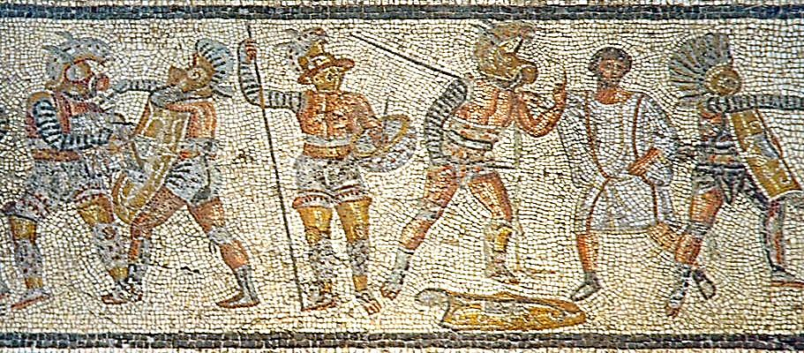The church’s leaders enjoined their members not to attend any of these Roman events. The church father Tertullian (d. ca. 220), in his book *de Spectaculis* (Concerning Shows), devotes an entire chapter to admonishing Christians not to attend gladiatorial contests. In another of his writings, he condemns the gladiatorial shows for shedding human blood and reveals that at these events “the entrails of the very bears, loaded with yet undigested human viscera, are in great request.”

Today the mere thought of the barbaric nature of the gladiatorial games and the fact that for hundreds of years people saw them as highly desired entertainment makes the average human recoil in horror. Such a reaction is powerful proof of Christianity’s great humanitarian influence on the world at large. Most people now recoil at the inhuman features of the gladiatorial shows because they have absorbed Christianity’s view of the sacredness of human life and rejected the pagan philosophy of Stoicism that was so prevalent among the Romans. Stoicism had no compassion for the weak and the oppressed. This view of human beings sheds considerable light on why abortion, infanticide, child abandonment, and delight in seeing helpless gladiators mangled to death were such an integral part of Roman culture.

Whether it was executing Christian martyrs, encouraging or committing suicide, assassinating emperors, or slaughtering gladiators, the Roman conscience was not stirred. Thus, the moral revulsion in regard to the taking of innocent life of humans, on a large or small scale, came about largely as the result of Christianity’s doctrine human life is sacred.   
Schmidt -pg 75

Christianity’s high view of human life and its concern for the weak and oppressed, together with its continual growth and influence, in time moved Christian emperors to ban the gladiatorial contests. “Under the reign of the Christian emperor Theodosius I (378-395), gladiatorial contests were terminated in the East, and his son Honorius ended them in 404 in the West”. (pg 63 Schmidt)

Jerome Carcopino says that “the butcheries of the arena were stopped at the command of Christian emperors.” Similarly, W.E.H. Lecky states, “There is scarcely any single reform so important in the moral history of mankind as the suppression of the gladiatorial shows, a feat that must be almost exclusively ascribed to the Christian church.”

**TRADE UNIONS AND WORKPLACE REFORM**

Christian involvement in the trade union movement is highlighted in four areas: the ‘Tolpuddle martyrs’, Methodist chapels, and the Roman Catholic doctrine of solidarity/subsidiarity.

The Industrial Revolution brought many concerns about the deteriorating working and living conditions of urban workers. Beginning with the Benedictines theology of work in 6-7C, and further influenced by the German Bishop von Ketteler, in 1891 Pope Leo XIII published the encyclical *Rerum Novarum*, which rejected socialism but advocated the regulation of working conditions. *Rerum Novarum* argued for the establishment of a living wage and the right of workers to form trade unions. Meanwhile, Methodists had been arrested and transported for advocating thus in England. The unions’ first branch-meeting were held in the wesleyan ‘chapels’ and so today union branches often carry that name. Socialist took up this cause mote thoroughly than established churches, however, who once again preferred a politically conservative response to biblical humanism.

Forty years later, *Quadragesimo Anno* was issued by Pope Pius XI, in 1931 which explored the ethical implications of the emerging social and economic order. He called for the reconstruction of the social order based on the principle of **solidarity and subsidiarity** . He noted major dangers for human freedom and dignity, arising from unrestrained capitalism and totalitarian communism.

Solidarity is the bond of unity or agreement between individuals, united around a common goal or against a common enemy, such as the unifying principle that defines the labour movement - mutual support within a group.

Subsidiarity holds that government should undertake only those initiatives which exceed the capacity of individuals or private groups acting independently. Functions of government, business, and other secular activities should be as local as possible to those most affected. The principle is based upon the autonomy and dignity of the human individual, and holds that all other forms of society, from the family to the state and the international order, should be in the service of the human person.

Popes Pius XII (r.1939-58) and recently Pope Francis (2014-) have added to this rich seam of social and political commentary. Protestants meanwhile have achieved wide networks, mostly city-based rather than denominationally based, which focus at a more personal level on faith-and-work theologies and practises.

**PRISON REFORM AND PRISONER REHABILITATION**

When Elizabeth Fry in 1813 entered Newgate jail, it was known as London's ''prototype of hell'' . A number of prisoners were held there before transportation to Australia.

*Adapted from an article in January 2013 by Deborah Swiss is a US historian and author of The Tin Ticket: The Heroic Journey of Australia's Convict Women.*

*Read more:*[*http://www.smh.com.au/opinion/politics/hands-off-elizabeth-fry-and-her-hardearned-place-in-history-20130127-2det5.html#ixzz2JK2wjyQF*](http://www.smh.com.au/opinion/politics/hands-off-elizabeth-fry-and-her-hardearned-place-in-history-20130127-2det5.html)

Although her image appears on the British £5 note, I had never heard of Fry until I studied Australia's convict women. Dubbed ''the Angel of the Prisons'', Fry helped orphans and other ''disposable'' citizens. She set up a schoolroom for children imprisoned with their mothers awaiting transportation 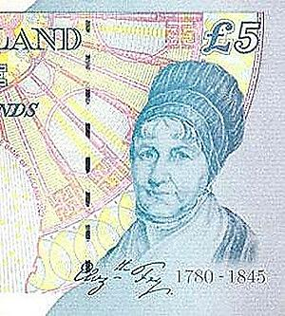to Van Diemen's Land. She dared to break convention by viewing Newgate's chattel as human beings and fanned the hope of a new life once they had served their sentences and were freed in a foreign land.

Fry was the first woman to testify before Parliament, a persuasive abolitionist and humanitarian lobbyist before world leaders, a pioneer in forging new roles for women. She is more relevant today than ever.

Over the course of three decades, Fry and her army of volunteers met nearly 12,000 of the 25,000 convict maids. Her influence crossed the globe as she tenaciously worked to improve conditions for the convict women aboard the transport ships and in Australia. She arranged for matrons to supervise female prisoners in place of the all-male crews, to reduce abuse. She worked to bring education and training into prisons across Europe, with the idea that desperate girls might find redemption as productive and contributing members of society. Ahead of her times, Fry believed that needless cruelty towards the downtrodden only hastened their descent into becoming hardened humans and repeat offenders.

This Quaker minister and mother of 11 demonstrated that one fearless person can change how a society responds to its problems. A distant cousin of Florence Nightingale, Fry trudged through London's slums to vaccinate the poor against smallpox. She set up clothing drives, soup kitchens, and homeless shelters across her city. Understanding that poverty is neither a choice nor a crime, she tirelessly worked to educate women in low-paid jobs, in workhouses, in halfway houses, and in prisons. Fearless and determined, she argued for better treatment of the mentally ill. She spoke for those who had no voice and persuaded Queen Victoria to contribute to her causes - most of which were considered radical for the 19th century.

Fry is a natural for lessons that include Queen Victoria because when older she became a mentor to the young queen. Students beginning to plot their own moral compass, and the world they want to live in, can certainly benefit from critical thinking about what ignites social change and what it takes to be a pioneer in any field. An even more important lesson is heroes come in all shapes, sizes and colours.

Elizabeth Fry touched the lives of everyday people, ordinary citizens who are often ignored for their role in history and in forming a culture. It's disconcerting to admit that we still face so many of the issues Fry first addressed in 1813: homelessness, hungry children, links between poverty and illiteracy, the mentally ill who wander our streets. Yet it's inspiring to consider how much we can affect change with simple acts of compassion: serving as coaches and mentors for at-risk youth; donating our time to homeless shelters; volunteering at schools, libraries, hospitals and nursing homes.

**SOME MORE THINGS WE TAKE FOR GRANTED**

Concepts of humanity, compassion and charity are now taken for granted as ‘normal’ or ‘human’ in post-Christian societies. Their Christian origins arise from the teaching of Jesus (though seldom stated) including the sacredness of each human life, care of orphans, charity for the aged and charitable organisations.

W.E.H. Lecky, who was not a friend of Christianity, once said: “The active, habitual, and detailed charity of private persons, which is such a conspicuous feature in all Christian societies, was scarcely known in antiquity.” -pg 128 Schmidt

Similarly, ...Emperor Julian the Apostate (who reigned from 361 to 363), to lament that the Christians, whom he detested, showed love and compassion, whereas his pagan countrymen did not. Said he: “The impious Galileans [his word for the Christians] relieve both their own poor and ours.” And, he continued, “It is shameful that ours should be so destitute of our assistance” (Epistles of Julian 49). -pg 129 Schmidt

Garrison, a physican and historian, says that before the birth of Christ “the spirit toward sickness and misfortune was not one of compassion, and the credit of ministering to human suffering on an extended scale belongs to Christianity.” The German historian Gerhard Uhlohorn states, “The idea of humanity was wanting in the old world.”

Nor were the Greeks and Romans the only people who had little or no compassion for the indigent. Before the compassionate, humanitarian values of Christianity spread to different parts of the world, the ancient Japanese culture, for instance, resembled that of the Greco-Romans: “The bonzas or Japanese priests, by maintaining that the sick and needy were odious to gods, prevented the rich from relieving them.”

When modern secularists show compassion upon seeing or hearing some human tragedy-for example, massive starvation, earthquake disaster, mass murders—they show that they have unknowingly internalized Christianity’s concept of compassion. Even so-called objective news reporters often find it difficult to hide their emotions when they report major calamities on radio or television. But had these reporters not grown up under the two-thousand-year-old umbrella of Christianity’s compassionate influence, they would probably be without much compassion, similar to the ancient Greeks, Romans, and others. As Josiah Stamp has said, “Christian ideals have permeated society until non-Christians, who claim to live a ‘decent life’ without religion, have forgotten the origin of the very content and context of their ‘decency.’” -pg 131 Schmidt

**CHARITY**

As a social organisation, the church had organised itself to be a giver of charity with compassion, as distinct from ‘cold charity’ or mere liberality and was not pre-occupied with legalistic questions of the ‘deserving poor’.

VIEW AND DISCUSS

https://publicchristianity.org/library/life-and-faith-christianitys-legacy-part-ii Audio July 11, 2012. What has Christianity ever done for the world? We look at the rise of science and the values of charity, service, and humility as key contributions that Christianity has made to the contemporary world. DO YOU AGREE?

THE WORDS OF JESUS

For I was hungry and you gave me something to eat, I was thirsty and you gave me something to drink, I was a stranger and you invited me in, I needed clothes and you clothed me, I was sick and you looked after me, I was in prison and you came to visit me” (Mathew 25:35-36).

These words of Christ, along with the parable of Good Samaritan (Luke 10:30-37), the almsgiving practiced in Hebrew synagogues and the Old Testament law which allowed the poor to glean the remainders after a harvest in the fields, all made a profound impression on the minds of early Christians, and they diligently sought to emulate these practices. We have heard already of the offerings taken to free slaves. There is much more.

Tertullian (d. ca. 220), the Latin church father in northern Africa, informs us that the early Christians had a common fund to which they gave voluntarily, without any compulsion, on a given day of the month or whenever they wished to contribute (Apology 39). This fund supported widows, the physically disabled, needy orphans, the sick, prisoners incarcerated for their Christian faith, and teachers requiring help; it provided burials for poor people and sometimes funds for the release of slaves. Historian W.E.H. Lecky says that every Christian was expected to give one-tenth of his income to charity. How many gave 10 percent is not known, but it is known that they gave generously.

-pg 125-126 Schmidt

CHARITY VERSUS LIBERALITY

Christian charity differed profoundly from that of Greco-Romans. The early Christians practiced caritas as opposed to the liberalitas of the Romans. Caritas meant giving to relieve the recipient’s economic or physical distress without expecting anything in return, whereas liberalitas meant giving to please the recipient, who later would bestow a favouur on the giver. For centuries the Roman pagans practiced liberalitas, not caritas. Only in extremely rare instances did some of the Romans give without expecting something in return. It was usually the most honorable, those who really did not need help, who received “all or most of the charity dispensed.”

-pg 126 Schmidt

These New Testament words provided the motive and direction for Christian charity, whether it was collecting money for the poor and starving or nursing the sick and dying. Thus Cyril, the bishop of Jerusalem (fourth century), “sold treasures and ornaments of the church for the relief of starving people, [and] Ethelwold, bishop of Winchester [tenth century] sold all of the gold and silver vessels of his cathedral to relieve the poor who were starved during a famine.” In doing so, he said, “There is no reason the temples of God should abound in riches, while the living temples of the Holy Ghost starve for hunger.” Christopher Dawson, speaking of early Christianity, writes: “Every church had its matriculum, or list of persons in receipt of relief, and enormous sums were spent in every kind of charitable work.”

There was still another difference between the pagans and the Christians with regard to charity. The Christians helped and gave to everyone in need. St Paul’s admonition to the church in Phillippi (noted above) made it clear that charity was to be given to all, Christian and pagan alike. A late first-century Christians document, the Didache, urged: “Give to everyone who asks thee, do not refuse.” Similarly, The Shepherd of Hermas, an early second-century epistle, enjoins all Christians: “Give simply to all without asking doubtfully to whom you give, but give to all.”

-pg 126-127 Schmidt

Finally, Christian charity was completely voluntary. According to the Roman culture of that era, such behaviour defied common sense; it was seen as a sign of weakness and was viewed with suspicion. There was nothing to be gained by expending time and energy, even if voluntary, with people who could not contribute to Roman valour and to the strength of the state. The prevalence of Stoic philosophy made it disrespectful to associate with the weak, the poor, and the downtrodden. To Christians, however, the individual, regardless of his social or economic status, was valuable because he possessed a soul redeemed by Jesus Christ. Thus, the difference between Christian and Roman charity in regard to motivation and practice were profound.

-pg 127 Schmidt

CHARITY FOR THE AGED

While care one’s aging parents is common in every culture, the care of those who have no family who have the capacity to care is not common. In the New Testament, such a care for ‘orphans and widows’ is a test case for genuine faith (James 1.27). From the early days of the church, this need was taken up.

At …the time of Emperor Justinian (483-565), churches were operating homes for the aged called gerontocomia (geras = aged + comeo = take care of).

pg 135

One finds no evidence of homes for the aged in years preceding Christianity. Given the absence of such homes, it is sometimes argued that homes for the aged were not needed in ancient times or in preliterate societies because the aged were highly respected and adequately cared for by respective families. But whether this was ever really so is doubtful. As Richard Posner has shown, “The Social status of the old has varied bewilderingly across different cultures and eras, and even within them.”29 Moreover, even when the elderly have relatively high status, as for instance among the Herero of Botswana, it does not necessarily result in their being adequately cared for when they are alone, frail, or ailing.30And it needs to be remembered that some research shows that “the poorer a society is, the more likely it will be to kill or let die its oldest members.”31

-pg 135

People today take these facilities for granted. Yet they all bear the compassionate marks of Jesus Christ.

-pg 136

DISCUSS

• “Those belonging to Christian churches also give more financially to non-church charities, and they give a higher proportion of their income to such charities.” Schmidt refers to surveys in the USA, and the same has been found in Australia in official surveys by the Australian Bureau of Statistics. Where 37% of the general public participate in voluntary activities, it is 57% of church attenders including around 90% of the Uniting Church. This is counter to the popular idea of church as a more or less ‘closed clubhouse’. How does this fact strike you? surprise you? What does it say to you about Christian influence?

• “Almost all the charity groups, ethnic societies, and service groups were begun or organized by concerned Christians from various denominations, …these organizations have all been touched by the pervasive tradition of Christian compassion. “ -pg 139 Schmidt

* Do you agree with this claim that the direction of influence is that non-Christians have been touched ethically by Christian examples of compassion such that they have become the ‘new normal’ in post-Christian societies?

**TRUTH AND RECONCILIATION - Restorative Justice in action**

What is **Restorative Justice** in the criminal system? Length 3.16 Published on 27 Jul 2012

<http://www.youtube.com/watch?v=sE8TDzlR2tg>

DISCUSS: Is this what you think is meant by the word “justice”is?

**BIBLICAL BASIS FOR RECONCILIATION**

* Jesus upsets everyone by teaching that Samaritans are role-models Luke 10
* The early church established reconciliation and compromise within the very raw controversy over Jew:Gentile conflicts Acts 10-11, Ephesians and Galatians
* Reconciliation is described a s a gospel ministry 2 Cor 5, Rev 21
* Principles for conflict resolution are enshrined in Matthew 18.10-17

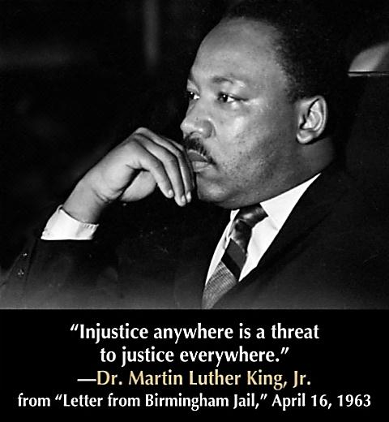

DISCUSS: Here are three names in recent history that show that Christians have been involved in leadership in the work of reconciliation? Google them to find out more. The first two are world famous. The third not so famous is Australian.

From the United States [Martin Luther King Jnr](http://en.wikipedia.org/wiki/Martin_Luther_King_Jr.)

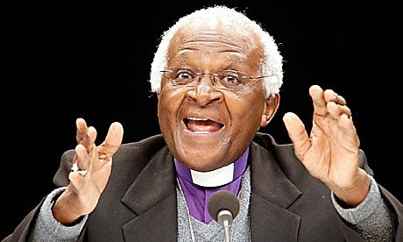

From South Africa [Desmond Tutu](http://en.wikipedia.org/wiki/Desmond_Tutu)

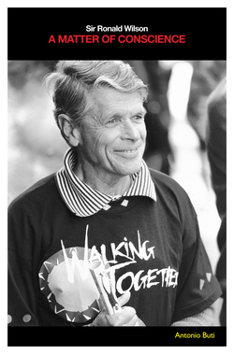

In Australia Sir [Ronald Wilson,](http://en.wikipedia.org/wiki/Ronald_Wilson) was the Human Rights Commissioner who co-presided over the investigation and publication of the [Bringing Them Home Report 1989](https://www.humanrights.gov.au/publications/bringing-them-home-report-1997). This report chronicled the appalling history of the legalised removal of aboriginal children from their families 1905-1977. A sincere Christian, Wilson had once been the moderator (top position) of the Presbyterian Church which had run one of the missions that received those children, so he was personally implicated. The enquiry stopped hearings from children whose removal was before 1977, just to set an end-date to the scope of the enquiry. It is often quoted in such a way as to suggest that removals had stopped then but a brief chat with Aboriginal families today will show that the practise continues.

**DISCUSS**

Research their lives and discuss -what did their Christianity had to do with it?

**HOW - DO YOU DO RESTORATIVE JUSTICE?**

Restorative Practices to Resolve Conflict/Build Relationships - a TED Talk Length 18.20

Published on 10 Jun 2013 http://www.youtube.com/watch?v=wcLuVeHlrSs

Katy Hutchison became a Restorative Justice advocate following the murder of her first husband. After ten years of sharing her story internationally to over five hundred schools and community groups, she views the education system as the structure with the most potential to affect positive social change. Katy sits on the Boards of Restorative Practices International & Glenlyon Norfolk School and volunteers for Leave Out Violence (LOVE).

**WHY - THE IMPORTANCE OF TRUTH AND RECONCILIATION COMMISSIONS**

VIEW AND DISCUSS

Published on 8 Nov 2012 Length 2.26.

http://www.youtube.com/watch?v=thefAVqR26E

Emory University religion professor Thee Smith discusses what truth and reconciliation commissions are, why they have emerged, how they differ from other forms of justice and why they're important

FROM http://en.wikipedia.org/wiki/Truth_and_reconciliation_commission

A truth commission or truth and reconciliation commission is a commission tasked with discovering and revealing past wrongdoing by a government (or, depending on the circumstances, non-state actors also), in the hope of resolving conflict left over from the past. They are, under various names, occasionally set up by states emerging from periods of internal unrest, civil war, or dictatorship. South Africa's Truth and Reconciliation Commission, established by President Nelson Mandela and chaired by Desmond Tutu after apartheid, is popularly considered a model of truth commissions.

As government reports, they can provide proof against historical revisionism of state terrorism and other crimes and human rights abuses.

Truth commissions are sometimes criticised for allowing crimes to go unpunished, and creating impunity for serious human rights abusers. Their roles and abilities in this respect depend on their mandates, which vary widely. Often, there is a public mandate to bring past human rights violators to justice, though in some cases (such as Argentina after 1983 and Chile after 1990), abuses of human rights have gone unpunished under truth commissions due to threats of antidemocratic coups by the powerful parties who endure in the military. In this sense, the militaries in question, having ceded control to a civilian government, insist that the "price" of ending their own military rule must be full impunity for any of their past abuses. In some cases, such as the "Full Stop" law of Argentina that prevented prosecution of officers of the military junta, this impunity has been enshrined in law under the civilian government.

To follow the T&R Commission, in 2000 The Institute for Justice and Reconciliation (IJR) was established as a non-governmental organisation and think tank based in Cape Town, South Africa. The aim was to ensure that lessons learnt from South Africa’s transition from apartheid to democracy were taken into account as the nation moved ahead. Patron of the IJR is Archbishop Emeritus Desmond Tutu. Today, the Institute’s vision is to build fair, democratic and inclusive societies in Africa. Through carefully selected engagements and interventions, the IJR seeks to shape national approaches to transitional justice and reconciliation in Africa by drawing on community intelligence as well as macro-trend research and comparative analysis.

CASE STUDY IN RECONCILIATION

Musalaha, Reconciliation Ministry , Founded 1990, Jerusalem

Headquarters Jerusalem . Key people Dr. Salim J. Munayer, Director

Website www.musalaha.org

Musalaha (Hebrew: מוסאלחה, Arabic: مصالحة) is a non-profit organization that works towards reconciliation between Israelis and Palestinians based on the Biblical principles of peace, justice, and love. The name Musalaha comes from the Arabic word for 'reconciliation'. The mission statement from their official website states:

"Musalaha is a non-profit organization that seeks to promote reconciliation between Israelis and Palestinians as demonstrated in the life and teaching of Jesus. We seek to be an encouragement and facilitator of reconciliation, first among Palestinian Christians and Messianic Israelis, and then beyond to our respective communities."

It also states that Musalaha seeks "to facilitate bridge building among different segments of the Israeli and Palestinian societies according to biblical reconciliation principles."

Musalaha partners with a number of different organization around the world, such as Reconciliation Ministries in the United States, and Amzi in Germany and Switzerland, as well with local Palestinian and Israeli organizations. Musalaha's Board members are all Messianic Jewish Israeli and Palestinian Christian leaders in Israel and the Palestinian Territories

CASE STUDY: Bethel University, Founded 2004, Minnesota

http://en.wikipedia.org/wiki/Bethel_University_(Minnesota)

Over the last decade Bethel University has embraced a call to Biblical Reconciliation. The ministry of reconciliation is dedicated to breaking down social divisions and barriers in order to bring people together, encouraging them to embrace their common bond of humanity rather than emphasizing the differences between them. In the case of Bethel this especially refers to the idea of racial reconciliation. Initially, the push toward reconciliation arose as a reaction to racially charged incidents that happened in the 2002–2003 school year. Since that time Bethel University has made great strides towards reconciliation. These include creating a Major in Reconciliation Studies housed in the Department of Anthropology and Sociology. Additionally, the University has created the Bethel Anti-Racism and Reconciliation Commission (BAARC) using materials and processes developed by the Minnesota Collaborative Anti-Racism Initiative(MCARI). The University has also sought to emphasize this issue through its core value statements, describing the biblical qualities of disciples of Jesus. The seventh of the core values reads:

"We are reconcilers— honoring the worth and dignity of people from all races and purposely seeking to create a community that reflects the diversity of the Body of Christ."

**CONCLUSION**

**Those eight specific examples of creative courageous Christian leadership are well documented.**

**DISCUSS**

* Where have you been involved in the work of reconciliation , either as an individual acting in the world or as a part of a team of people?
* Describe why you became involved in that action and why you remained involved (If you did)?

.

**STEP FIVE**

**THE CHURCH’S FOUR GREAT CORRUPTIONS**

 I have to admit that although I am trying to minimise the pain for myself here, each one genuinely tears at my heart and soul all over again. The church’s moral strength becomes a weakness when it is aligned with racial privilege or power. In that regard it no different from any other social organisation. What is **more** corrupt about the church’s failings is its high moral commitments and sometimes fraudulent claims

The ethics of Christianity have not always been followed by Christians or by the church. Sometimes the church has done the completely wrong thing. So which is the ‘real’ church – the good guys or the bad guys?

Christians often claim that where the church had a positive influence it keen be seen that they were following directly the teachings of Jesus Christ - to care for the neighbour ‘as much as you love yourself’. Christian ethics involve a care of the whole person and not just their soul, generous hospitality and a clear politics of social solidarity with the poor, the sick, and the prisoner (Matt 25).

Where its influence was negative, it is said, it was not following those teachings but acting out of a tribal fear of others , a desire to maintain its social privileges - following a prevailing philosophy which was divorced from Jesus’ teachings. In these cases, reform later arrived in the form of a small courageous group or person who remembered. Very often they were Christians.

“Never doubt that a small group of thoughtful, committed citizens can change the world; indeed, it's the only thing that ever has.” [**Margaret Mead**](http://www.brainyquote.com/quotes/authors/m/margaret_mead.html) 1917-78

Nevertheless, it was done by the church, visible or invisible, sincere or fraudulent, corrupt or pure does not matter the victims. . We must simply admit it.

**DISCUSS**

Is this a time when you should be more vitally involved in the reform of the church or instutiutions of power? Why or why not?

There is plenty to do. I am sorry to say, I need to list the following acts of corruption by the church

I used to visit many churches as a visiting encourager and consultant. They all thought of themselves as quite good at the welcome and inclusion of all kinds of people. If you are on the inside it is quite loving. But they were usually culture-bound and could not see their own exclusionary habits. Various surveys have often but not always identified social bias towards younger persons, males, gays or the uneducated. Though people of almost every race on earth can be found to be Christian, they do not often meet together.

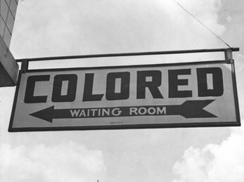 *“It is appalling that the most segregated hour of Christian America is eleven o’clock on Sunday morning” – Martin Luther King Jr*

**DISCUSS**

Is this like your church, if you have one?

The church’s claimed moral force easily lets them down when it is aligned with social conservatism or communism. Christians in politics are often a disapointment in the churches - with their speeches full of the party-line, rarely capable of being able to reflect upon anything else, maybe espousing a occasional general moral principle and one or two specific demands that the government should reinforce their view of morality, even though governments can only make laws.

Therefore they have often been domineering, marginalising the weak and - in terms of the teachings of Jesus – corrupted by power and self -interest. They are not the only ones who do this.

DISCUSS

* You may have heard the quote: ‘absolute power corrupts absolutely’ . It is an elegant polemic, a truth somewhat over-stated; for the same corruptions accompany any other social organisation. But it still states a sombre truth about the church as a SPIRITUAL organization. Why are church moral corruptions so especially hurtful?
* The church’s failings echo their high moral calling. This goes beyond situations where a rude word said in jest or a minister gets caught in a brothel or in a bottle or embezzlement. How do these public sins affect local communities?

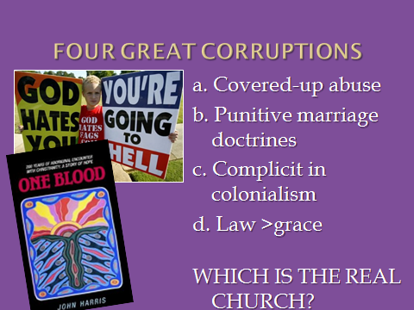

There is much worse to be named. These are my short list of the four great corruptions of the church in relation to its role ion the Law:

a. Covered-up abuse

b. Punitive marriage doctrines

c. Complicit in colonialism

d. Tradition > scripture

1. COVERED UP ABUSE

In recent days the Royal Commission into Institutional; responses to child sexual abuse, 2-4% of Roman Catholic clergy in those organisations have been found to be corrupt, which is thought to be slightly higher than the general average. Commentators have quickly run to the potential influence of celibacy. That is not the most important finding. Widespread abuse and the covering up of child sexual abuse have been reported in many different kinds of organisation, religious and non-religious. It seems too much to ask but slow careful debate is needed. One church in Sydney where many children were abused was recently burnt to the ground.

Here is the website for all the news: <http://www.childabuseroyalcommission.gov.au/>

We might to some degree applaud the church’s historic commitment to child care and adoption, when the alternative as we see in other parts of the world, is prostitution and destitution. But we know there has been an abuse of children, a failure of duty of care. It is not only the fact of abuse happening but the sustained non-belief, devaluation and silencing of their stories as they began to face their need for healing.

Most of us are glad the truth is out, the victims are recognised, whatever the cost in moral credibility and finance for compensation. The church will need at least a half a century of apology and humility to redress these wounds. We shake our heads in disbelief, while knowing it is true. Clergy are collectively ashamed of their colleagues, which inhibits dramatically their vital and difficult community role, often going where angels fear to tread. Their denominations have enacted Codes of Ethics to prevent the future repeat of these slippery slides into corruption. An analogy can be seen in the police who move from involvement in a world of crime to involvement in crime. At this point it is hard to see how they can publically restore the credibility of child-care institutions and of clergy of any kind.

But that is only one of several great corruptions. I think of three more.

B. PUNITIVE MARRIAGE DOCTRINE

Though the churches do well in their doctrine of equality in marriage, resisting the over-emphasis on romance and the commodifying of sex, it has also at times been **punitive** (using shame = no hope for change) in some marriage and sex related doctrines - illegitimacy, homosexuality, abortion and birth control arguments, and even punitive with divorce as a life sentence. Similarly, it has acted to suppress women’s rights and opportunities and remained patriarchal like all the rest despite Jesus’ championing of women’s rights.

Fundamentally, it confuses civil structures with moral structures, as though the church owned the institution when in fact the bible does not maintain one unambiguous social structure for marriage. The fallacy leads to the belief that if you do not keep *our rules* then you are immoral, when in reality there are several ethical positions with strong moral bases.

The churches’ interest is justified by the biblical importance of coupling, complicated as it is by the wants of lust, the needs of children and the social impact upon young identities. It is further complicated by a host of unreliable claims, the technology of contraception, and the tragedy of abortion which have separated sexuality from family and spirituality. In all that confusion, punitive reactions are not justified.

c. COMPLICIT IN COLONIALISM

Though bringing good service to the health and education of the poor, the church has been **complicit in colonialism** and its many atrocities. The church has benefitted from or even condoned thefts of land, acts of genocide like the legalised removal of children and in other aspects of the destruction of culture and families. Yes, they really did. Here is an article about a movie “The Mission” from 1986, which does represent (loosely, it’s only a movie) the level of corruption carried out by the church in many parts of the world, both Catholic and Protestant.

<https://en.wikipedia.org/wiki/The_Mission_(1986_film)> Watch the movie if you can.

Australia saw significant use of social-Darwinism ( a social theory not espoused by Darwin , but deriving a concept from ‘survival of the fittest’, that a stronger race ought to overcome the weaker in the cause of biological improvement of the race) to justify the colonial enterprise , even in the face of degrading and violent behaviour towards Aboriginal peoples. Good church folk participated in these atrocities and today’s Australians are the wealthy beneficiaries. This is not controversial or disputed, it is a matter of record. See this article that surveys its spread:

<https://en.wikipedia.org/wiki/Social_Darwinism>

Conservatives today who tend to trust the government are loathe to hear this but in colonial countries the Law has been used as sword or a club to justify the interests of a few over the many. What is more, it is still going on, e.g. 2013 Collard Case. when the first page of the judge’s determination showed that it was going to be a re-run of colonial bias.

<http://www.abc.net.au/news/2013-12-20/stolen-generations-test-case-dismissed-in-wa-court/5169640>

To be honest, clergy who opposed the force of colonialism were routinely expelled by their churches (e.g. Las Casas in the Americas, John Gribble in Western Australia).

Case Study: JOHN GRIBBLE (1847–1893)

*This article was published in Australian Dictionary of Biography, Volume 4, (MUP), 1972*

John Brown Gribble (1847-1893), missionary, was born on 1 September 1847 at Redruth, Cornwall, England, son of Benjamin Gribble, miner, and his wife Mary, née Brown. He arrived at Port Phillip in 1848 with his parents. They settled at Geelong where John was educated and on 4 February 1868 married Mary Ann Elizabeth Bulmer.

****In October 1876 Gribble was admitted to the ministry of the United Free Methodist Church, but soon joined the Congregational Union of Victoria and became a home missionary at Rutherglen and Wahgunyah near the Murray River. His travels took him into the Riverina where he preached at Jerilderie, became its first resident missionary, had an encounter with the Kelly gang and made contact with the remnants of Aboriginal tribes. In 1879 he visited Maloga mission on the Murray, toured the Murrumbidgee with Daniel Matthews, at Jerilderie published A Plea for the Aborigines of New South Wales, and with £6 15s. and the help of his wife opened the Warangesdah Aboriginal Mission at Darlington Point. They built huts, dormitories and a church and made several converts. In 1880 the mission received a government grant and was visited by Bishop Mesac Thomas, of Goulburn, who baptized nineteen Aborigines and decided to sponsor the mission. Gribble was made a stipendiary reader that year, deacon in 1881 and priest in 1883. With help from the government, diocese and Aborigines Protection Association the mission prospered but the costs rose to £1200. In 1883 a report on Warangesdah by the protector of Aborigines provoked a government inquiry which led to the reform of the Aborigines Protection Board.

In 1884 Gribble was invited by Bishop Henry Parry of Perth to work in Western Australia and went to England where he raised funds and published Black but Comely, a description of Aboriginal life in Australia. In 1885 he opened a mission on the Gascoyne River but was strongly opposed by settlers who exploited native labour. In 1886 he published *Dark Deeds in a Sunny Land*: this fierce castigation of his opponents created a furore and the welfare of the Aborigines was obscured by much blackening of reputations until 1905. In 1887 the mission was abandoned and Gribble returned to New South Wales where he opened a mission on the Darling River for the Aborigines Protection Association. In 1889-90 he was rector of Temora where he built the first church; after losing all his belongings when the rectory was burnt down he became rector at Batlow. In both parishes he continued to devote much time to the Aborigines. In 1892 he went to Queensland to open Yarrabah mission near Cairns. Suffering from malaria he retired to Sydney where he died on 3 June 1893. His tombstone in the Waverley cemetery described him as the 'Blackfellows' Friend'. He was survived by his wife, four sons and five daughters.

There are other accounts of positive interaction between church and Aboriginal nations as recounted in John Harris’ book *One Blood* (pictured). And there is more in the study series preceding this one “What is the Church?” available from Makesyouwonder.yolasite.com

But the link with Colonialism has been a great heresy from which arose a great atrocity whose effects are felt in each Aboriginal person’s flesh every day. .

D. TRADITION vs SCRIPTURE

Though acting to brake some laissez-faire measures, conservatives have habitually described the recent past of their grandmothers as some kind of **sacred tradition** that deserves privileged status over all other views and even earlier traditions. To do this they have **codified parts of scripture** **as timeless law** that were not written as such and may legitimately be taken as community-ethics of the time. To maintain that stance they have falsely excluded and ungraciously pilloried all other viewpoints as non-Christian or non-biblical. E.g. safe injecting rooms.

These all boil down to the elevation of clergy-privilege or temporal power at the expense of the very commands of Jesus, the head of the church, to follow him in care for the poorest. Mark 7.8 shows Jesus opposition to this practise. Thus, it is not ‘the church’ that has contributed so fully but the persons who adhered to the biblical shape of the gospel of Jesus. He is the epicentre of all this, as the gospel says ‘full of grace and truth’, It is to his credit that these things have taken place. The latter have succeeded from time to time in reforming or renewing the former. This remains my burning hope.

HOW CAN IT BE?

Sometimes the church has done the completely wrong thing. So do you ask - which is the ‘real’ church – the good guys or the bad guys?

It seems from this survey that where the church had positive influence it was following directly the teachings of Jesus Christ to care for the neighbour ‘as much as you love yourself’. This bases Christian ethics on care of the whole person and not just their soul, generous hospitality and a politics of humble servant rulers, and social solidarity with poor, the sick, and the prisoner (Matt 25). This is the adventurous Jesus-breathing church.

Where its influence was negative, it was acting out of fear of others or a desire to maintain privileges or following a prevailing philosophy that was already divorced from those teachings. It wasn’t even “the church” it was “fearful and privileged church”, or “unaccountable church”.

In many of these cases, reform arrived in a courageous person who remembered. The Church can shift into gear. Christians have a way of self-correcting from **corruption** and resilient from change. So, in the meanwhile, we have to stay in the conversation or become a sect.

 As a clergyman of the church, with some kind of responsibility for the conduct of the church, I apologise. To church persons, I hope that we can see it and learn deeply enough. To all of us I say that it is not over yet. But we cant wait around until we sort it all out. Other needs are more pressing right now.

People are entitled to ask the church how good in practise is the gospel really? The most important lesson from this is – tell me who is NOT a hypocrite, that is, who does not fail their own standards let alone any higher ideals? Human failures at every level become a systemic practise in unions, universities, families, professions and churches. So this is not just about human failures, not just about institutional behaviour, but the nature of humanity. Who can we ever trust if everyone is sometimes untrustworthy? A question for another time.

The good news is that the gospel is not about joining the church but connecting and following Jesus. The church is not supposed to emulate the great days of the church (whatever and wherever you imagine that is) but to emulate the humble ways of Jesus.

**STEP SIX**

**CAN CHRISTIANITY BE GOOD NEWS FOR THE LAW?**

Where can we go from today? Several ripe openings for close collaboration today, including four ways the Law can be good for the church.

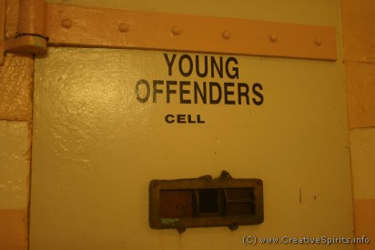

Can I say - someone within the Law, which I am not, would state these differently. I really hope you do. Please please DO this work for us all.

Meanwhile , here is my hot list of good collaborations from the point of view of church then vice versa.

* **Re-abolition of slavery**, THE NOT FOR SALE campaign.

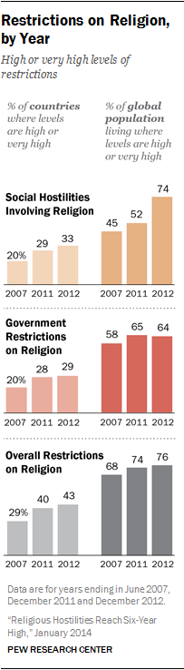

* More **prison reform** - build communities not prisons
* International advocacy of **human rights** including religious freedom, refugees WELCOME, LOVE FINDS A WAY (recent arrests). Speak against the rhetoric of “illegal refugees”.
* Oppose mandatory **sentencing**, support wholistic sentencing.
* The real nature of **property** law as stewardship not possession.
* Religion as an aid to **peace-making** (works in neighbourhoods). TBFF. Good Friday Peace Accord 1998 *(pictured)*
* The Church can shift into gear. Christians have a way of self-correcting from **corruption** – repentance, humility, identity, charity, dedication, without the inertia of Stoic or Buddhist detachment.





*Good Friday Peace Accord,*

*Northern Ireland 1998*

**CAN THE LAW BE GOOD FOR THE CHURCH?**

**How may the church benefit from staying in the conversation with law?** I see four immediate ways.

* 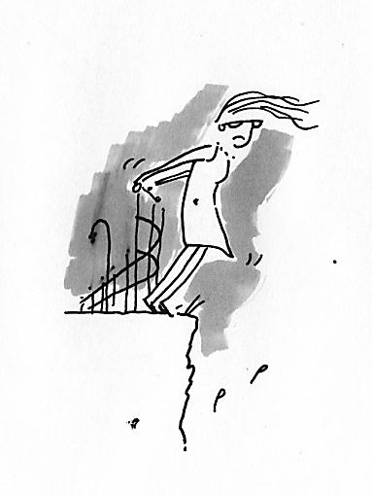Church public statements earn little respect unless they move from getting out in **protest** to getting involved in the **process of change**. This is often long term, more complex than slogans, and requires different skills in leadership, teaching and management.
* The church can do with **more Pro bono** high-commitment pro-active legal involvement in particular issues. If we learn the art of case-management of issues, it could release pro-bono workers before they are worn out by the churches’ habit of making every event a lofty talking matter.
* Enforce **religious freedom** both ways.

See: Exclusion or Saturation? Rethinking the Place of Religion in Public Life

Miroslav Volf ABC RELIGION AND ETHICS 11 MAR 2014

Many kinds of political arrangements are compatible with christianity. But in a pluralistic context, christians must grant other religious communities the same freedoms that they claim for themselves.

http://www.abc.net.au/religion/articles/2014/03/11/3960854.htm

Form a policy ‘position for now” rather than an ethical law for all time. Liberalism can be cruel when it is ‘sink or swim’ , or ‘wait and see’ and charity can become cold. Social justice means building **legal ‘fences at the top of the cliff’**

**CONSTANT TENSIONS**

I think on some aspects of these issues there is no answer just navigation or balance, all six of these in current debate as they should be:

1.I will call this one Conscientious Objection, not as ‘a safe course of action’, but sometimes as the hardest action e.g. the jailing or execution of objectors during ww1 ; Dietrich Bonhoeffer and the plot to assassinate Adolf Hitler. This past few months over a hundred Christians have been arrested in sit ins in senior politicians offices over children in detention. Anglican, Baptist, Pentecostal, Uniting, Salvation Army, and others.

2. The serpentine issue of the separation of church and state. Australia is not like the US nor the UK. Secularity in natural law, kingdom ethics etc

3. Religious freedom as a civil responsibility – cuts both ways, conscience in commerce?, current report from Pew

4. Vilification, free speech, blasphemy – what is provocative, constructive, fair-dealing e.g. currently in Parliament.

5. Competing versions of Justice - – restorative, punitive, distributive, equal opportunity, no advantage, other?

Did I say six?

6. A sixth tension about the meaning of ‘secular’

* There are three kinds of secular. I want to ask you to do them differently.
  + ‘public life is free from all religion’
  + ‘public life does not establish any one religion but may support the work of all’
  + ‘ public life promotes all religions, (e.g. against communism)

The third form is practised in parts of Europe, Asia and the Pacific. Most often in France, Canada, the USA and Australia, ‘secular’ means the first form, though in the Australian constitution it actually states the second. I want to go back to the second where no belief-system is privileged. We currently have an unacknowledged privilege to atheism, and I for one am quite tired of the censorship it imposes.

In research departments, the value of critique is held so highly that they say that they cannot be a Christian or a Muslim because they have to remain ‘open’ to question everything. Generalisation coming, but I find they are not very open to critique of their particular philosophical assumptions or critique of the bias inherent in their socio-economic context.

The consequence is that we cant discuss these questions very well, and so cant think about them very well. People then resist new paradigms, and may even hold two opposite traditions at once. As a thought experiment let us imagine a Prime Minister who claims to be a traditional Christian on the one hand but who on the other hand illegally exiles innocent refugees to an offshore gulag as an example to others. Two sets of ‘question nothing’.

It doesn’t matter that you cant take it all in, just note that there is work to be done to choose between assumptions. From my view, we have become narrow thinkers in narcissistic and rationalistic western culture. There are social and psychological indicators that our culture has had enough of it. Romanticism in literature and private life was one reaction but these have not been enough in the relentless march of de-humanised technology to keep the children away from the abyss of meaninglessness. But let us come closer to home for our final set of challenges...

**THE NEW STUDY OF RELIGION AND LAW**

**I**n the past thirty years, Law schools have led the way in re-engaging with these questions. For special mention, the RUSSLR in Adelaide, Oxford and at the University of Western Australia more generally aimed is the Religion and Globalisation Initiative.

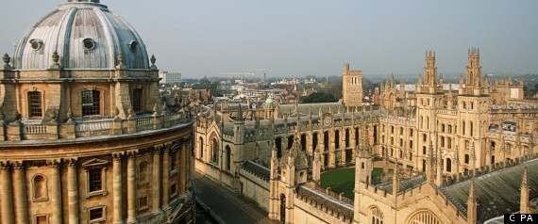

The issues are widespread and the tension is rising. Those issues already mentioned plus specific discussions in:

* social, legal and political issues;
* religion and state institutions;
* Comparing canon law, natural law and state law;
* wearing religious symbols in public;
* justice and mercy, rule and equity, discipline and love, marriage and the family, human rights;
* law and religion in the Muslim Middle East and pagan Rome.

And as stated at the beginning of this study, they are driven by a level of engagement by church leaders that I have never seen before.

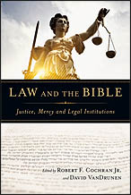Book cover is from **Law and the Bible: Justice, Mercy and Legal Institutions**

by [Robert F. Cochran Jr.](http://www.amazon.com/s/ref=dp_byline_sr_book_1?ie=UTF8&field-author=Robert+F.+Cochran+Jr.&search-alias=books&text=Robert+F.+Cochran+Jr.&sort=relevancerank) (Editor), [David VanDrunen](http://www.amazon.com/s/ref=dp_byline_sr_book_2?ie=UTF8&field-author=David+VanDrunen&search-alias=books&text=David+VanDrunen&sort=relevancerank) (Editor), [John Witte Jr.](http://www.amazon.com/s/ref=dp_byline_sr_book_3?ie=UTF8&field-author=John+Witte++Jr.&search-alias=books&text=John+Witte++Jr.&sort=relevancerank) (Foreword)

The Bible is full of law. Yet too often, Christians either pick and choose verses out of context to bolster existing positions, or assume that any moral judgment the Bible expresses should become the law of the land. *Law and the Bible* asks: What inspired light does the Bible shed on Christians’ participation in contemporary legal systems? It concludes that more often than not the Bible overturns our faulty assumptions and skewed commitments rather than bolsters them. In the process, God gives us greater insight into what all of life, including law, should be. Each chapter is cowritten by a legal professional and a theologian, and focuses on a key aspect of the biblical witness concerning civil or positive law--that is, law that human societies create to order their communities, implementing and enforcing it through civil government. A foundational text for legal professionals, law and prelaw students, and all who want to think in a faithfully Christian way about law and their relationship to i.

**CONCLUSION**

Let us summarise this journey in WHATS CHRISTIANITY EVER DONE FOR THE LAW?

By codifying, ethical strength, inclusivity, emergency responses, and new advances,

Because of belief in the impartial Judge of all, the imperfections of all humans, and the specific contours of Jesus’ measures of justice and of virtue,

Despite coruption and hypocrisy in affairs of money, sex, power and privilege, punitive authority, colonial complicity, departures from Jesus and the pretence of innocence,

The church continues to exercise a positive influence for the common good and against sectional self interest, including its own.

Too often, on the one hand, Christians either pick and choose verses out of context to bolster existing positions, or assume that any moral judgment the Bible expresses should become the law of the land.

On the other hand, what if society should reduce or remove all these inspired influences by callous disregard or anti-Christian ignorance? Because of its long influence in culture, because of some generous and sacrificial commitments, Xty has so built into the culture until everyone in western culture feels these values to be right. **But** new influences are here and shouting, the removal of these protections is under way, so what will sustain these human values? The public square has been left to be dominated by self-interest, by fashions in politics or propaganda.

In this time of change, once you hear this story, choose carefully, that’s all.

**Whether you know it or not,**

**whether you like it or not,**

**you are a gift of God to the world**

**May you be a nuisance, a fool and a God-send.**

**May beauty, truth and goodness**

**flow into the world**

**from your faith, hope and love.**

**May the God of all wisdom guide your path,**

**shine hope into your struggle**

**and heal your love.**

**Do not fear,**

**it is enough to say ‘yes’,**

**and take one step. Amen**

**This is one a series of small group discussion books on “What’s Christianity Ever Done?” Each study looks backwards across the cultural impact of Christianity and describes -**

* **how the principles of faith have undergirded that discipline,**
* **how persons of faith have been pioneers and creators of that discipline,**
* **how the church has sometimes corrupted their role and**
* **how there might be potential need for collaboration into the future.**

WXED LAW

In practise, in principle and in persons, the huge creative contribution of the church to the Law of this culture and internationally has so shaped western culture that Christian humanism is unknowingly the widespread common sense - for instance the value of the child, of each life, womens rights in marriage, just war charters, the right to conscientious objection, secular government, help in emergency, the right to healthcare, universal education, welfare support, freedom from slavery, human rights, prison habilitation, the prevalence of voluntary charity. That’s an impressive description of much that we hold dear in Western society.

What if all this became sidelined by an uninformed disregard or anti-Christian ignorance? New influences are here and shouting, what will sustain these human values? IN late modernity we have trouble integrating outside our silos of thought, can’t action changes that we all know we need, which leaves the public square dominated by self-interest, fashions in cultural priorities or propaganda. Spirituality is inherently wholistic, so its voice adds value in our dilemma.

In time of change, once you hear this story, choose carefully, that’s all